
Financial Plan 2025-2035

10-year projection of financial sustainability

May 2025
report subtitle
(Insert author name if applicable) | (Insert publication date i.e. January 2025)

;;;;;KK



Contents
1 Purpose 5
2 Executive Summary 5
2.1 Financial Vision 6
3 Integrated Strategic Planning and Reporting Framework 7
3.1 Strategic Planning Principles 8
3.2 Financial Management Principles 8
3.3 Service Performance Principles 9
3.4 Community Engagement 9
3.5 Asset Plan Integration 10
4 Council Plan 2025-29 11
5 Financial Plan Context 13
5.1 Financial Policy Statement 13
5.2 Assumptions to the Financial Plan Statements 14
6 Financial Plan Statements 17
6.1 Comprehensive Income Statement 18
6.2 Balance Sheet 20
6.3 Statement of Changes in Equity 21
6.4 Statement of Cash Flows 24
6.5 Statement of Capital Works 25
6.6 Statement of Human Resources 26
7 Financial Performance Indicators 32
8 Strategies and Plans 39
8.1 Borrowing Strategy 39
8.2 Reserves Strategy 41
8.3 Treasury Management Approach and Investment Strategy 42



1 Purpose
The Financial Plan aims to provide a 10-year project of financial sustainability, detailing how the Council Plan and other Integrated Plans will be funded to achieve Council’s Community Vision 2040. This Plan is crucial for supporting the long-term goals and aspirations of the community and is supported by the Council Plan, Health and Wellbeing Plan, Budgets, Workforce Plans and other key strategies and documents, especially the Council’s Financial Vision.

Council is dedicated to regularly reviewing and updating this document to ensure the information remains accurate and up to date, and that it aligns consistently with the annual budget.

2 Executive Summary
Hepburn Shire Council is entering a new phase, marked by a strong commitment to our community, improving our customer responsiveness, and ensuring our financial sustainability. Financial sustainability is at the heart of our future plans. We need solid economic foundations to address the challenges ahead. By making difficult but necessary decisions today, we are securing our ability to serve our community in the future.

In September 2024, Council adopted its Financial Vision, which was proactively developed to support its commitment to financial sustainability. This vision, created in collaboration with Council and the community, serves as a strategic guide for providing services, setting priorities, and executing projects that meet community needs while ensuring financial stability over the next decade.

In creating the Financial Plan, key financial principles underpin Council’s projected financial performance and position over a 10-year period, fulfilling our statutory requirements. The financial forecasts within this plan outline Council’s future direction and financial capacity, serving as a guide for future actions or opportunities. This allows Council to assess the future impacts of its current decisions and review the Plan annually following the adoption of the Annual Budget.

2.1 Financial Vision
This Financial Plan is underpinned by the Financial Vision, which had the following high-level inclusions:
- That the current and projected financial outlook of Council must be a key consideration in the development of the Council Plan 2025-29 and Financial Plan 2025-34 (completed);
- That Council must consider operational savings, services changes and revenue opportunities in the development of the 2025/26 budget (completed);
- That Council prepare and submit an application to the Essential Services Commission for a rate cap variation applicable for the 2025/26 financial year of 7% (completed, and approved in full);
- Subject to a successful application for a rate cap variation, the rebate on rate charges for pensioners who qualify under the State Government’s Pensioner Rate Remission scheme will be doubled. This initiative will increase Council’s rebate from $21 to $42 to assist pensioners in their rate payments (completed, to apply in the 2025/26 year);
- The Chief Executive Officer will work with Councillors to analyse all services offered by Council, to ensure that the Council Plan 2025-2029 and Budget 2025/26 identify operational saving and/or new revenue opportunities needed to deliver the Financial Vision (completed, and service changes will be ongoing);
- That the funding of asset renewal is a priority, and that capital works expenditure is limited to effectively renewal works only. Council will actively seek State and Federal Government funding, if new or extended assets are to be considered (completed, and ongoing); and
- Creation of a ‘grant funding reserve’, if the rate cap variation is approved, which will mean funds will be available to allocate to government grant applications as ‘matching’ funds (ongoing).
This Financial Plan ensures that the objectives outlined within the Financial Vision are achieved:
- Ensure that cash reserves are sufficient to sustain service delivery for the community and to fulfill our obligations;
- Strive to have an amount of unallocated cash to provide a buffer so that we can adequately respond to any unforeseen emergencies;
- In the long-term, establish a reserve that can provide matching funds for grants received from other tiers of government to deliver for our future generations.

3 Integrated Strategic Planning and Reporting Framework

The Integrated Planning and Reporting Framework sets out the range of strategic documents Council is required to adopt under the Local Government Act 2020. The framework sets out Hepburn Shire’s integrated approach to planning, monitoring, and performance reporting.
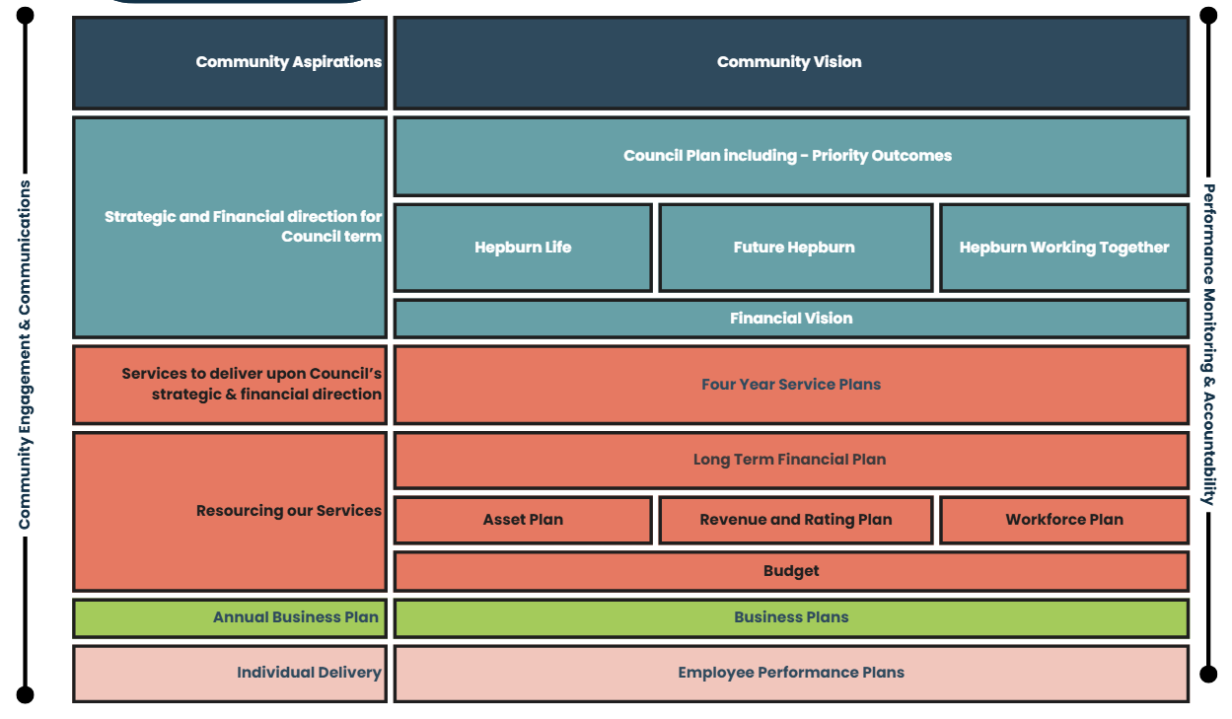
Council holds itself accountable through the Annual Report.

3.1 Strategic Planning Principles
The Financial Plan provides a 10-year financially sustainable projection regarding how the actions of the Financial Vision and Council Plan may be funded to achieve the Community Vision. The Financial Plan is developed in the context of the following strategic planning principles:
- Council has an integrated approach to planning, monitoring and performance reporting.
- Council’s Financial Plan addresses the Community Vision by funding the aspirations of the Council Plan. The Council Plan outcomes and strategies are formulated in the context of the Community Vision.
- The Financial Plan statements articulate the 10-year financial resources necessary to implement the goals and aspirations of the Council Plan to achieve the Community Vision.
- Council's strategic planning principles identify and address the risks to effective implementation of the Financial Plan.
- The Financial Plan provides for the strategic planning principles of progress monitoring and reviews to identify and adapt to changing circumstances.

3.2 Financial Management Principles
The Financial Plan demonstrates the following financial management principles:
- Revenue, expenses, assets, liabilities, investments and financial transactions are managed in accordance with Council's financial policies and strategic plans.
- Management of the following financial risks:
  - The financial viability of the Council (refer to Section 5.1 Financial Policy Statement)
  - The management of current and future liabilities of the Council. The estimated 10-year liabilities are disclosed in Section 6.2 Balance Sheet projections.
- Financial policies and strategic plans are designed to provide financial stability and predictability for the community.
- Council maintains accounts and records that explain its financial operations and financial position (refer to Section 6 Financial Plan Statements)

3.3 Service Performance Principles
Council services are designed to be purposeful, targeted to community needs and value for money. The service performance principles are listed below:
- Services are provided in an equitable manner and are responsive to the diverse needs of the community. The Council Plan is designed to identify the key services and projects to be delivered to the community. The Financial Plan provides the mechanism to demonstrate how the service aspirations within the Council Plan may be funded.
- Services are accessible to the relevant users within the community.
- Council provides quality services that provide value for money to the community. The Local Government Performance Reporting Framework (LGPRF) is designed to communicate Council’s performance regarding the provision of quality and efficient services.

3.4 Community Engagement
The Local Government Act 2020 prescribes that community engagement be undertaken in accordance with Council’s Community Engagement Policy and include deliberative engagement for the Financial Plan.
Consultancy group Conversation Co was contracted to develop and manage a Deliberative Engagement panel process to ensure community views and input were considered and included in the Council Plan. Details of the engagement process, and findings is included within the Council Plan and on Council’s website.
The recent community engagement was further supplemented by the work undertaken with the Financial Vision 2024-2027 that was adopted by Council in September 2024.

3.5 Asset Plan Integration
Integration of the Asset Plan is a key principle of the Council’s strategic financial planning principles. The purpose of this integration is designed to ensure that future funding is allocated in a manner that supports service delivery and the effective management of Council’s assets into the future.
The Asset Plan identifies the operational and strategic practices which will ensure that Council manages assets across their life cycle in a financially sustainable manner. The Asset Plan, and associated asset management policies, provide Council with a sound base to understand the risks associated with managing its assets for the community’s benefit.
The Asset Plan is designed to inform the 10-year Financial Plan by identifying the capital renewal gap and maintenance funding that is required over the life of each asset category. The level of funding will incorporate knowledge of asset condition, the risk assessment issues, as well as the impact of reviewing and setting intervention and service levels for each asset class. The intervention levels can be adjusted and adopted across a range of scenarios considering the longer-term financial capacity which is reviewed annually.
In addition to identifying the operational and strategic practices that ensure Council manages assets across their life cycle in a financially sustainable manner, the Asset Plan quantifies the asset portfolio and the financial implications of those practices. Together the Financial Plan and Asset Plan seek to balance projected investment requirements against projected budgets.

4 Council Plan 2025-29
The Council Plan outlines the strategic framework that guides Council’s planning and decision-making over the current Council term. It sets a clear direction for how the Council will work towards delivering long-term community aspirations while responding to current priorities and challenges.
Progress and outcomes will be reported through the Hepburn Shire Council Annual Report and quarterly business reports. Our work is measured annually against the Performance Statement in the Annual Report and the community rates our performance through the annual Community Satisfaction Survey.
Council delivers activities and initiatives under major service categories. Each contributes to the achievement of one of the domain strategies as set out in the four-year Council Plan 2025-2029. The three domain strategies described in the Council Plan are:

Hepburn Life
Outcome 1 | Connected communities that are resilient, adaptable, and empowered - able to respond to and recover from climate-related impacts, emergencies, and other community challenges.
Outcome 2 | A healthy and inclusive community, where all people regardless of background or stage of life and have the opportunity to participate and thrive.
Outcome 3 | An informed and engaged community.
Future Hepburn
Outcome 1 | Preserve the unique character of our towns and communities, plan for future growth and protect our productive rural landscape.
Outcome 2 | Responsible management of infrastructure and environment to support wellbeing now and for future generations.
Outcome 3 | A dynamic, vibrant, and resilient economic environment.
Hepburn Working Together
Outcome 1 | Future focused services that are easy to use and inclusive.
Outcome 2 | Maintain corporate governance to enable good Council decision making and to ensure long-term financial viability.
Outcome 3 | An engaged, safe, and skillful workforce.

5 Financial Plan Context
This section describes the context and external / internal environment and consideration in determining the 10-year financial projections and assumptions.

5.1 Financial Policy Statement
This section defines the measures that demonstrate Council’s financial sustainability in order to fund the aspirations of the Community Vision and the Council Plan.
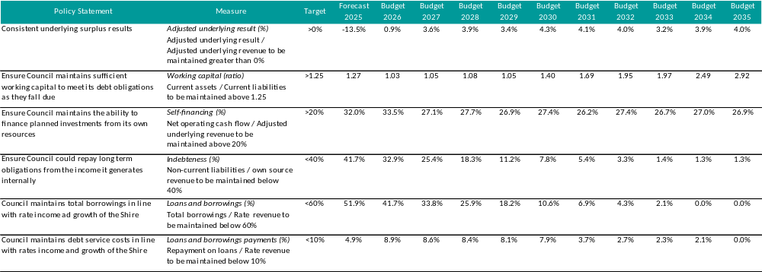

5.2 Assumptions to the Financial Plan Statements
This section outlines the assumptions for the Comprehensive Income Statement over the 10-year period from 2025/26 to 2034/35. It includes the annual escalations and movements for each line item of the Comprehensive Income Statement.
Further details on Council’s approach and recommendations in relation to revenue are contained in Council’s Revenue and Rating Plan, available on Council’s website.
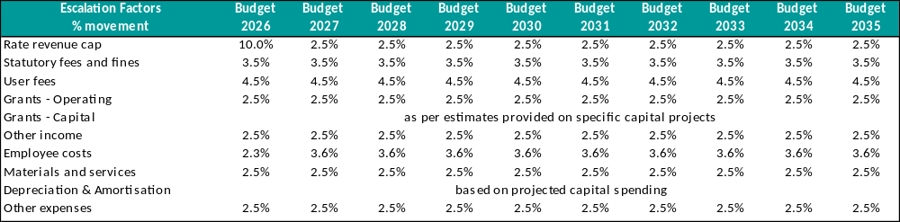

Rates and Charges
The base rate revenue will increase by 10 per cent for the 2025/26 year, with future annual increases in line with the State Government rate cap, estimated as outlined in the long-term Financial Plan. The level of required rates and charges has been considered in the context of Financial Vision 2024-2027, with reference to Council's other income sources and planned community services and works expenditures.
A rate cap variation has been approved by the Essential Services Commission (ESC), aligning with Council’s current and projected financial outlook. Consequently, the average revenue from the general rate will rise by 10 per cent, which includes:
- A permanent 7 per cent uplift to ensure Council’s financial viability and long-term sustainability; and
- A 3 per cent increase as set by the Minister for Local Government for 2025/26.
Statutory Fees and Fines
The Financial Plan applies a conservative indexation of 3.5 per cent for future years' statutory fees as they are outside of the control of Council, as these are predominately set up by the State Government.
User Fees
User fees are projected to rise by 4.5 per cent for the 2025/26 fiscal year and are expected to continue increasing in subsequent years as outlined in the financial plan. Council is committed to making a concerted effort to boost revenue sources over the coming years. Detailed information about the user fees for the 2025/26 Budget year can be found in Council’s Fees and Charges Schedule, which is included in the Budget document.
Grants
Operating grants are projected to increase annually by approximately 2.5 per cent while Financial Assistance grants are expected to grow by 4.0 per cent each year.
Capital grants, which include funds from state and federal sources for the capital works program, can vary significantly each year depending on the types of projects included. For this Financial Plan, the forecast is based on estimates provided for specific capital projects.

Other Income
Revenue from other income mainly comprises investment income plus the recovery income from a variety of sources and rental income received from the lease and hire of Council buildings.
Employee Costs
Hepburn Shire Council plans to introduce a new Enterprise Agreement starting in 2026, which will include provisions for employee remuneration increases until the agreement expires. This plan is based on an annual employee cost increase of 3.6 per cent from 2026/27 onwards, which needs to take into account wage increases, superannuation increases, WorkCover insurance, training and development, and other employee related costs.
Materials and Services
Material costs encompass items necessary for the maintenance and repair of Council buildings, roads, drains and footpaths which are more influenced by market availability than by CPI. This category also includes utilities and consumable items for various services. Additionally, Council relies on external expertise for various matters, such as legal services and audits. The plan anticipates an annual increase of 2.5 per cent to manage these costs.
Depreciation and Amortisation
Depreciation estimates have been calculated based on the anticipated capital expenditures outlined in this plan.
Borrowing Costs
Borrowing costs comprise of the interest expense to service Council’s loan portfolio that is described in Section Borrowing Strategy. This part of the plan does not include any new loan funding.
Other Expenses
Other expenses encompass administration costs such as Councillor allowances, election expenses, community grants, fire services property levy, audit fees, and various other costs related to the daily operations of Council.

6 Financial Plan Statements
This section presents details regarding the Financial Plan Statements for the 10-year period from 2025/26 to 2034/35.
- Comprehensive Income Statement
- Balance Sheet
- Statement of Changes in Equity
- Statement of Cash Flows
- Statement of Capital Works
- Statement of Human Resources

6.1 Comprehensive Income Statement
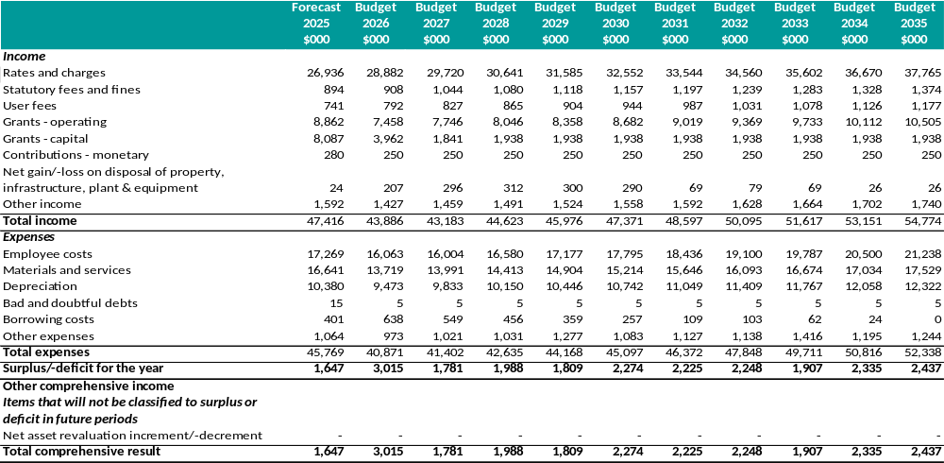
Adjusted Underlying Result
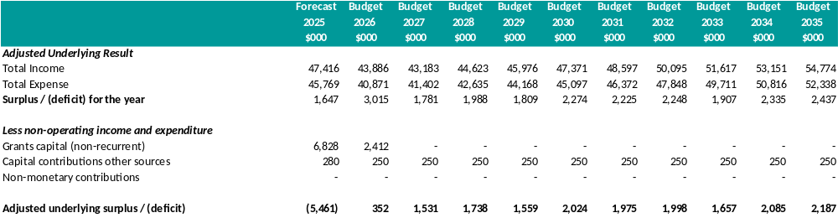

The adjusted underlying result reflects the net surplus for the year, excluding non-recurrent capital grants, capital contributions from other sources, and non-monetary contributions. It serves as a crucial indicator of Council’s financial health and its ability to achieve its service delivery goals.
The 10-year financial plan is aligned with the Financial Vision 2024-2027, which aims to establish a fiscally responsible budget and ensure financial sustainability for Council. This plan includes a reduction in operating expenditure for 2025/26 financial year of $2.53 million. The plan considers the challenging environment faced by the Local Government sector, including increased capital delivery costs, general inflation and significant cost of living pressures on the community. As a result of the strategic direction to reduce operating expenditure while increasing revenue, Council has budgeted for an adjusted underlying surplus for 2025/26 year. This positive trend in the adjusted underlying surplus is expected to continue throughout the duration of the plan.

6.2 Balance Sheet
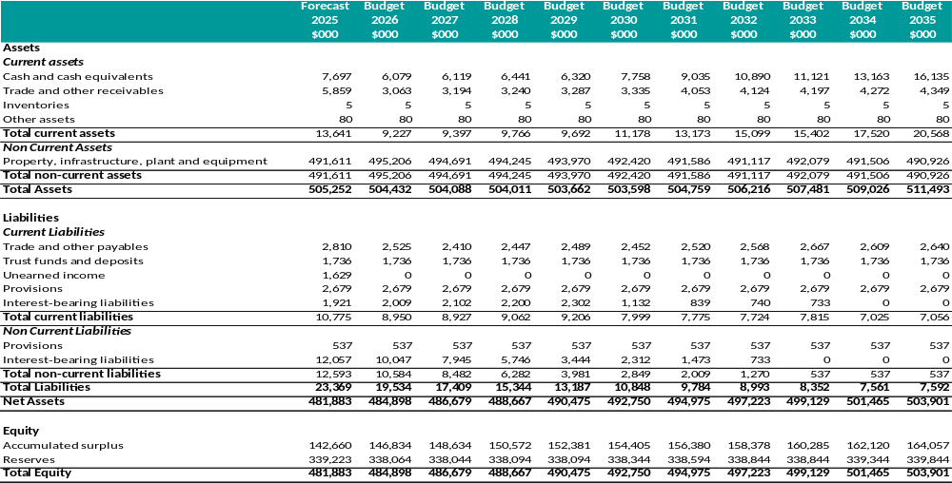

6.3 Statement of Changes in Equity
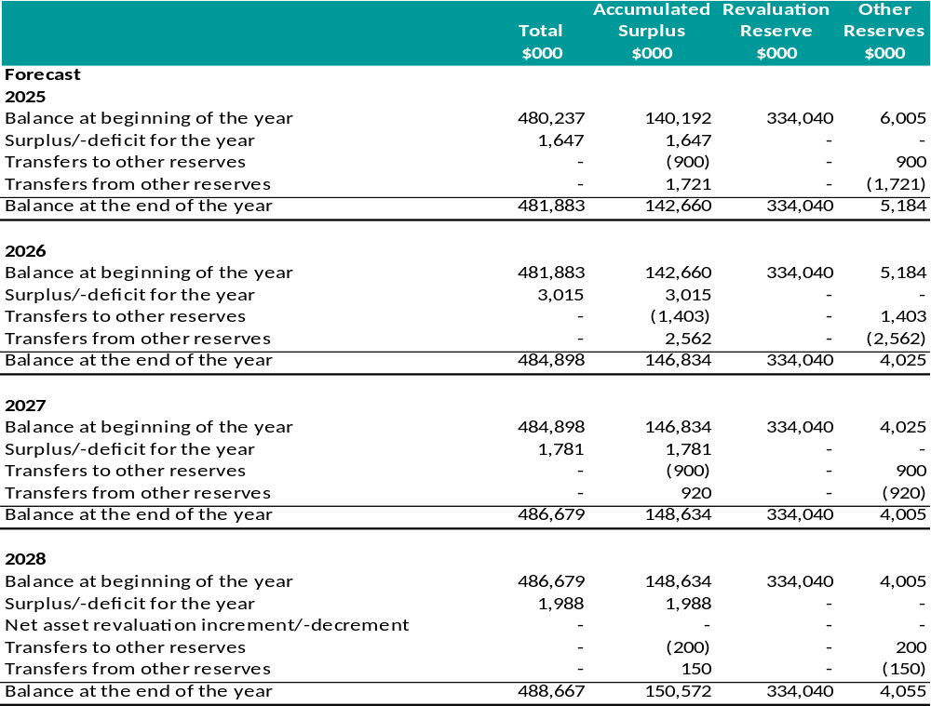
Statement of Changes in Equity (cont.)
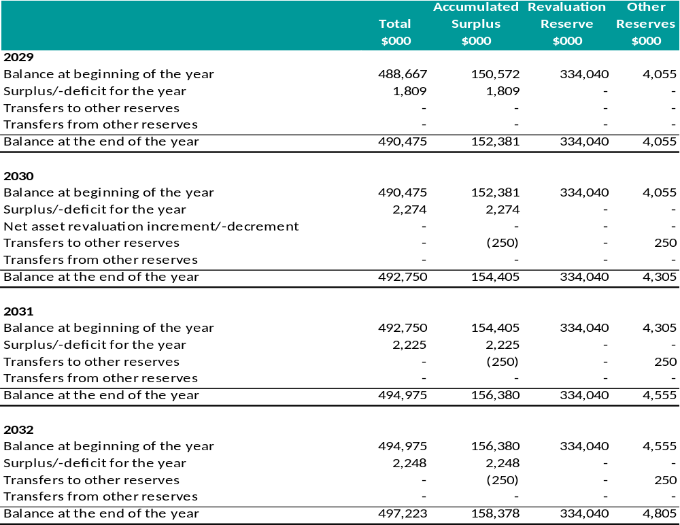
Statement of Changes in Equity (cont.)
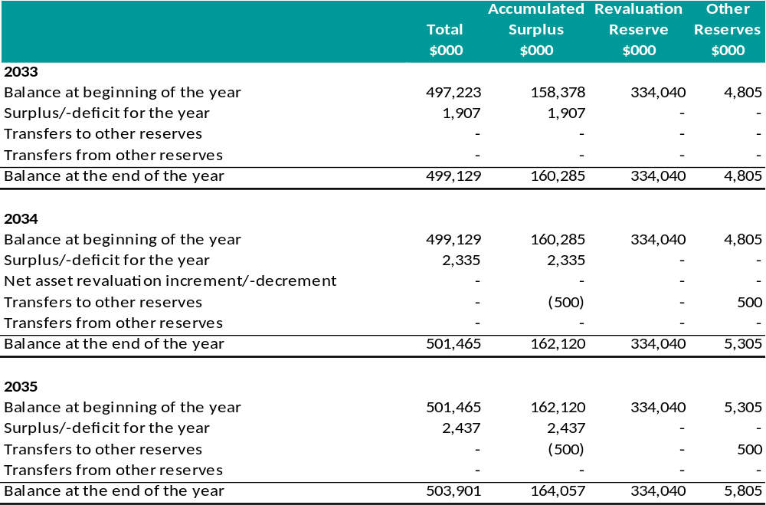

6.4 Statement of Cash Flows
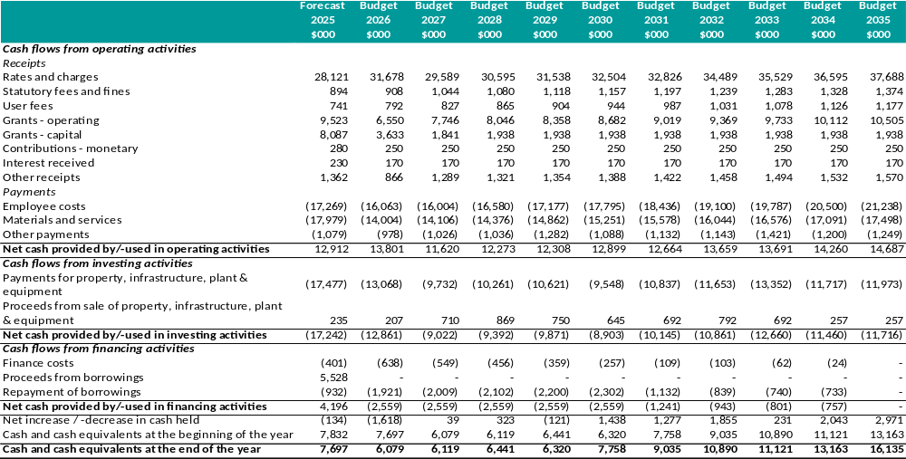

6.5 Statement of Capital Works
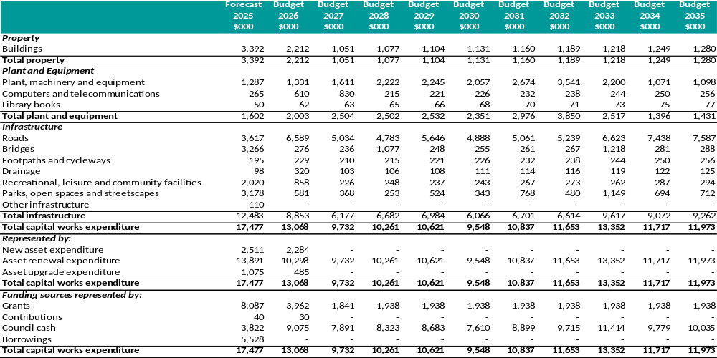

6.6 Statement of Human Resources
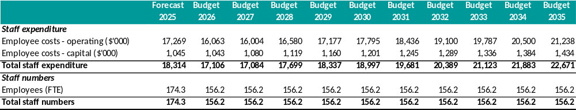

A summary of human resources expenditure categorised according to the 2024/25 organisational structure of Hepburn Shire Council is included below:

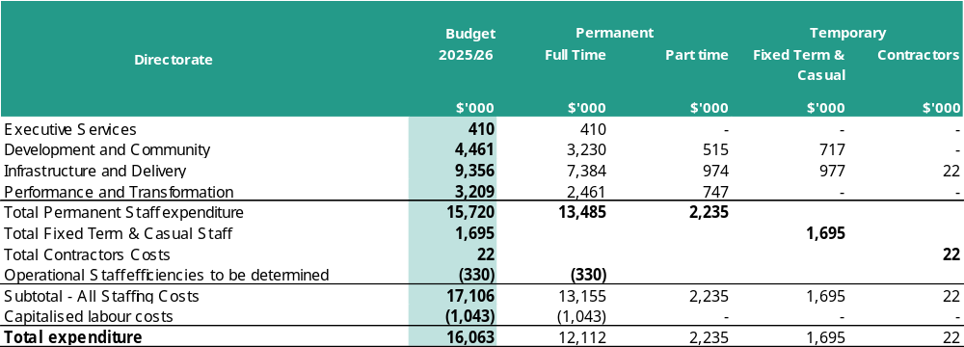

A summary of the number of full-time equivalents (FTE) Council staff in relation to the above expenditure is included below.
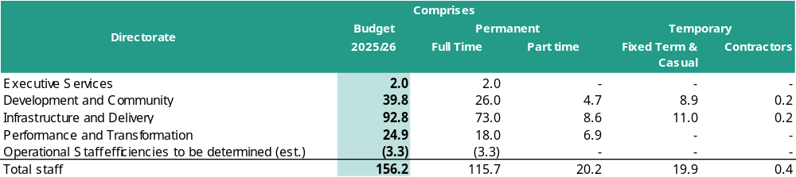
Planned Human Resources Expenditure
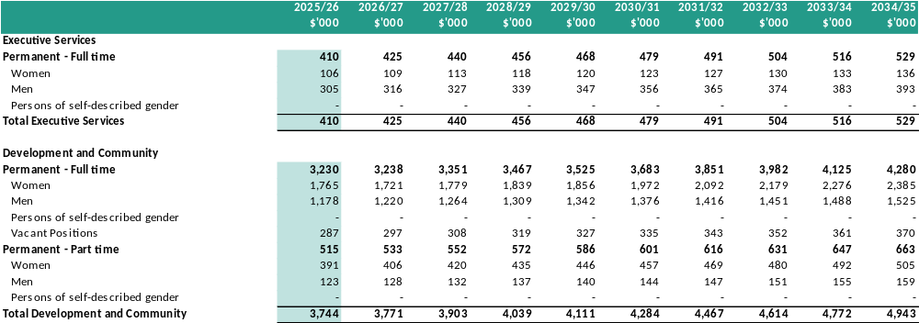

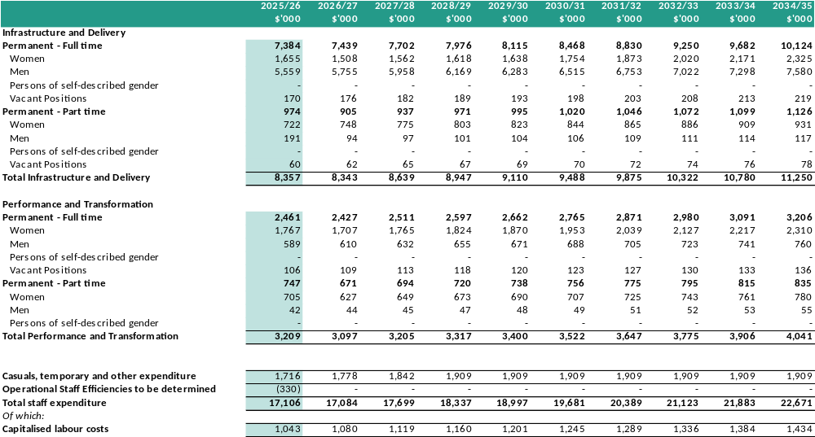
Planned Human Resources – Full Time Equivalents
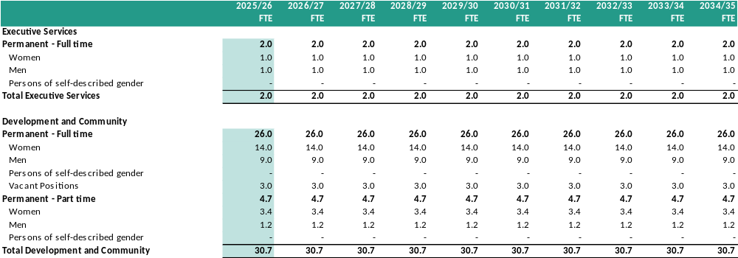

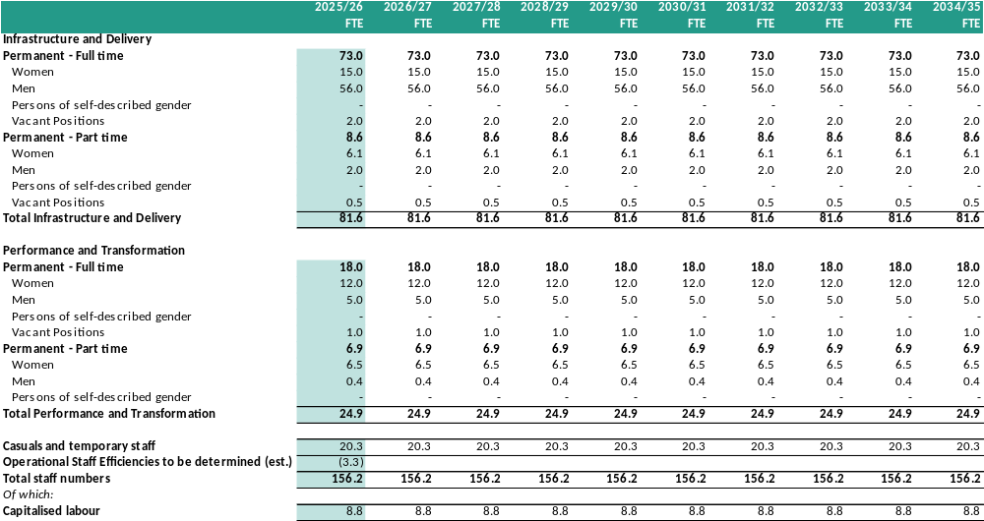

7 Financial Performance Indicators
The following table highlights Council’s projected performance across a range of key financial performance indicators. These indicators provide an analysis of Council’s 10-year financial projections and should be interpreted in the context of the organisation’s objectives and financial management principles.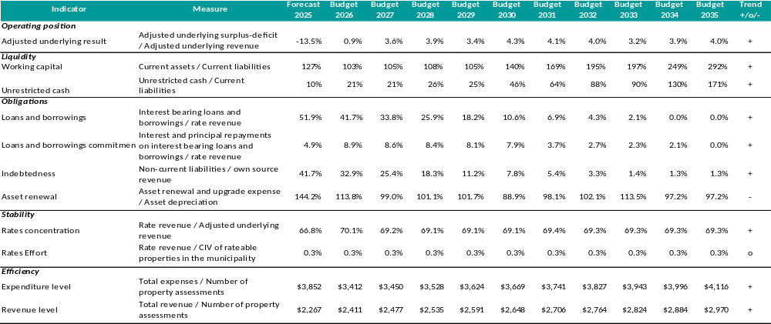
Key to Forecast Trend
+ Forecasts improvement in Council’s financial performance/financial position indicator
o Forecasts that Council’s financial performance/financial position indicator will be steady
- Forecasts deterioration in Council’s financial performance/financial position indicator

Graphs – Key Performance Indicators
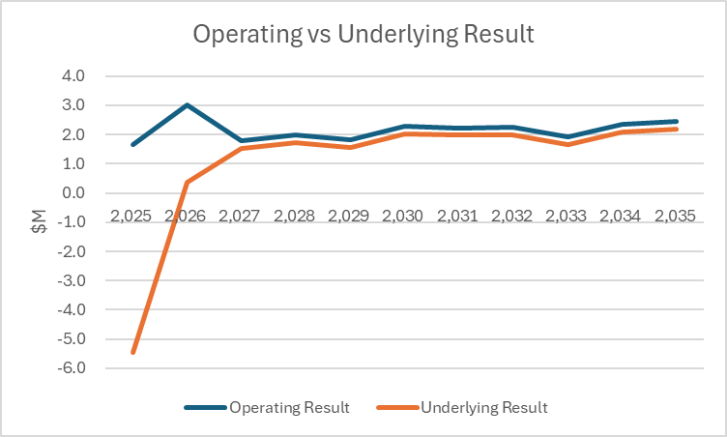
- Adjusted underlying result – An indicator of the sustainable operating result required to enable Council to continue to provide core services and meet its objectives. The positive result for this indicator identifies an adjusted underlying surplus and the trend indicates improving underlying surpluses over the strategic resource plan.
- Positive outcomes for both operating and adjusted underlying result.
- Combination of increasing revenues and decreasing operating expenditures.
- Promising financial health and shows ability to achieve Councils service delivery goals.

Graphs – Key Performance Indicators (cont.)
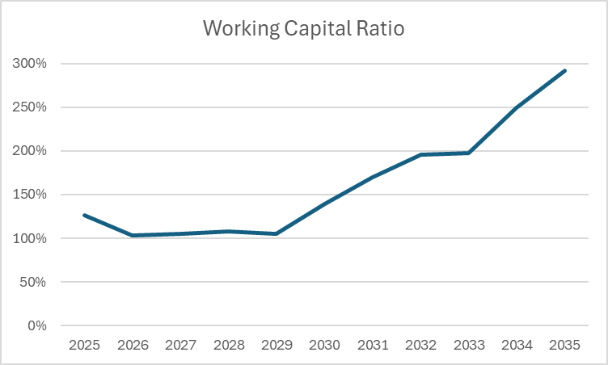
- Working capital – The proportion of current liabilities represented by current assets. The indicator shows an increase over most of the plan, primarily due to rising cash balances and decreasing expenditure on loan interest and loan principal repayments.
- Significant improvements in the latter part of the plan will allow for increased allocation of capital works expenditure or the ability for Council to respond to increased costs, or unforeseen costs.
- Increasing cash balances and reducing debt levels.

Graphs – Key Performance Indicators (cont.)
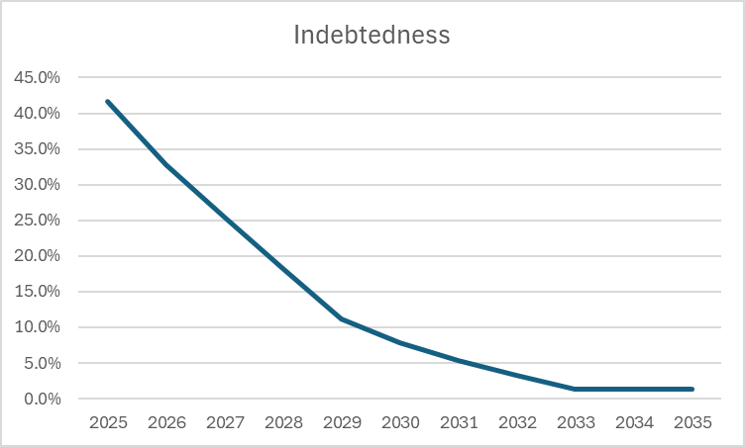
- Indebtedness – to assess Council’s ability to cover its medium to long-term liabilities with revenue not sourced by grants, monetary contributions, or non-monetary contributions.
- Improvements to the indicator throughout as the repayment of debt obligations occur.
- Within the State Government target of between 0-40% with capacity for future borrowings subject to any new capital developments.

Graphs – Key Performance Indicators (cont.)
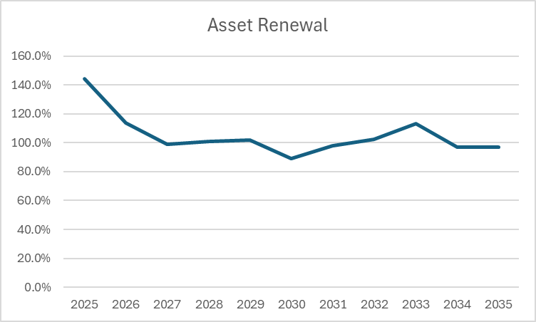
- Asset renewal – This percentage indicates the extent of Council’s renewals against its depreciation charge (an indication of the decline in value of its existing capital assets).
- A percentage greater than 100 indicates that Council is maintaining its existing assets, while a percentage less than 100 indicates that assets are deteriorating faster than they are being renewed, necessitating future capital expenditure for asset renewal.
- 2025 is artificially high as it includes carry-forward projects in addition to the annual allocation.

Unrestricted Cash Position
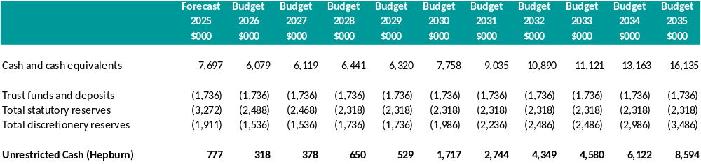

- Unrestricted cash – This indicator represents Council’s ability to meet its short-term commitments without using funds allocated for other purposes.
- Remains positive throughout the plan but requires ongoing attention.
- Aligns with our Financial Vision, starting on the lower side in the early years and improving over the medium term.

8 Strategies and Plans
This section describes the strategies and plans that support the 10-year financial projections included in the Financial Plan.

8.1 Borrowing Strategy
Current Debt Position
Council’s adopted Treasury Management Policy (50C) specifies the conditions under which borrowings can be used as a funding source. This policy acknowledges the principles of inter-generational equity funding and states that borrowings should be for specific purposes, such as strategically significant capital works that cannot be funded within the required timeframe. Additionally, it mandates that future borrowings must align with the Financial Plan’s capacity to cover debt servicing costs throughout the loan’s duration.
Council has utilised debt funding for several major infrastructure projects, including the completion of Djuwang Baring – All abilities mountain biking project and the Daylesford Town Hall roof and electrical works.
The total amount outstanding as at 30 June 2026 is projected to be $12.07 million.
Future Borrowing Requirements
The following table highlights Council’s projected loan balance, including new loans and loan repayments for the 10-years of the Financial Plan.
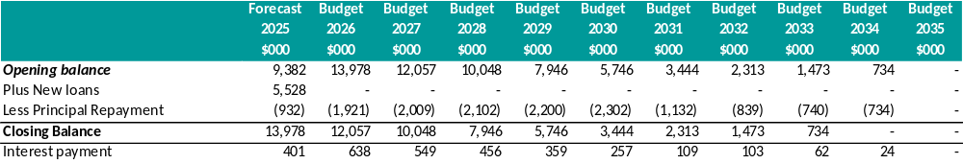
Performance Indicators
The following table highlights Council’s projected performance across a range of debt management performance indicators.
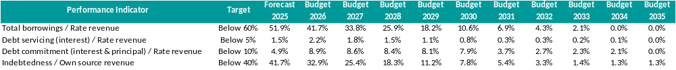
Council maintains its loan borrowing within prudent and management limits as demonstrated by the following performance indicators, and the medium-long term of this plan allows the capacity to borrow for appropriate projects if Council resolves too.
Total borrowings / Rate revenue
This evaluates the use of debt to finance Council’s long-term projects in relation to rates and charges revenue. Since it is within the 60 per cent target, Council can borrow funds for major capital projects in the future. The financial plan does not include any new borrowings.
Debt Servicing / Rate revenue
This indicates Council’s capacity to meet its debt obligations using the revenue generated from rates. Being significantly below the 5 per cent target demonstrates that Council can cover its loan interest payments through rates without needing to seek alternative funding sources.
Debt commitment / Rate revenue
This evaluates how dependent Council is on revenue from rates and charges to meet its interest and principal loan repayments. With ratios below the 10 per cent target, it indicates that Council can fulfill its debt obligations without needing to seek alternative funding sources.
Indebtedness / Own source revenue
This measures Council’s capacity to meet its long-term obligations using internally generated revenue (excluding external grants and contributions). The indebtedness target is higher in the initial years but remains within the target of 40 per cent.

8.2 Reserves Strategy
Council maintains both statutory and discretionary reserves in accordance with standard practice. Financial reserves are funds set aside from operating and capital incomes for future funding of capital projects. From an accounting perspective, these funds are recorded under ‘Equity’ in Council’s Balance Sheet. The nature, purpose, and any usage restrictions of major reserves are outlined below.
- Public Open Space Reserve - The Public Open Space Reserve is used to hold developer contributions towards public open space infrastructure arising from property developers undertaking property subdivisions. These funds are then used to expand and upgrade Council's public open space facilities. Use of the funds in the Public Open Space Reserve is restricted by legislation.
- Mineral Springs Financial Reserve - The purpose of this reserve is to fund future works associated with mineral springs across the shire and the refurbishment of the spa complex. The annual operating surplus of the Hepburn Mineral Springs Reserve is transferred to this reserve each year. Reserve funds are then used for capital projects at the Hepburn Mineral Springs Reserve. The use of funds in this reserve is not restricted by legislation and is at the discretion of Council.
- Waste Management Reserve - The annual operating surplus of Council's waste management function is transferred to the Waste Management Reserve each year. Reserve funds are then used for waste management capital projects. Council has continued with the Waste Strategy during 2024/2025 which informs future waste management capital projects required by the Shire. The use of funds in this reserve is not restricted by legislation and is at the discretion of Council.
- Staff Accommodation and Community Facilities Reserve - This reserve is the surplus from the sale of The Rex and the repayment of the loan drawn down to purchase The Rex. This reserve is to be allocated to projects associated with accommodation for Hepburn Shire Staff and Community Facilities within the Birch Ward.
- Grant Funding Reserve – A newly established reserve, through the Financial Vision, designed to provide ‘match’ funding for government grants. This reserve ensures that the necessary co-contributions for future projects are available, facilitating the allocation of funds to government grant applications. Allocations to this reserve will depend on the available cash surpluses and will be reviewed annually.

Reserve Usage Projections
The table below presents the balance and projected annual movement for each reserve over the 10-year duration of the Financial Plan. The total amount of reserves for each year aligns with the Statement of Changes in Equity, excluding the Asset Revaluation Reserve.
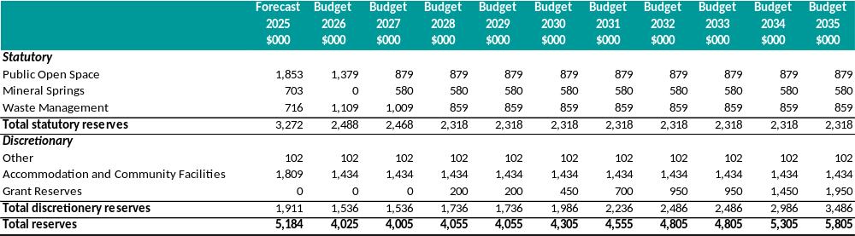

8.3 Treasury Management Approach and Investment Strategy
Council’s Treasury Management Policy (50C) governs the management of its financial resources, including cash and investments.
Council must maintain adequate cash and cash equivalents to meet all reasonably anticipated cash flow needs as they arise. For any surplus cash, Council will invest in term deposits, ensuring that investments with any single financial institution does not exceed the policy’s specified limits. Speculative investments are strictly prohibited.

