
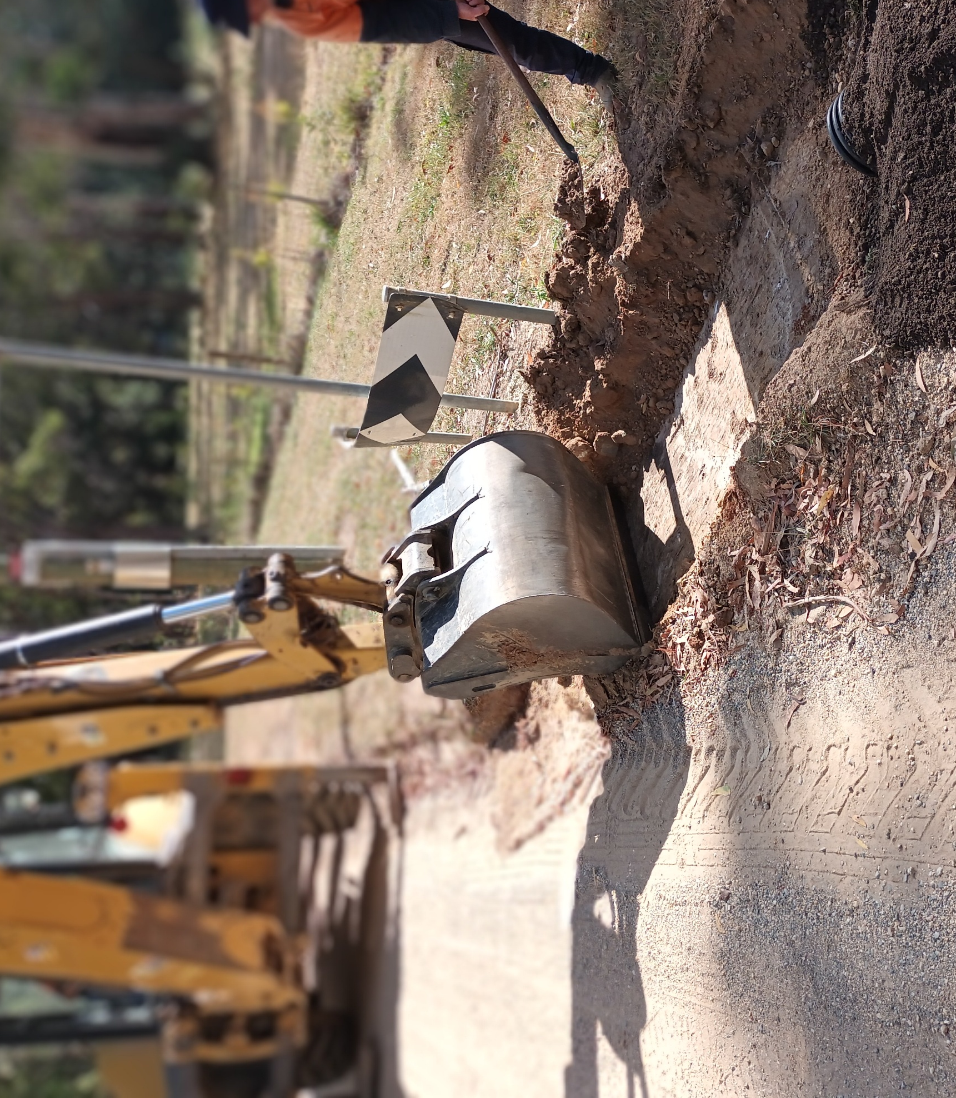
Draft Budget 2025/26

May 2025



This Budget Report has been prepared with reference to Local Government Victoria’s Model Budget 2025-2026 and Best Practice Guide.

CONTENTS
Mayor and CEO Introduction 4
Executive Summary 7
Operating Results 7
1. Rates and Charges 8
2. Financial Position 8
3. Operating Result 9
4. Financial Sustainability 9
5. Services 10
6. Cash and Investments 14
7. Capital Works 14
01. Delivering on the Council Plan 15
1.1 Integrated Strategic Planning and Reporting Framework 15
1.2 Our Community Vision 16
1.4 Council’s Strategic Vision 17
02. Services and Performance Indicators 18
2.1 Development and Community 19
2.2 Infrastructure and Delivery 21
2.3 Performance and Transformation 23
2.4 Service Performance Outcome Indicators 24
2.5 Reconciliation of Strategic Objectives with Budgeted Result 25
2.6 Total budgeted expenditure by domain 25
2.7 Operating Efficiencies 26
03. Financial Statements 27
3.1 Comprehensive Income Statement 28
3.2 Balance Sheet 29
3.3 Statement of Changes in Equity 30
3.4 Statement of Cash Flows 31
3.5 Capital Works Program 32
3.6 Statement of Human Resources 33
04. Notes to the Financial Statements 36
4.1 Comprehensive Income Statement 36
4.2 Balance Sheet 46
4.3 Statement of Changes in Equity 48
4.4 Statement of Cash Flows 50
4.5 Capital Works Program 52
4.6 Non-Capital Projects Program 56
05. Targeted Performance Indicators 57
5.1 Targeted Performance Indicators – Service 57
5.2 Targeted Performance Indicators – Financial 58
5.3 Financial Performance Indicators 59
Appendix A: Fees and Charges Schedule (refer to following pages) 62

Mayor and CEO Introduction
Hepburn Shire Council is entering a new chapter, one defined by a strong commitment to our community, improving our customer responsiveness and ensuring our financial sustainability.

Financial sustainability is at the core of our plan for the future. We need strong economic foundations to allow us to meet the challenges ahead. By making the difficult but important decisions today, we will be protecting our ability to deliver for our community tomorrow.

In the first year of our Council term, the Council Plan 2025-2029 (including the Municipal Health & Wellbeing Plan), and the draft 2025/2026 budget identifies a financial outlook being repeated across many of the 79 local governments in Victoria.

In September 2024 Council adopted its Financial Vision, which was proactively created to support Council’s obligations towards financial sustainability. The vision was created in partnership with Council and the community, and acts as a strategic guide to detail the provision of services, priorities, and projects that meet community needs, while ensuring financial stability over the next ten years.

Our Council Plan 2025–2029 has been developed within the remit of our Financial Vision, and is focused on getting back to the basics, this budget delivers on year 1 of the Council Plan.

The draft 2025/26 budget strives to make tough but responsible decisions to ensure that Hepburn Shire is financially viable in the short and long-term.

The operating expenditure for 2025/2026 is projected to be $40.9 million ($31.4 million excluding depreciation). The budget will deliver a $13.07 million capital works program for 2025/2026, focused on the delivery of previous project commitments and renewal of our existing assets.

Major areas of investment throughout 2025/2026 includes:
- Over $1 million of strategic planning investment to continue the implementation of Future Hepburn (Township Structure Plans, Rural Strategy and Integrated Transport Strategy).
- The roads capital expenditure is $6.59 million, significantly higher than recent years and likely to be the largest non-flood recovery investment. Over the past five financial years, the average expenditure on roads capital works has been $3.03 million. This investment has been made possible with $3.64 million of State and Federal funding.
- Renewal funding
- Operational funding for roads, facilities, and asset maintenance of $4.88 million, Parks and Open Space funding of $2.23 million and investment in waste operations (kerbside collections, transfer stations) of $3.97 million.

Council has made the difficult but necessary decision to reduce operating expenditure by $2.53 million across services, further detailed throughout the budget.

This budget leaves little or no room for discretionary funding outside what is planned in the budget or to respond to unplanned emergencies. This reality poses risks for Council and amplifies that Council’s strategic decisions on project delivery are critical now more than ever.

The budget projects $6.08 million in cash reserves on 30 June 2026 and unrestricted cash is forecast as $0.32 million. This is an extremely modest buffer and has required Council to consider thoroughly the most effective means to ensure financial stability and sustainability.

Revenue collected through rates and charges, State and Federal Government grants and other sources, is projected to be $43.9 million. Rates have been increased by 10%, in line with the State Government Rate Cap of 3.0%, together with a permanent uplift of 7% rate cap variation for 2025/2026 as approved by the Essential Services Commission to ensure the financial viability and long-term sustainability of Council.

It is important to note, the actual rate increases experienced by individual ratepayers may differ from the 10.0% increase due to revaluations. Rate increases are impacted by the average rate increase (10.0%) and the property valuation increases (or decreases) of individual properties relative to the average across the municipality. If your property increased in value by more than the average for the Shire, your rates may increase by more than 10.0%. If your property value increased by less than the average, your rates may increase by less than 10.0% and may in fact reduce from the previous year.

This decision supports the previous work identified through the Financial Vision 2024-2027 and is made in conjunction with the operating efficiencies to be delivered.

Council has weekly kerbside collections across the Shire and a review of the standard annual fees for 2025/2026 has retained these annual fees at the 2024/2025 rates with the except of food and organics (FOGO) for township residents which has reduced by $40 per annum. This ability to reduce overall charges associated with waste collection is extremely positive and demonstrates Council working hard to ensure value of money and reducing costs where possible.

This budget includes $11.42 million of revenue collected through government grants and other sources. There is a strong need for Council to remain actively seeking other income sources, including grants. It is important to note that although planning and design allocations for capital projects are funded in this budget, many projects will require successful sourcing of external funding if they are to progress to the construction stage.

This budget includes no new borrowings.

The financial outlook of many local governments highlights the need for ongoing advocacy and partnerships with all tiers of government. We will continue to emphasise to State and Federal Governments that local government is a vital tier of government that must be appropriately funded.

Creating this budget has been a challenging process, as anticipated. Numerous workshops have been conducted with Councillors and Officers to develop the draft Council Plan and the associated budget. We recognise that many of the decisions in this budget may not be well-received. However, it is crucial that we make these tough decisions. Not only do we have a legal responsibility to ensure the Council's financial viability, but we also have a moral duty to make what we believe are the best decisions for both the present and the future. We are confident that this budget accomplishes that.

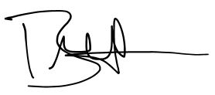
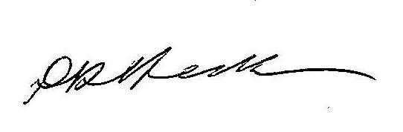

Cr Don Henderson Bradley Thomas
Mayor Chief Executive Officer

Executive Summary
The overall operating expenditure budgeted for 2025/2026 is projected to decrease by 11% (or $4.9m) from the 2024/2025 forecast actual, bringing it down to $40.9m. This reduction aligns with the Financial Vision 2024-2027, which aims to achieve a fiscally responsible budget and ensure financial sustainability for Council. This budget takes into account the challenging environment characterised by the Local Government sectors tough financial position, increased capital delivery costs, general inflation and significant cost of living pressures for the community.
The 2025/2026 budget has been developed within the objectives of the Financial Vision and the new Council Plan 2025-29 acknowledging operational savings are required to ensure unrestricted cash remains positive. The 2025/2026 budget is also developed in the context that Councillors are reviewing the wide range of services offered by Council, and the limited opportunities to increase revenue as part of the 10-year Financial Plan development.

The 2025/2026 budget is founded on a number of assumptions, including the final impact of the 2024/2025 financial year. It is difficult to estimate a closing cash position as at June 2025 given a number of factors including the timing of grant payments, project delivery and carry-forward impacts. The closing cash position as at 30th June 2025, as reflected in the audited 2024/2025 financial statements, will have an influence on the 2025/2026 budget, and forms part of reporting in September 2025.

Council has budgeted both a surplus, and an adjusted underlying surplus for the 2025/2026 year, and while a positive unrestricted cash position – these are positive trends and improvements on prior financial years.

Operating Results
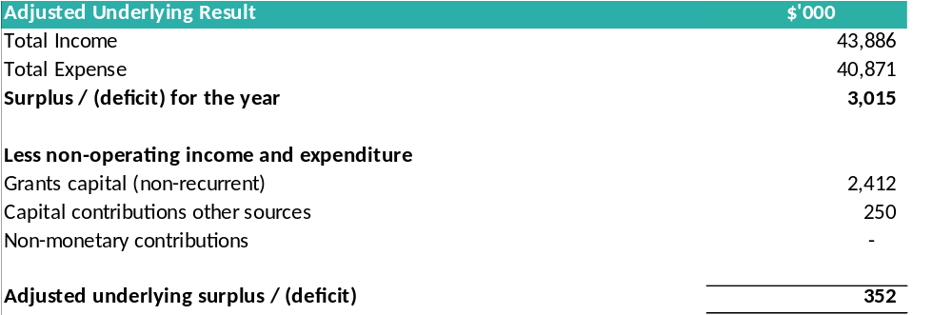

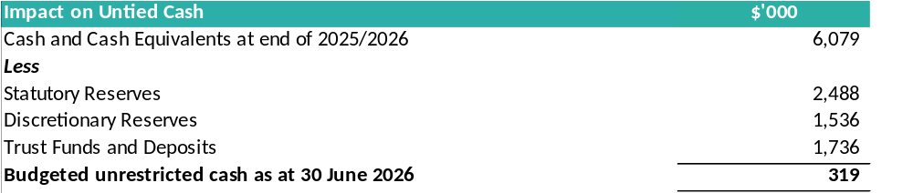

1. Rates and Charges
The projected total revenue from rates and charges is $28.9m, which includes an average rate increase of 10.0%. This increase consists of a rate cap variation for a permanent uplift of 7% to ensure the financial viability and long-term sustainability of the Council, and a 3% rate cap in accordance with the Fair Go Rates System (FGRS), which limits rate increases for Victorian councils as determined by the Minister for Local Government.

The required level of rates and charges has been evaluated in the context of the Financial Vision 2024-2027, considering the Council's other income sources and the planned expenditure on community services and works. A 7% rate cap variation has been requested from the Essential Services Commission, aligning with the Council's current and projected financial outlook.

It is important to note, the actual rate increases experienced by individual ratepayers may differ from the 10.0% increase due to revaluations. Rate increases are impacted by the average rate increase (10.0%) and the property valuation increases (or decreases) of individual properties relative to the average across the municipality. If your property increased in value by more than the average for the Shire, your rates may increase by more than 10.0%. If your property value increased by less than the average, your rates may increase by less than 10.0% and may in fact reduce from the previous year.

Based on current revaluation movements, 8% of ratepayers will actually pay less rates, 42% in the 0-10% category and 50% will be over the 10% when comparting 2024/25 to 2025/26 rates.

Council has weekly kerbside collections across the Shire and a review of the standard annual fees for 2025/2026 has retained these annual fees at the 2024/2025 rates with the except of food and organics (FOGO) for township residents which has reduced by $40 per annum. The standard annual fee for a residential property kerbside collection (fortnightly garbage collection, recycling and weekly FOGO) will be $610 per annum or the equivalent of $11.73 per week. This is in comparison to the prior year of $650 per annum for a residential property that had the same kerbside collections. This ability to reduce overall charges associated with waste collection is extremely positive and demonstrates Council working hard to ensure value of money and reducing costs where possible.

2. Financial Position
The financial position of Council is expected to slightly improve with net assets (net worth) to increase by $3.02m to $484.89m during 2025/2026 – predominately due to the increase in capital works undertaken.

Working capital is an indicator of council’s ability to meet its financial obligations as and when they fall due (being current assets less current liabilities). When comparing this measure against the forecast as at 30/6/2025 this measure is budgeted to slightly deteriorate from 1.27 to 1.03 predominately due to a decreasing cash balance at 30/6/2026. The trend on the budgeted ratio for 2025/2026 remains within an acceptable range according to the Victorian Auditor General’s Office’s standard for this measure and is closely monitored by Council.

Council has adequate funds to meet all debts and obligations, including to staff and contractors, however cashflow and total expenditure will continue to be monitored closely as projections show there is unlikely to be any major reserves of unrestricted cash to buffer against unforeseen events. This is consistent with Council’s Financial Vision, with the financial position improving over the medium term.

3. Operating Result
The expected operating result for the 2024/2025 year is a surplus of $3.02m, which is an improvement of $1.37m in comparison to the 2024/2026 forecast – predominately due to the planned $2.53m in operation savings, and the fact that rates income will increase by $2.18m due to the increased rates cap and growth.

It is vital that a Council generates operating surpluses across the life of budget, to fund capital works and borrowing repayments.

Operating grants will decrease by $1.15m due to the removal of one-off grants for special operating projects in 2024/2025 removed from the 2025/2026 budget, as these projects are scheduled for completion. Capital Grants will decrease by $4.12m as major capital projects with associated grant funding associated are scheduled for completion in 2024/2025.

Although the total grants is decreasing, due to one off grants, it is pleasing to note that recurrent (on-going) grants are budgeted to increase by $0.55m to a total of $8.97m for our community.

Expenditure will decrease by $4.89m, which includes a reduction in materials and services of $2.92m, partly due to operational efficiency targets set for 2025/2026, amount to $2.53m. Further reductions are attributed to a scaled-back special operating projects program in 2025/2026 compared to 2024/2025. Employee costs will decrease by a net of $1.21m as a result of the efficiency targets, although allowances have been made for the Enterprise Agreement increase, and employer on-cost increases.

Council has achieved an adjusted underlying surplus of $0.35m for the 2025/2026 fiscal year, which is projected to grow over the budget period. This adjusted underlying result represents the net surplus for the year, modified to exclude non-recurrent capital grants, capital contributions from other sources, and non-monetary contributions. It serves as a key indicator of Council’s financial sustainability and its capacity to meet its service delivery goals.

4. Financial Sustainability
A budget spanning four years until 30 June 2029 has been developed to align with the overarching Financial Plan, aiding the Council in adopting a budget within a comprehensive financial framework. The primary aim of the Financial Plan is to ensure financial sustainability in the medium to long term, while also fulfilling the Council’s strategic objectives. Continued collaboration with the community remains essential for:

- Assessing and prioritising our service offerings.
- Determining feasible and affordable levels of expenditure.
- Identifying necessary assets for delivering prioritised services.
- Evaluating surplus assets for potential disposal.
- Adjusting resources to support the delivery of prioritised services.
- Reviewing borrowing levels.
- Reviewing opportunities for additional revenue, including an application for a rate cap variation.

With a commitment to safeguarding Council’s long-term financial health, a comprehensive review of the ten-year Financial Plan, alongside a broad evaluation of service provisions, has been undertaken and continues on from the previous work associated with the Financial Vision 2024-2027. Striking a balance between financial constraints, community expectations, and statutory obligations remains a formidable task, particularly given the constraints of the State Government rate cap and fluctuations in government grant funding.

This budget has undergone rigorous scrutiny and is supplemented with detailed information dispersed throughout this document.

5. Services
In mid-2024, the Council collaborated with the community to create the Financial Vision. This was followed by the development of the Council Plan 2025-29 and other essential documents that are part of the Integrated Strategic Planning and Reporting Framework in early 2025 (section 1.1).
As part of the adopted Financial Vision was a commitment that Council would:
- Requests that the Chief Executive Officer work with Councillors to analyse all services offered by Council, so as to ensure that the Council Plan 2025-2029 and Budget 2025-26 identify operational saving and/or new revenue opportunities needed to realise the Financial Vision; and
- Take into account operational savings, services changes and new revenue opportunities in the development of the 2025/26 budget, and by 30 June 2025.
Council will continue to work with the community in the coming years to ensure that community priorities and expectations are aligned with the Council’s service delivery model. This alignment must be achieved within a financially sustainable framework. For more details on the cost of the Council’s services, please refer to section 2 of this document. The following table provides a summary of the budgeted permanent savings or additional revenue for 2025/2026 onwards, with more specific details in section 2. It is important to note that these savings or additional revenue are in addition to the $1.5m identified and achieved for 2024/2025.

Area | Saving 2025/26 compared to 2024/25 |  | Explanation
Councillors, Executive and Leadership | $505k | 28% | There has been a reduction in the number of roles within the Executive and Leadership structure. While some service reductions are inevitable, it has been crucial to prioritise and protect investment in direct service delivery to the community as much as possible.
Inclusive Communities | $264k | 36% | Reduction in services and realignment of purpose in relation to services such as wellbeing ($50k), inclusion and positive aging ($95k), reconciliation ($10k), arts and culture ($67k). Council will move away from delivering services and rather partner with and advocate for our community, with other stakeholders.
ICT (Technology) | $258k | 14% | Due to significant enhancements in ICT infrastructure and processes over recent years, along with capital funding in the 2025/2026 budget, the Council has been able to ensure operational efficiencies and reduce ICT investment. Council will maintain highly secure ICT infrastructure and continue to invest in digital improvements to enhance service delivery.
Recreation and Sport | $229k | 26% | Likely reduction in aquatic opening hours, as well as streamlining support provided to clubs and partners in the recreation sector. Council has a continued priority to invest in capital renewal (and upgrades when funding is available).  $82k relates to the reduction in funding for aquatics. $32k of this is actually a budgeting input error and so the true reduction in funding of swimming pool operations is $50,000 (or around 10%). The additional $147k savings is proposed to be in staffing within our recreation services.
Waste, Sustainability and Circular Economy | $212k | 3% | There will be a reduction in services related to the circular economy ($100k) and biodiversity ($28k), along with a realignment of purpose concerning sustainability ($84k). Council will shift from delivering services and direct funding to community groups, instead focusing on partnering with and advocating for our community. Additionally, the Council will ensure that sustainability practices have a greater internal focus, and are embedded across the organisation.
Roads and Infrastructure ^ | $209k | 4% | Minor reduction (4%) in spend across these key infrastructure areas to be achieved through creating efficiencies. Council will continue to maintain significant investment in assets including renewal, upgrades and maintenance.
Financial Services | $170k | 8% | A primary focus for funding reduction has been achieving savings within internal services to prioritise and protect investment in direct service delivery to the community. It is crucial to manage this while ensuring appropriate oversight and governance continue.
Planning and Building | $162k | 7% | Significant increases to statutory planning, building and strategic planning have occurred over recent years. This high level of funding compared to other small rural councils will continue even with the slight reduction.
Customers, Libraries and Communications | $152k | 10% | There are opportunities to explore the most effective ways to deliver services and engagement. With the launch of Open Libraries in mid-2025 and improved digital access, savings can be achieved without significantly impacting service delivery. The likely closure of Duke Street Customer Service will align Daylesford with the hub-like services available in Creswick, Clunes, and Trentham.  The $152k reduction is spilt into two – Customer Experience (CX) / Libraries of $75,000 and Communications of $77,000.
Early, Middle and Youth Years | $146k | 23% | Reduction in services and realignment of purpose in relation to services, with reduction in Early and Middle Years ($66k) and Youth Services ($80k). Council will move away from delivering services and rather partner with and advocate for our community.
Economic Development and Visitor Economy | $130k | 13% | Operational savings ($82k) and a refocus on economic development resources will enable us to continue supporting our strong visitor economy and partners, Daylesford Macedon Tourism and Tourism Midwest Victoria. Additionally, we will place an increased focus on assisting new and growing businesses across the shire and in all industries.
Governance | $115k | 7% | A primary focus for funding reduction has been achieving savings within internal services to prioritise and protect investment in direct service delivery to the community. It is crucial to manage this while ensuring appropriate oversight and governance continue.
Emergency Management and Community Safety | $50k | 4% | Increase revenue by maintaining a strong focus on ensuring compliance with local laws to safeguard our community, including areas such as animal control, environmental health, planning, and local regulations.
Buildings and Facilities ^ | $20k | 1% | Minor savings as we realign our cleaning schedules of council facilities, mainly staff office areas.
People and Culture | $18k | 2% | A primary focus for funding reduction has been achieving savings within internal services to prioritise and protect investment in direct service delivery to the community. It is crucial to manage this while ensuring appropriate oversight and governance continue.
Parks and Open Spaces ^ | $0 | 0% | Although there are no direct savings, the responsibility for maintaining Djuwang Baring and increased open spaces ensures that efficiencies will need to be achieved within the teams to deliver more services without a significant increase in the budget.
Total | $2,639k | 8% | Includes $103k reduction of funding within waste charges as a result of reduced allocation of services within the Circular Economy area, and thus total savings amount to $2.535 million.
^ These areas are subject to a detailed service review in 2025/2026 to further identify opportunities for efficiencies and possible savings as a result of service changes, which would inform any proposed changes in the 2026/2027 budget.

6. Cash and Investments
Cash and investments are expected to decrease by $1.62m over the year, reaching $6.08m by 30 June 2026. This reduction is in comparison to the 2024/2025 forecast. The primary factor affecting the cash balance in the upcoming year is the anticipated decline in grant funding for both operating and capital programs. The 2024/2025 capital program heavily relied on substantial capital grant funding to complete major projects. Moving forward, the focus of the capital program will be on renewing and protecting the existing asset base.
Council has continued to focus on returning its unrestricted cash to a positive position. Unrestricted cash is forecast as a surplus of only $0.32m at June 2026. This is a modest buffer against unforeseen circumstances and leaves little room for discretionary expenditure.
It is important to note that Council adopts a conservative approach in calculating unrestricted cash by including discretionary reserve balances. This approach is taken because Council has committed to the community on the use of these funds, even though there are no legislative restrictions. Reporting by State Government, including that by the Victorian Auditor Generals Officers (VAGO) excludes discretionary reserves. If Council were to use this ratio, the unrestricted cash would be higher than the budgeted position of $0.32m.
The level of unrestricted cash is manageable but needs constant attention, and is in line with our Financial Vision, with the level being on the lower side early in the 10-years and improving over the medium term.

7. Capital Works
Detail of the Capital Works program for 2025/2026 can be found in section 4.5 of this document.
The $13.07m capital works program is funded by Council cash and reserves as well as:
- $4.17m in grants and contributions; and
- No new borrowings will be used to fund the 2025/2026 capital works program.

The 2025/2026 capital works budget prioritises the completion of current projects and the renewal of existing assets, rather than creating new assets given the financial outlook. Any new assets or upgrades to existing assets will be managed through the use of grant and reserve funds.
Council’s draft budget does not include carried forward projects from 2024/2025. Carry forward balances are considered and approved by Council after the conclusion of the end of financial year process.

01. Delivering on the Council Plan
This section outlines the alignment between the Annual Budget and the realisation of the Community Vision and Council Plan within a cohesive integrated planning and budgeting structure. This framework steers the Council in recognising community needs and aspirations across varying timelines: long term (Community Vision and Financial Plan), medium term (Council Plan, Asset Plan, Workforce Plan, and Revenue and Rating Plan), and short term (Annual Budget), while ensuring accountability through the Annual Report.

1.1 Integrated Strategic Planning and Reporting Framework
The Budget serves as a dynamic four-year blueprint delineating both financial and non-financial resources necessary for the Council to fulfill the strategic objectives outlined in the Council Plan. The diagram below illustrates the integrated planning and reporting framework applicable to local government in Victoria. At each phase of this framework, community and stakeholder input opportunities are present, ensuring transparency and accountability to residents and ratepayers.

As per the requirements of the Local Government Act 2020, the following documents must be in place:

- A Community Vision (spanning at least the next 10 financial years)
- A Council Plan (covering at least the next 4 financial years)
- A Financial Plan (encompassing at least the next 10 financial years)
- An Asset Plan (for at least the next 10 financial years)
- A Revenue and Rating Plan (projecting at least the next 4 financial years)
- A Budget (detailing at least the next 4 financial years)
- A Workforce Plan (including projected staffing needs for a minimum of 4 years)
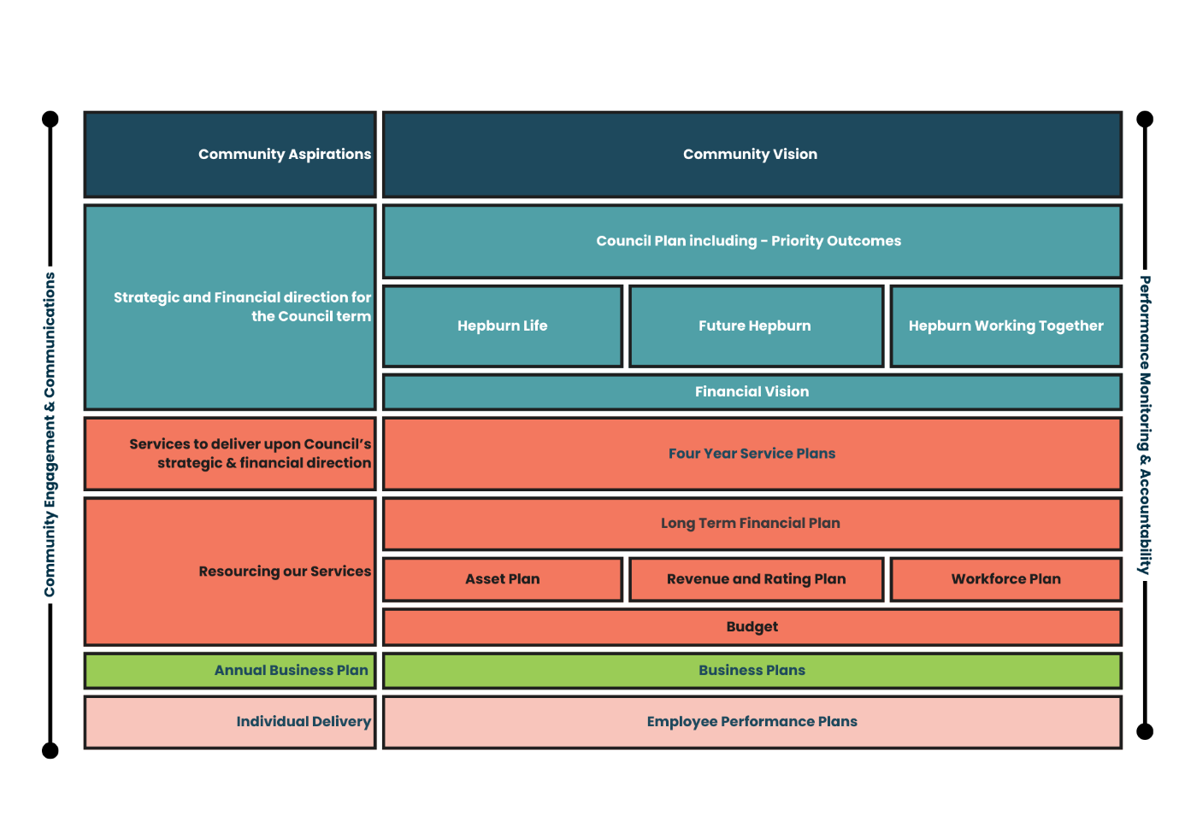
While councils are obligated to offer certain services like animal management, local roads, food safety, and statutory planning, the majority of council services, including libraries, building permits, and sporting facilities, are discretionary. Moreover, community needs and expectations evolve over time. Councils must establish robust procedures for service planning and evaluation to ensure the ongoing value and alignment of all services with community expectations. In this endeavour, councils actively involve communities to prioritise resources and strike a balance between service delivery and other obligations such as asset maintenance and infrastructure projects.

1.2 Our Community Vision
The Community Vision is a result of extensive engagement activities undertaken with a broad cross-section of our community during the Hepburn Together project in 2021. The engagement activities brought the voice of the community to Council. Our community’s goals, aspirations and priorities were captured and used to develop the Community Vision to shape the long-term direction of the Shire.

The Community Vision states:
Hepburn Shire - an inclusive rural community located in Dja Dja Wurrung country where all people are valued, partnerships are fostered, environment is protected, diversity supported, and innovation embraced.

1.4 Council’s Strategic Vision
Council delivers activities and initiatives under major service categories. Each contributes to the achievement of one of the domain strategies as set out in the four-year Council Plan 2025-2029. The three domain strategies described in the Council Plan are:

Domain Strategies | Outcomes
- Hepburn Life | - Connected communities that are resilient and adaptable, and empowered - able to respond to and recover from climate-related impacts, emergencies and other community challenges.  - A healthy and inclusive community, where all people regardless of background or life stage have the opportunity to participate and thrive.  - An informed and engaged community.
- Future Hepburn | - Preserve the unique character of our towns and communities, plan for future growth and protect our productive rural landscape.  - Responsible management of infrastructure and environment to support wellbeing now and for future generations.  - A dynamic, vibrant and resilient economic environment.
- Hepburn working together | - Future-focused services that are easy to use and inclusive.  - Maintain corporate governance to enable good Council decision making and to ensure long-term financial viability.  - An engaged, safe and skillful workforce.



02. Services and Performance Indicators
This section provides a description of the services and initiatives to be funded in the Budget for the 2025-26 year and how these will contribute to achieving the strategic objectives outlined in the Council Plan.

It also describes several initiatives and service performance indicators for key areas of Council’s operations.

Council is required by legislation to identify major initiatives, initiatives and service performance outcome indicators in the Budget and report against them in their Annual Report to support transparency and accountability. The relationship between these accountability requirements in the Council Plan, the Budget and the Annual Report is shown below.

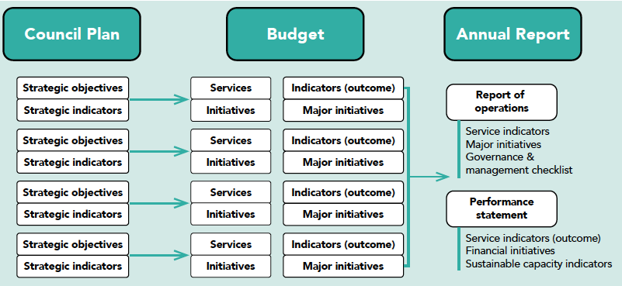
Source: Department of Jobs, Precincts and Regions

It should be noted that reporting lines within the organisation structure can impact the income and expenditure associated with each service. The income includes capital grants which can distort the income in a particular year.
For each service area, the primary domain has been chosen to align services with the Council Plan. However, it is important to note that each service will inevitably overlap with multiple domains.

2.1 Development and Community
Service Area | Alignment with Council Plan  Domains and Objectives |  |  |  | 2023-24 Actual | 2024-25 Forecast | 2025-26 Budget
 | Life | Future | Together |  | $’000 | $’000 | $’000
Emergency Management |  |  |  | Exp | 439 | 982 | 469
 |  |  |  | Rev | 121 | 774 | 273
 |  |  |  | Net | 318 | 208 | 196
We work with the community and response agencies to develop robust and innovative plans to prepare, respond and recover from emergencies.
Environmental Health |  |  |  | Exp  Rev | 657  218 | 475  198 | 393  263
 |  |  |  | Net | 439 | 277 | 130
To provide a range of public health programs including food safety throughout the community which focus on a preventative approach to health and aim to minimise future problems.
Compliance |  |  |  | Exp  Rev | 572  236 | 723  227 | 676  261
 |  |  |  | Net | 335 | 495 | 415
Through education and Local Law enforcement, including animal management, the Compliance team provides a safe community for all to enjoy.
Statutory and Strategic Planning |  |  |  | Exp | 1,970 | 2,240 | 2,427
 |  |  |  | Rev | 485 | 491 | 360
 |  |  |  | Net | 1,486 | 1,749 | 2,067
The Planning team provides advice and guidance for responsible current and future land use planning which includes the consideration of applications for planning permits and ensuring compliance with planning permits and controls. Through regular review of the Hepburn Shire Planning Scheme and development of new policy documents, the team ensures that statutory planning, investment and decision making for the Shire is relevant to the needs of the community and provides a sustainable base for future generations.
Biodiversity |  |  |  | Exp | 164 | 305 | 105
 |  |  |  | Rev | - | 128 | -
 |  |  |  | Net | 164 | 177 | 105
In partnership with the community, natural resources are managed to ensure their conservation, enhancement and control.
Building Services |  |  |  | Exp | 586 | 609 | 499
 |  |  |  | Rev | 180 | - | 80
 |  |  |  | Net | 406 | 609 | 419
To provide quality regulatory advice on all building matters associated with properties in the Shire.
Library Services |  |  |  | Exp | 565 | 662 | 495
 |  |  |  | Rev | 187 | 368 | 183
 |  |  |  | Net | 378 | 295 | 312
This service provides, through our public libraries, a welcoming space that develops strong and connected communities, supports a culture of reading and improves quality of life.

Service Area | Alignment with Council Plan  Domains and Objectives |  |  |  | 2023-24 Actual | 2024-25 Forecast | 2025-26 Budget
 | Life | Future | Together |  | $’000 | $’000 | $’000
Customer Experience |  |  |  | Exp | 753 | 745 | 749
 |  |  |  | Rev | 5 | 5 | 5
 |  |  |  | Net | 748 | 740 | 744
To provide consistent, high quality customer service, by managing, resolving, and preventing problems; empowering and educating our customers with self-service tools and solutions; communicating effectively; and exceeding customer expectations which will enable Council and our community to reach their goals.
Communications |  |  |  | Exp  Rev | 389  - | 412  - | 327  -
 |  |  |  | Net | 389 | 412 | 327
Council delivers effective communication through varied channels to ensure all who wish to be informed are.
Net Cost to Council for Development and Community |  |  |  |  | 4,663 | 4,962 | 4,715

INITIATIVES
- Adoption of the Creswick Flood Study and initiate the Clunes Flood Study (if grant successful).
- Operate Open Library services across our four library sites.
- Adoption of the Integrated Transport Strategy.
- Ensure the successful transition of the Building Services functions to Mount Alexander Shire Council as a shared service.
- Undertake the next stage of Future Hepburn strategic planning implementation (subject to Council resolution).
- Completion of submission to the environment effects statement (EES) in opposition to the Western Renewables Link.

Service | Indicator | 2023-24 Actual | 2024-25 Forecast | 2025-26 Budget
Food Safety | Health and safety | 100% | 100% | 100%
Animal Management | Health and safety | 100% | 100% | 100%
Statutory Planning | Service Standard | 18% | 20% | 30%
Libraries | Participation | 28% | 30% | 30%

2.2 Infrastructure and Delivery
Service Area | Alignment with Council Plan  Domains and Objectives |  |  |  | 2023-24 Actual | 2024-25 Forecast | 2025-26 Budget
 | Life | Future | Together |  | $’000 | $’000 | $’000
Assets, Roads and Maintenance |  |  |  | Exp | 7,915 | 5,696 | 5,385
 |  |  |  | Rev | 172 | 103 | 84
 |  |  |  | Net | 7,743 | 5,593 | 5,301
With forward planning, the timely intervention and replacement of infrastructure assets is programmed to maximise the serviceability of assets and minimise escalating maintenance costs. This proactive management of assets also allows long term financial demands for asset renewal works to be anticipated and planned for. Also includes storm recovery works undertaken.
Early Years Services |  |  |  | Exp  Rev | 847  334 | 602  225 | 490  230
 |  |  |  | Net | 513 | 377 | 260
This service provides leadership in the planning and development of early years services and programs and in partnership with community and service providers facilitate integrated and coordinated service provision including maternal and child health.
Recreation |  |  |  | Exp  Rev | 1,057  26 | 1,043  211 | 725  81
 |  |  |  | Net | 1,031 | 831 | 643
This service provides a proactive and planned approach to the maintenance, renewal and upgrade of recreation assets, and provide strategic direction for future recreation and aquatic facilities.
Community Services |  |  |  | Exp | 769 | 1,020 | 503
 |  |  |  | Rev | - | - | -
 |  |  |  | Net | 769 | 1,020 | 503
This service seeks to identify and create opportunities with residents to participate in enhancing community health and wellbeing
Parks and Open Spaces |  |  |  | Exp | 2,330 | 2,362 | 2,366
 |  |  |  | Rev | - | - | -
 |  |  |  | Net | 2,330 | 2,362 | 2,366
This service provides well-presented Parks & Gardens, Public Open Space and Sporting Fields for the enjoyment, amenity and well-being of our community and visitors to the Shire.
Economic Development and Tourism |  |  |  | Exp | 1,077 | 910 | 893
 |  |  |  | Rev | 65 | 63 | 25
 |  |  |  | Net | 1,013 | 846 | 868
To facilitate Hepburn Shire becoming a recognised tourist destination and to foster economic development that is appropriate within the Shire which increases employment and business opportunities To provide quality regulatory advice on all building matters associated with properties in the Shire.
Youth |  |  |  | Exp | 288 | 236 | 180
 |  |  |  | Rev | 36 | 36 | 40
 |  |  |  | Net | 252 | 201 | 140
This service seeks to engage our young people. Invest in them now and create our community leaders for the future.

Service Area | Alignment with Council Plan  Domains and Objectives |  |  |  | 2023-24 Actual | 2024-25 Forecast | 2025-26 Budget
 | Life | Future | Together |  | $’000 | $’000 | $’000
Waste Management and Cleaning Services |  |  |  | Exp | 5,934 | 6,552 | 6,005
 |  |  |  | Rev | 6,040 | 6,471 | 6,116
 |  |  |  | Net | (106) | 81 | (110)
This service is to deliver high quality kerbside waste and recycling collection services, and general waste management which includes transfer stations, transporting materials, public place bins, disposing of waste, street cleaning, rehabilitating closed landfills and other waste management services.
Sustainability |  |  |  | Exp  Rev | 472  65 | 378  - | 195  -
 |  |  |  | Net | 407 | 378 | 195
To guide and support Council and the community in the development of innovative sustainable practices that ensure the preservation of limited resources.
Property & Facilities |  |  |  | Exp  Rev | 1,906  1,182 | 1,863  1,217 | 1,823  1,205
 |  |  |  | Net | 723 | 647 | 618
To make decisions on property management arrangements that are underpinned by service plans, the long-term financial plan and a minimisation of risks.
Net Cost to Council for Infrastructure and Delivery |  |  |  |  | 14,676 | 12,336 | 10,785

INITIATIVES
- Prepare a briefing for Councillors that reviews the implementation of the Leases and Licences policy to ensure equitable compliance is fast-tracked across the shire.
- Undertake the largest single year of capital works associated with Roads spend ($6.6m)
- Complete a service review to identify efficiencies and opportunities within the works and operations services.
- Complete a service review to identify efficiencies and opportunities within the Parks and Open Spaces services.
- Finalise a 12-month evaluation of the Food and Garden Organics roll out.
- Transition community services, youth, and early years services to a partnership and advocacy model with other community organisations rather than direct service delivery, where appropriate.
- Transition to the new Visitor Economy Partnership.

Service | Indicator | 2023-24 Actual | 2024-25 Forecast | 2025-26 Budget
Roads | Condition | 98% | 98% | 98%
Waste Management | Waste Diversion | 38% | 45% | 50%
Aquatic Facilities | Utilisation | 1.10 | 1.66 | 1.67

2.3 Performance and Transformation
Service Area | Alignment with Council Plan  Domains and Objectives |  |  |  | 2023-24 Actual | 2024-25 Forecast | 2025-26 Budget
 | Life | Future | Together |  | $’000 | $’000 | $’000
Financial Services |  |  |  | Exp | 1,931 | 1,365 | 1,533
 |  |  |  | Rev | 988 | 436 | 252
 |  |  |  | Net | 943 | 928 | 1,281
To deliver efficient and effective allocation of resources through sound financial planning and management, that is guided by the long-term financial plan and secures the financial viability of the municipality.
ICT |  |  |  | Exp  Rev | 2,088  - | 2,324  0 | 1,735  -
 |  |  |  | Net | 2,088 | 2,324 | 1,735
To provide the highest quality technology-based services, in the most cost-effective manner, to facilitate the delivery of services to Council and the community.
People and Culture |  |  |  | Exp  Rev | 1,120  - | 1,121  - | 1,168  -
 |  |  |  | Net | 1,120 | 1,121 | 1,168
In partnership with Management, Culture and Performance provide a high level of service and support to the organisation for recruiting and retaining qualified and diverse staff, facilitating positive employee relations, developing and delivering training to enhance employees skills and capabilities, measuring employee performance and job satisfaction and providing industrial relations advice to contribute to Council’s organisational effectiveness.
Governance and Risk |  |  |  | Exp | 1,556 | 1,871 | 1,618
 |  |  |  | Rev | 7 | 6 | 3
 |  |  |  | Net | 1,549 | 1,866 | 1,615
Good governance is provided through the development and implementation of policies and procedures that support good decision making.
Net Cost to Council for Performance and Transformation
 |  |  |  |  | 5,700 | 6,239 | 5,800

INITIATIVES
- Council is committed to the improvement of its ICT infrastructure and in addition to maintaining a higher level of recurrent budget to enhance its day-to-day capability. It is also investing in a number of capital works projects to improve infrastructure, which will benefit both residents and staff, and ensure adequate cyber security in place.
- Further digitise payment methods, especially in relation to rate notice payments.
- Implementation of new organisational structure, to support the new Council Plan.
- Develop four-year service plans to ensure each service aligns with the direction of the new Council Plan.

Service | Indicator | 2023-24 Actual | 2024-25 Forecast | 2025-26 Budget
Governance | Consultation and engagement | 52 | 52 | 53

2.4 Service Performance Outcome Indicators
These are standard service performance indicators as required by State Legislation.
Service | Indicator | Performance Measure | Computation
Governance | Consultation and engagement | Satisfaction with community consultation and engagement.  (Community satisfaction rating out of 100 with the consultation and engagement efforts of Council) | Community satisfaction rating out of 100 with how Council has performed on community consultation and engagement
Statutory planning | Service Standard | Planning applications decided within required timeframes  (Percentage of regular and VicSmart planning application decisions made within legislated timeframes) | [Number of planning application decisions made within 60 days for regular permits and 10 days for VicSmart permits / Number of planning application decisions made] x100
Roads | Condition | Sealed local roads below the intervention level  (Percentage of sealed local roads that are below the renewal intervention level set by Council and not requiring renewal) | [Number of kilometres of sealed local roads below the renewal intervention level set by Council / Kilometres of sealed local roads] x100
Libraries | Participation | Library membership  (Percentage of the population that are registered library members) | [Number of registered library members / Population] x100
Waste collection | Waste diversion | Kerbside collection waste diverted from landfill.  (Percentage of recyclables and green organics collected from kerbside bins that is diverted from landfill) | [Weight of recyclables and green organics collected from kerbside bins / Weight of garbage, recyclables and green organics collected from kerbside bins] x100
Aquatic Facilities | Utilisation | Utilisation of aquatic facilities.  (Number of visits to aquatic facilities per head of population) | Number of visits to aquatic facilities / Population
Animal Management | Health and safety | Animal management prosecutions.  (Percentage of animal management prosecutions which are successful) | Number of successful animal management prosecutions / Total number of animal management prosecutions
Food safety | Health and safety | Critical and major non-compliance outcome notifications  (Percentage of critical and major non-compliance outcome notifications that are followed up by Council) | [Number of critical non-compliance outcome notifications and major non-compliance outcome notifications about a food premises followed up / Number of critical non-compliance outcome notifications and major non-compliance outcome notifications about food premises] x100
Maternal and Child Health | Participation | Participation in the MCH service  (Percentage of children enrolled who participate in the MCH service)  Participation in MCH service by Aboriginal children  (Percentage of Aboriginal children enrolled who participate in the MCH service) | [Number of children who attend the MCH service at least once (in the year) / Number of children enrolled in the MCH service] x100  [Number of Aboriginal children who attend the MCH service at least once (in the year) / Number of Aboriginal children enrolled in the MCH service] x100

2.5 Reconciliation of Strategic Objectives with Budgeted Result
Operating Result Reconciliation
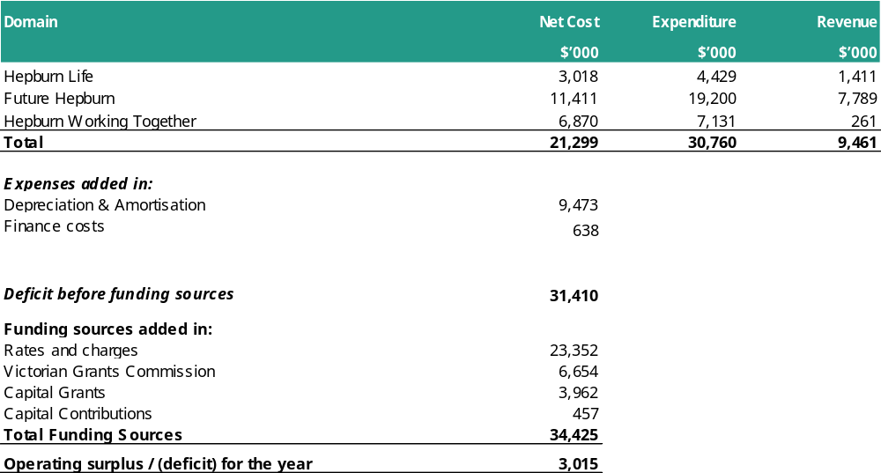

2.6 Total budgeted expenditure by domain

2.7 Operating Efficiencies
Council has been required this year to make decisions on the reduction of $2.53m in operational budgets while minimising the impact on services. This is in addition to the $1.5m of operational efficiencies that was achieved in 2024/2025. The table in the services section of the Executive
Summary details the areas identified for changes to budgets in 2025/2026 to achieve these operational efficiencies.

Councillors and Officers have worked together over a number of years to reduce the costs of delivering services, and therefore any reduction in operating expenditure will have an impact on service delivery. The $2.53m in operational expenditure savings is equivalent to 6.2% of the total operating expenditure and comes on top of implementing $1.50m in 2024/25.

It is noted that these operational efficiencies are over, and above the offset of costs associated with a general increase in expense. Across the organisation we have seen increases to almost all costs – including materials, legal fees, insurances, software licenses, and utilities.

03. Financial Statements
This section presents information in regard to the Financial Statements and Statement of Human Resources. The budget information for the year 2025/2026 has been supplemented with projections to 2028/2029.
This section includes the following financial statements prepared in accordance with the Local Government Act 2020 and the Local Government (Planning and Reporting) Regulations 2020.

- Comprehensive Income Statement
- Balance Sheet
- Statement of Changes in Equity
- Statement of Cash Flows
- Capital Works Program
- Human Resources

3.1 Comprehensive Income Statement
For the four years ending 30 June 2029

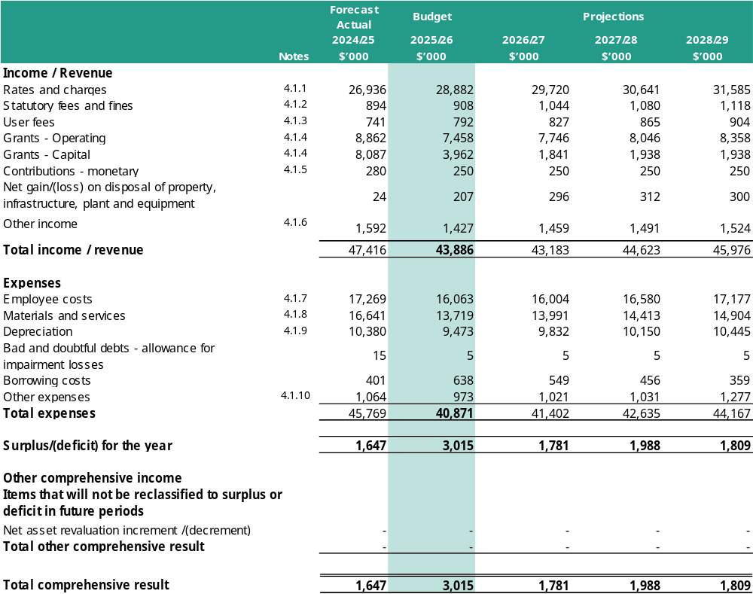

3.2 Balance Sheet
For the four years ending 30 June 2029

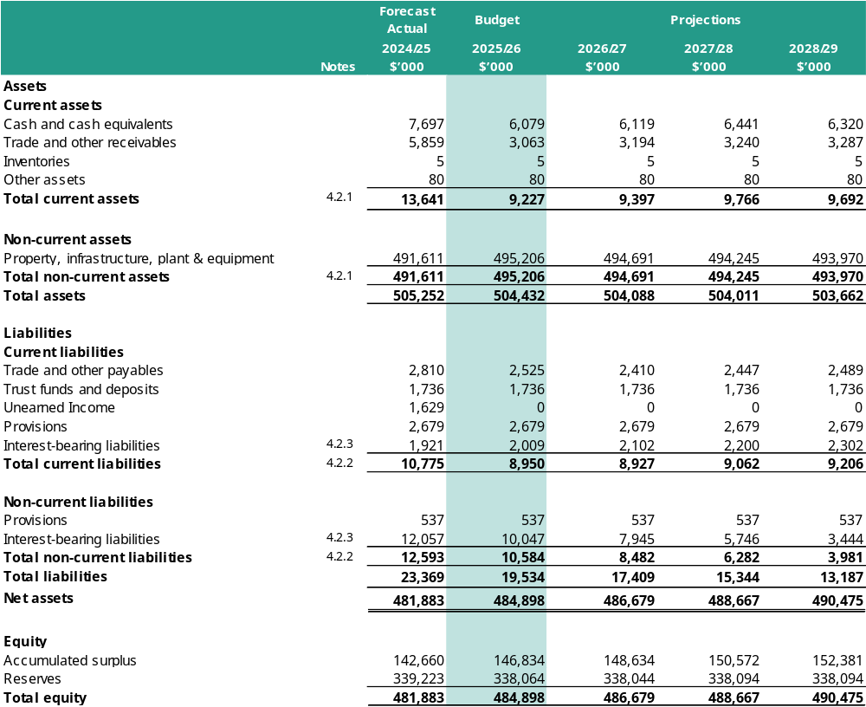

3.3 Statement of Changes in Equity
For the four years ending 30 June 2029
G9

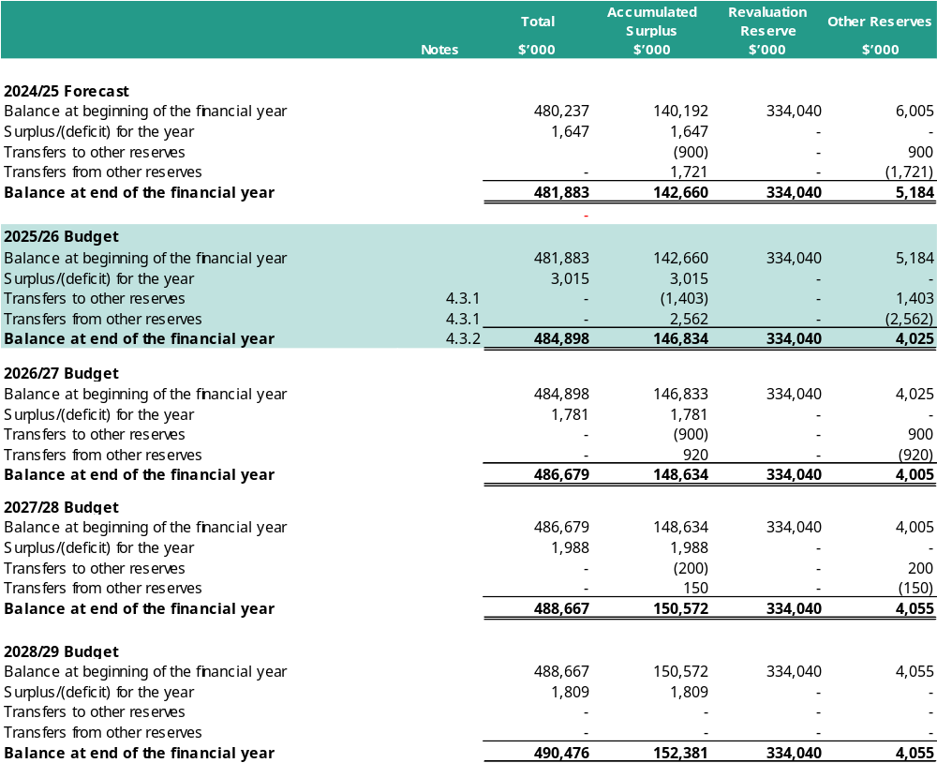

3.4 Statement of Cash Flows
For the four years ending 30 June 2029

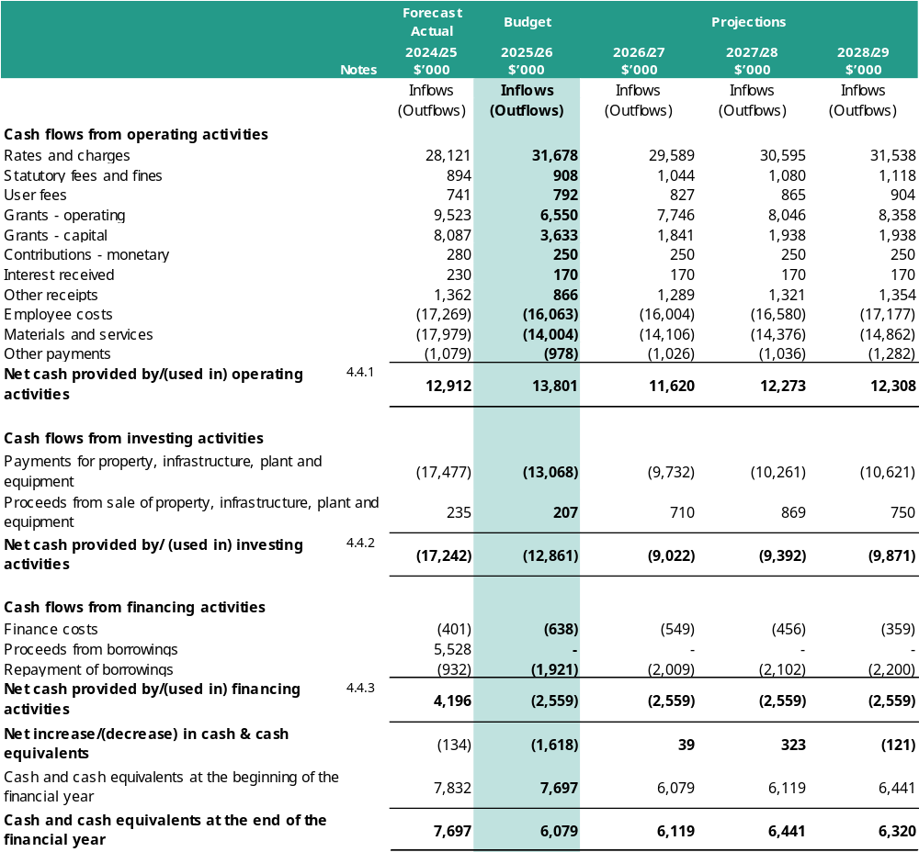

3.5 Capital Works Program
For the four years ending 30 June 2029

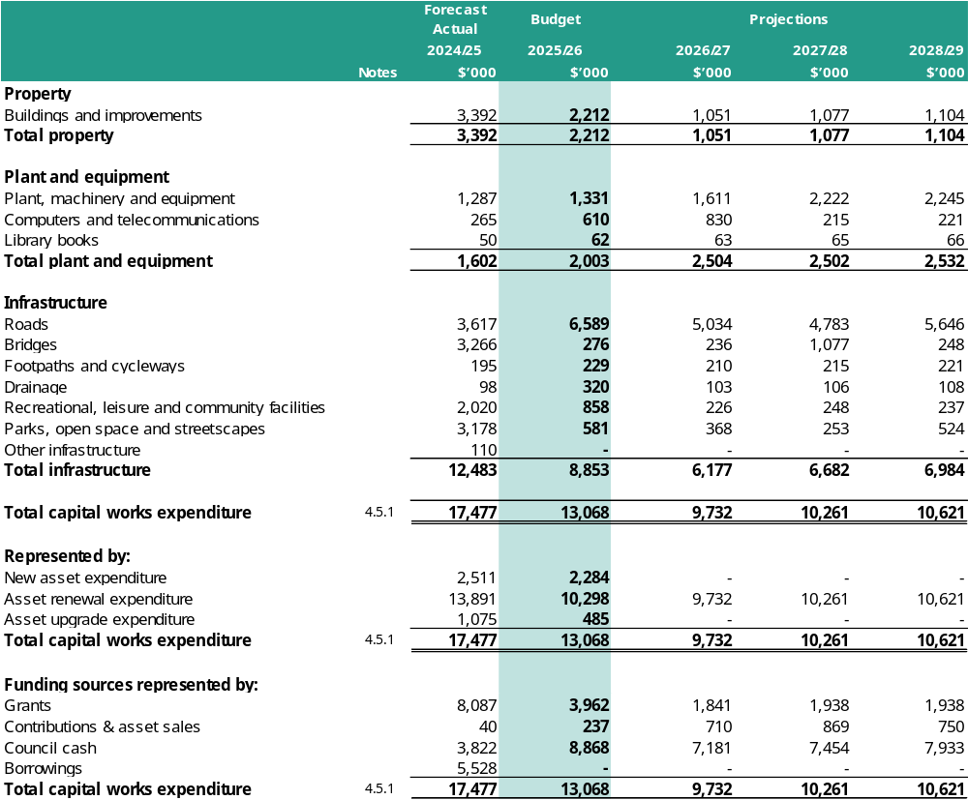

3.6 Statement of Human Resources
For the four years ending 30 June 2029

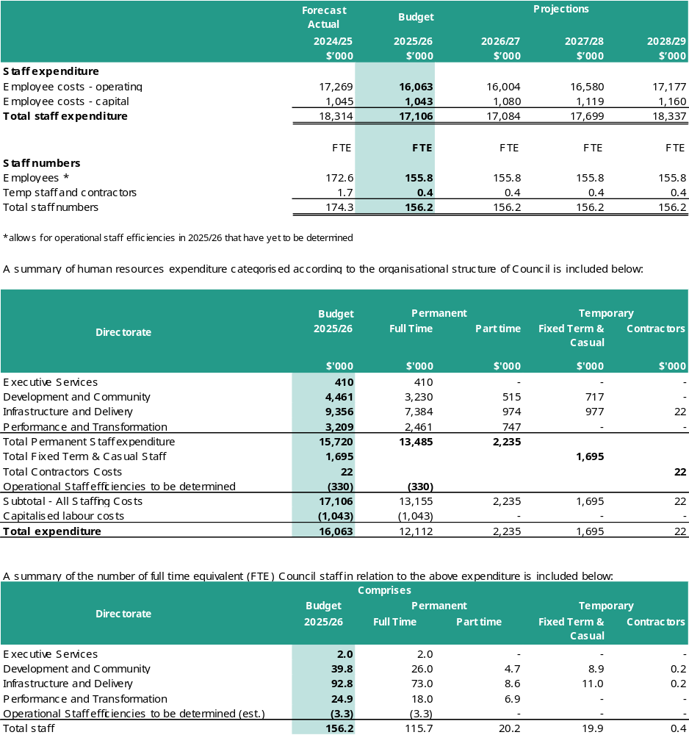
Several vacancies that arose during the 2024/25 year have not been filled in anticipation of reduced FTE numbers in 2025/26 due to the required operational savings.

Summary of Planned Human Resources Expenditure
For the four years ending 30 June 2029
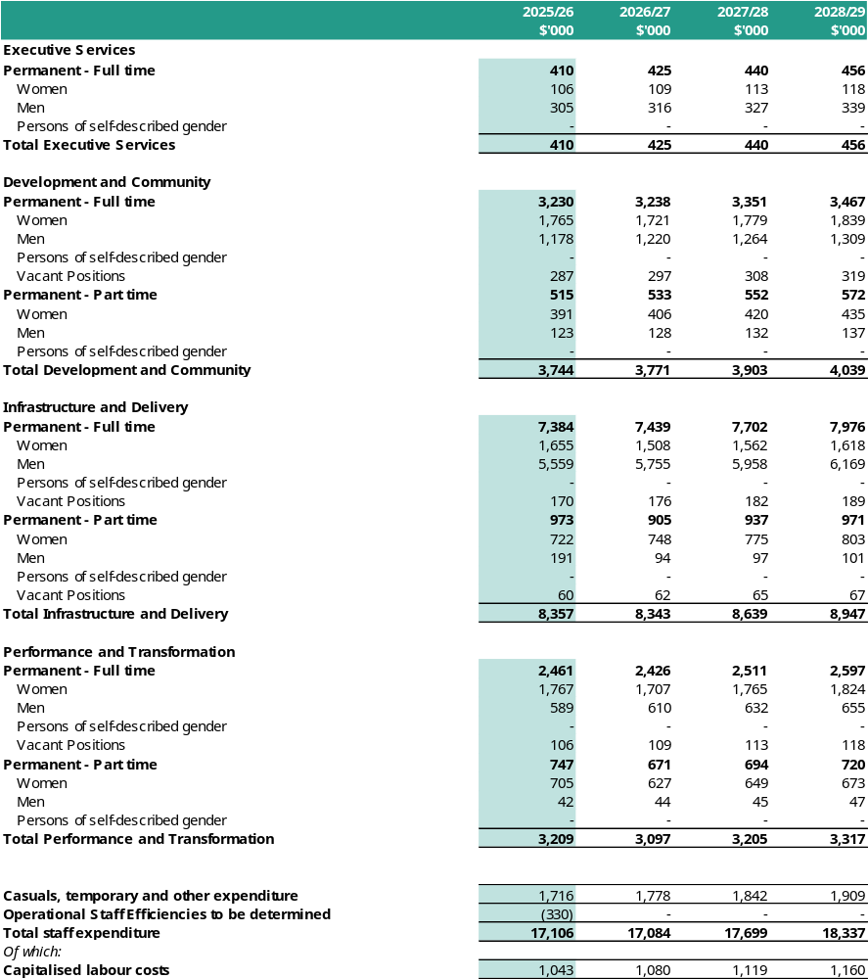

Summary of Planned Human Resources Expenditure
For the four years ending 30 June 2029
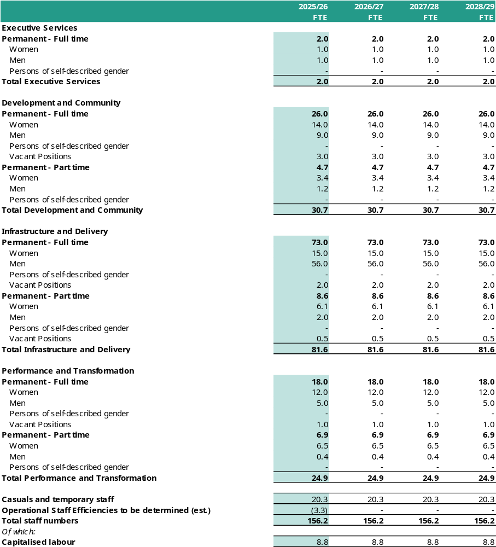

04. Notes to the Financial Statements
This section presents detailed information on material components of the financial statements. Council needs to assess which components are material, considering the dollar amounts and nature of these components.

4.1 Comprehensive Income Statement

4.1.1 Rates and charges
Rates and charges are required by the Act and the Regulations to be disclosed in Council’s budget.

As per the Local Government Act 2020, Council is required to have a Revenue and Rating Plan which is a four-year plan for how Council will generate income to deliver the Council Plan, program and services and capital works commitments over a four-year period.

In developing the Budget, rates and charges were identified as an important source of revenue. Planning for future rate increases has therefore been an important component of the financial planning process. The Fair Go Rates System (FGRS) sets out the maximum amount Councils may increase rates in a year, without an approved Essential Services Commission (ESC) approved rate cap application. For 2025/2026 year the FGRS cap has been set at 3.00%. The cap applies to both general rates and municipal charges and is calculated on the basis of Council’s average rates and charges.

The level of required rates and charges has been considered in the context of the Financial Vision 2024-2027, with reference to Council's other sources of income and the planned expenditure on services and works to be undertaken for the community. A rate cap variation has been sought from the ESC that aligns with the current and projected financial outlook of Council and as such, the average revenue generated by the general rate and municipal charge will increase by 10.00%. This comprises:
- A permanent uplift of 7% relating to the financial viability and long-term sustainability of the Council; and
- 3% being the rate cap set by the Minister for Local Government for 2025/26.

This budget will raise total rates and charges for 2025/2026 of $28,881,818.

4.1.1(a) The reconciliation of the total rates and charges to the Comprehensive Income Statement is as follows:
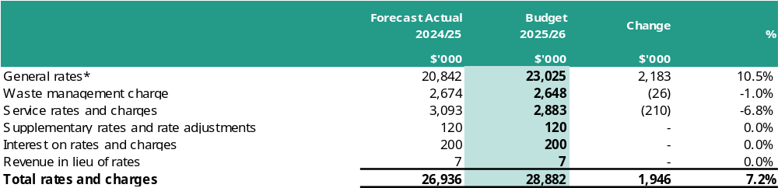*These items are subject to the rate cap established under the FGRS

4.1.1(b) The rate in the dollar to be levied as general rates under section 158 of the Act for each type or class of land compared with the previous financial year
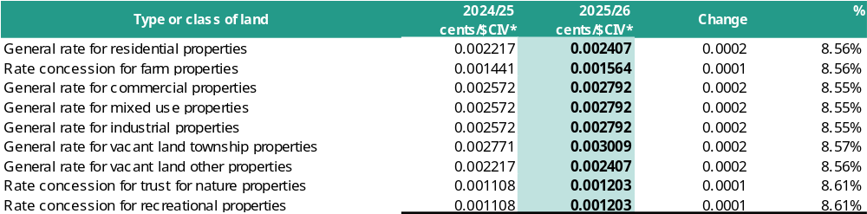

*Cents/$CIV are subject to minor changes as the general revaluation is finalised and will be adopted when the proposed budget is adopted in June 2025. The percentage change is not equal to 10% (the rate rise) as the cents/$CIV considers the movement in valuations of properties.

4.1.1(c) The estimated total amount to be raised by general rates in relation to each type or class of land, and the estimated total amount to be raised by general rates, compared with the previous financial year

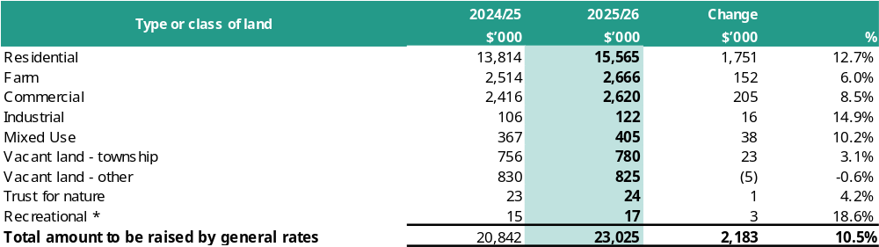
*Recreational not subject to the rate cap.

4.1.1(d) The number of assessments in relation to each type or class of land, and the total number of assessments, compared with the previous financial year
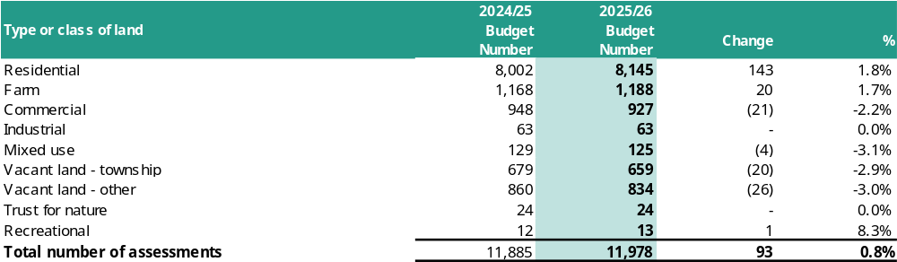

4.1.1(e) The basis of valuation to be used is the Capital Improved Value (CIV)
4.1.1(f) The estimated total value of each type or class of land, and the estimated total value of land, compared with the previous financial year
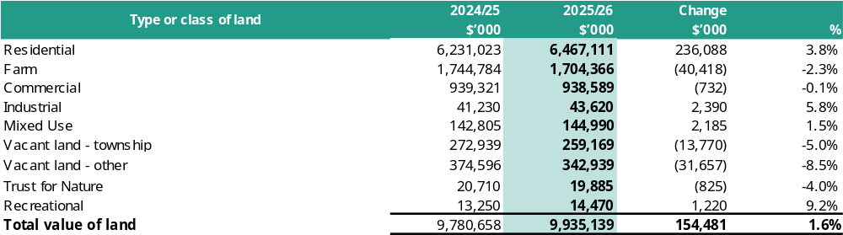

4.1.1(g) The rate or unit amount to be levied for each type of service rate or charge under Section 162 of the Act compared with the previous financial year
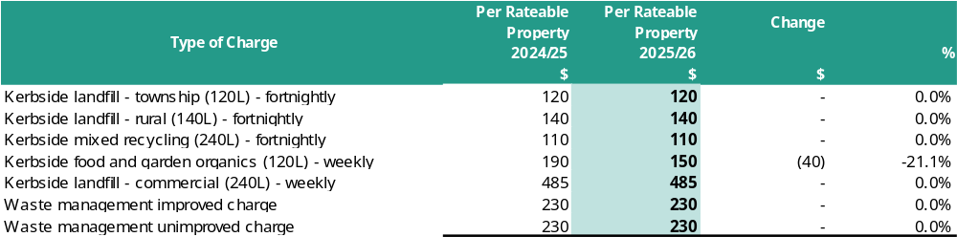

4.1.1(h) The estimated total amount to be raised by each type of service rate or charge, and the estimated total amount to be raised by service rates and charges, compared with the previous financial year
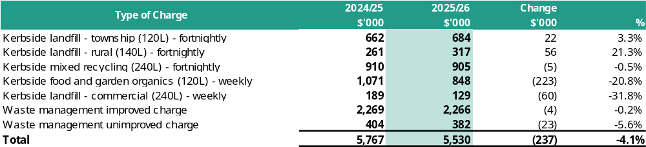

4.1.1(i) The estimated total amount to be raised by all rates and charges compared with the previous financial year
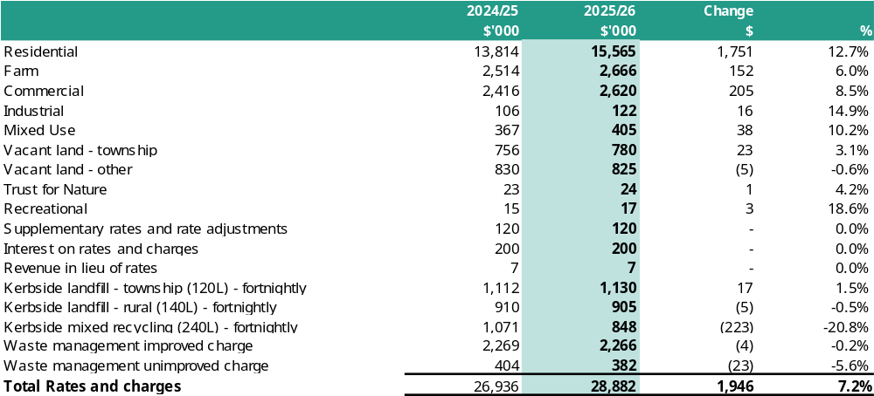

4.1.1(j) Fair Go Rates System Compliance
Hepburn Shire Council is fully compliant with the State Government’s Fair Go Rates System. The table below details the budget assumptions consistent with the requirements of the Fair Go Rates System.

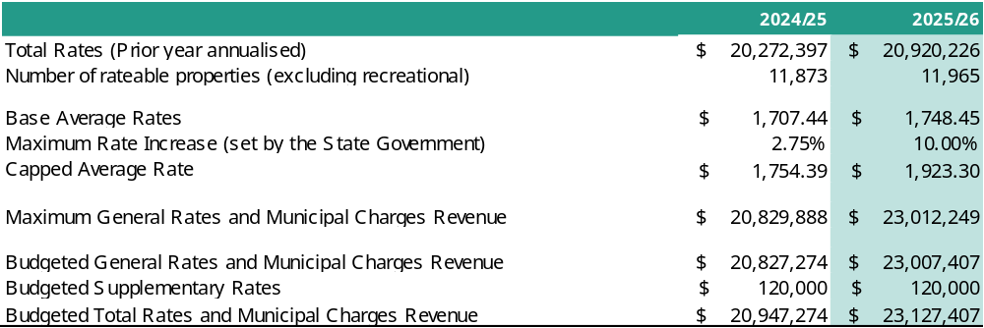

4.1.1(k) Any significant changes that may affect the estimated amounts to be raised by rates and charges
There are no known significant changes which may affect the estimated amounts to be raised by rates and charges. However, the total amount to be raised by rates and charges may be affected by:
- The making of supplementary valuations (2025/2026: estimated $120,000)
- The variation of returned levels of value (eg. valuation appeals)
- Changes of use of land such that rateable land becomes non-rateable land and vice versa
- Changes of use of land such that residential land that becomes commercial land and vice versa.

4.1.1(l) Differential rates
Rates to be levied
The rate and amount of rates payable in relation to land in each category of differential are:
- A general rate of 0.0024068% (0.24068 cents in the dollar of CIV) for all rateable residential properties;
- A concessional rate of 0.0015644% (0.15644 cents in the dollar of CIV) for all rateable farm properties;
- A general rate of 0.0027919% (0.27919 cents in the dollar of CIV) for all rateable commercial properties;
- A general rate of 0.0027919% (0.27919 cents in the dollar of CIV) for all rateable industrial properties;
- A general rate of 0.0027919% (0.27919 cents in the dollar of CIV) for all rateable mixed use properties;
- A general rate of 0.0030085% (0.30085 cents in the dollar of CIV) for all rateable vacant land-township properties;
- A general rate of 0.0024068% (0.24068 cents in the dollar of CIV) for all rateable vacant land-other properties;
- A concessional rate of 0.0012034% (0.12034 cents in the dollar of CIV) for all rateable trust for nature properties;
- A concessional rate of 0.0012034% (0.12034 cents in the dollar of CIV) for all rateable recreation properties;

Council considers that each differential rate will contribute to the equitable and efficient carrying out of council functions. Details of the objectives of each differential rate, the type of classes of land, which are subject to each differential rate and the uses of each differential rate, are set out below. There are no changes to rating differentials proposed in the 2025/26 budget. Comprehensive details on rates can be found in the Revenue and Rating Plan 2025-2029.

General Rate - Residential rateable land which is used solely for residential purposes and the balance of land defined by exception to the general rate.

Farm Rate - Rateable land identified and defined as farmland and which is used solely for the purpose of farming as defined in section 2(1) of the Valuation of Land Act 1960 and is deemed to be a property for primary production purposes as accepted by the Australian Taxation Office

Commercial Rate - Rateable land which is used solely for commercial purposes. Includes rateable land which is used for short term accommodation which does not qualify as Residential under the Residential Tenancies Act 1997 characterised by stays of greater than 60 days and the existence of a tenancy agreement to which the Residential Tenancy Act 1997 applies.

Industrial Rate - Rateable land which is used solely for industrial purposes.

Mixed Used Rate - Rateable land which is not used solely for residential or commercial or farmland or industrial or recreational but is a combination of residential and at least one other category.

Trust For Nature Rate - Rateable land which has a Trust for Nature Covenant applying to the land. A Trust for Nature Covenant enables the permanent protecting of significant areas of natural bush land. To encourage landowners to voluntarily place conservation covenants on their land, Council will offer a lower differential compared to the general rate.

Vacant Land (Township Rate) - Rateable land, within township boundaries, which does not form part of a commercial or industrial or farming enterprise or recreational purpose or upon which a residence is erected.

Vacant Land (Other Rate) - Rateable land which does not form part of a commercial or industrial or farming enterprise or recreational purpose or upon which a residence is erected. This applies to all vacant land that does not meet the definition of “township” above.

Vacant Premises (Commercial) - Vacant rateable premises which, if occupied, would be used solely for commercial purposes.

Vacant Premises (Industrial) - Vacant rateable premises which, if occupied, would be used solely for industrial purposes.

Recreational Rate - Rateable land upon which sporting, recreational or cultural activities are conducted, including buildings which may be ancillary to such activities. Profits from recreational land must be applied in promoting its objectives. The definition of "recreational lands" is per section 2 of the Cultural and Recreational Lands Act 1964. The recreational differential will not apply to any component of the property that is used for gaming. This component will be rated as commercial.

4.1.2 Statutory fees and fines
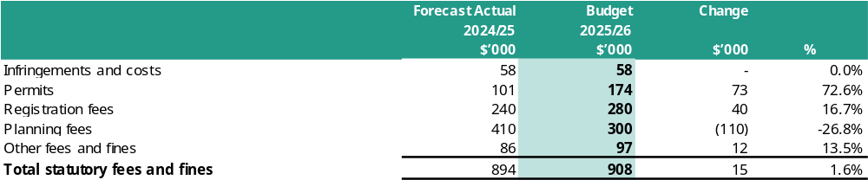

Statutory fees relate mainly to fees and fines levied in accordance with legislation and include animal registrations, Public Health and Wellbeing Act 2008 registrations, infringements and planning fees. Increases in statutory fees unit rates are made in accordance with legislative requirements. The reduction in planning fees is due to a decrease in development activities (planning applications) compared to previous years, which saw an increase in development post-pandemic.

4.1.3 User fees
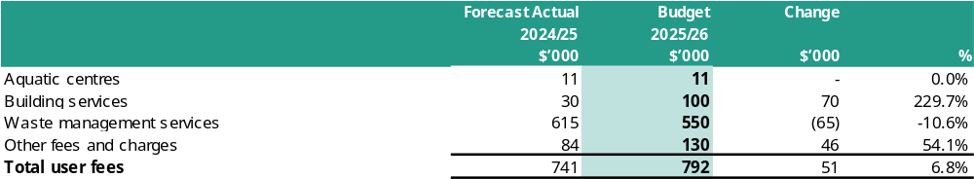

User fees relate mainly to the recovery of service delivery costs through the charging of fees to users of Council’s services. These include use of transfer stations, leisure, and other community facilities and the provision of building services. User charges are projected to increase by 6.8% or $51,000 over 2025/2026, mainly due to increases as a result of reviewing service delivery methods, and a desire following community deliberate panel to increase user fees where possible rather than have further reduction in services. The draft council plan includes a strategy to actively purse alternative revenue opportunities.

4.1.4 Grants
Grants are required by the Act and the Regulations to be disclosed in Council’s budget.
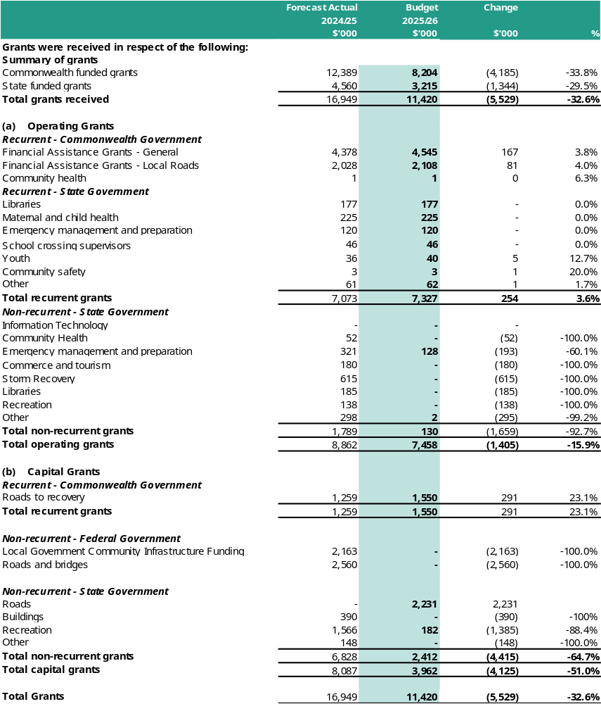

Operating grants encompass all monies received from State and Federal sources to support the delivery of Council’s services to ratepayers. Overall, the projected level of operating grants is expected to decrease by 15.9% or $1.405m compared to 2024/2025. This reduction is due to the completion of various one-off grants received for specific projects in previous financial years, which do not need to be budgeted for in 2025/2026. A detailed list of all grants by type and source, classified by type and source into recurrent and non-recurrent, has been included above.

Capital grants include all monies received from State and Federal sources for the purposes of funding the capital works program. Overall, the level of capital grants is budgeted to decrease by 51% or $5.146m compared to 2024/2025. This is due to the completion of projects in 2024/2025 that had received capital funding. Section 4.5 “Capital works program” includes a more detailed listing of the capital grants expected to be received during the 2025/2026 year.

Although the total grants are decreasing, due to one off grants, it is pleasing to not that recurrent (on-going) grants are budgeted to increase by $0.55m to a total of $8.97m for our community.

4.1.5 Contributions
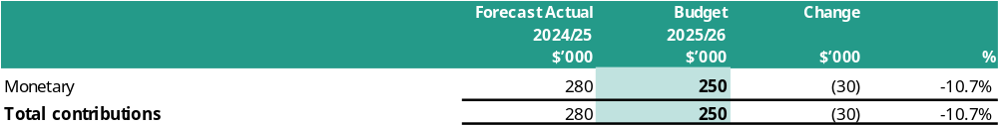

Contributions can relate to monies paid by developers in regard to public resort and recreation, drainage and car parking in accordance with planning permits issued for property development, as well as community groups contributions to capital works. Reduction is as a result of development decreasing to more consistent levels than the post-pandemic surge.

4.1.6 Other income
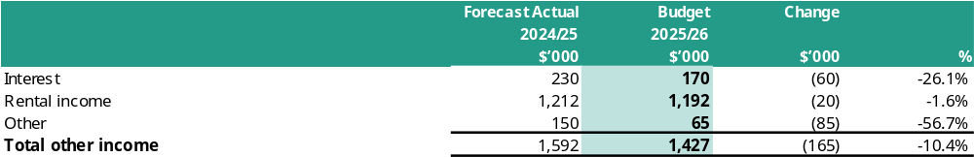

Other income relates to a range of items such as sale of materials, cost recoups and other miscellaneous income items. It also includes interest revenue on investments which is expected to reduce given Councils lower cash holdings, and rental income. Sale of materials within Other is anticipated to reduce in line with current sales trends from 2024/2025.

4.1.7 Employee costs
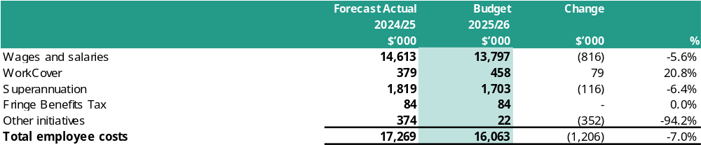

Employee costs include all labour related expenditure such as wages and salaries and on-costs such as allowances, leave entitlements, employer superannuation, workcover premium and fringe benefits tax.

Employee costs are budgeted to decrease by 7.0% or $1.21m compared to 2024/2025 due to a planned review of operational effectiveness across all services within Council to ensure future financial sustainability, and service cuts required per the Financial Vision.

A summary of human resources expenditure categorised according to the organisational structure of Council is included in the ‘3.6 Statement of Human Resources’.

4.1.8 Materials and services
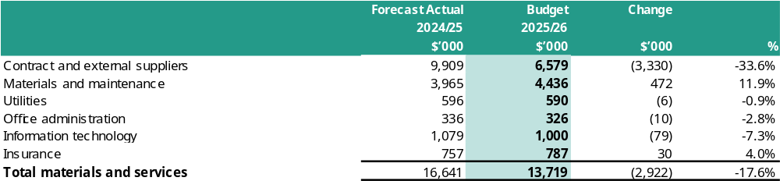

Materials and services include the purchases of consumables, payments to contractors for the provision of services and utility costs. Materials and services are budgeted to decrease by 17.6% or $2.922m compared to 2024/2025. A major impact of the decrease in costs relates to the identified operational efficiencies for Council and the finishing of works in 2024/2025 on one-off special operating projects.

4.1.9 Depreciation
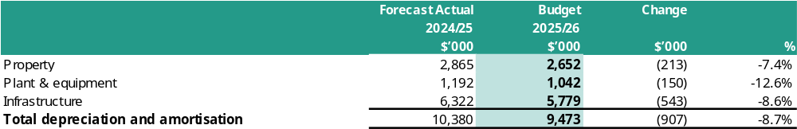

Depreciation is an accounting measure which attempts to allocate the value of an asset over its useful life for Council’s property, plant and equipment including infrastructure assets such as roads and drains. Depreciation has decreased due to a reduced capital program over the last year.

4.1.10 Other expenses
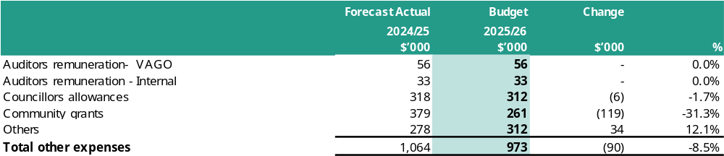

Other expenses relate to a range of unclassified items including contributions to community groups, audit expenses, Councillor allowances and other miscellaneous expenditure items. Other expenses are budgeted to decrease by 8.5% or $90,000 compared to 2024/2025 due to a planned review of operational effectiveness across all services within Council to ensure future financial sustainability.

4.2 Balance Sheet

4.2.1 Assets
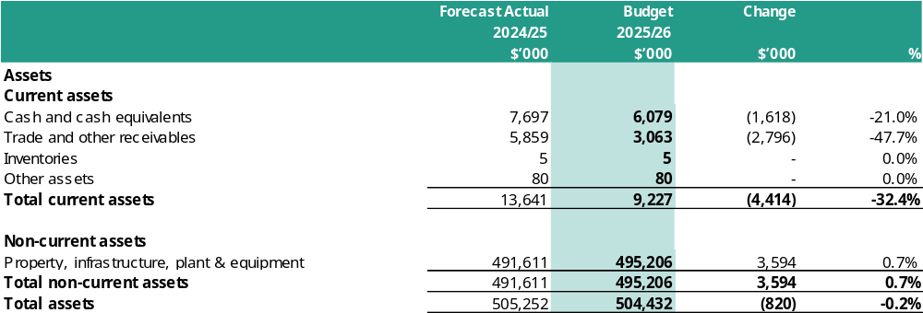

Cash and cash equivalents include cash on hand, deposits at call and term deposits with original maturity dates of 90 days or less. Other financial assets include term deposits which will mature within the next twelve months with original maturity dates of greater than 90 days.

Trade and other receivables include monies owing to Council and include Council rates and charges, fire services property levy, and GST receivable. Inventories include Council’s diesel storage and other assets include accrued income and prepaid expenses.

Property, infrastructure, plant and equipment includes all of Council’s land, buildings, vehicles, plant, information technology, roads, bridges, recreational and other infrastructure assets. The value of these non-current assets represent their written down values, which is either their acquisition cost less accumulated depreciation or current valuation following an asset revaluation.

4.2.2 Liabilities
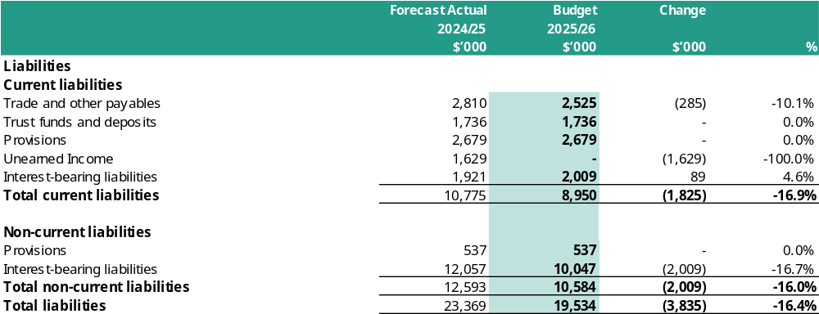

Trade and other payables include amounts owed to suppliers for goods and or services and other accrued expenses. Trust funds and deposits represent amounts received as deposits and retention amounts controlled by Council until they are returned, transferred in accordance with the purpose of the receipt, or forfeited. Provisions include liability for accrued employee benefits and landfill rehabilitation. Interest bearing liabilities reflect the outstanding principal balance of previous borrowings.

The classification as current liabilities illustrate that portion that is likely to be repaid in the upcoming twelve months. Total liabilities were impacted by new borrowings in 2024/2025 of $5.528m.

Council has been, and will continue to be in a position to pay all debts as they are due and payable.

4.2.3 Borrowings
The table below shows information on borrowings specifically required by the Regulations.
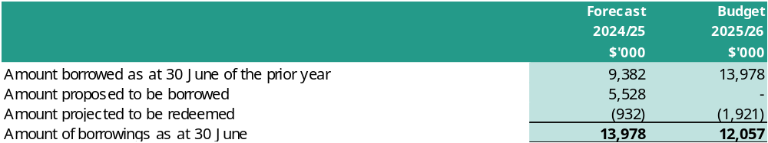

Borrowings are an important funding source which enables funding for capital works or other items as identified without adversely affecting Council’s liquidity position. Council has determined that no new loans will be taken out in 2025/2026.

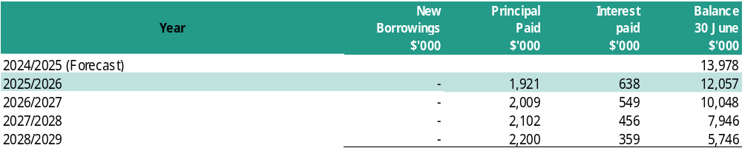

4.2.4 Unrestricted Cash
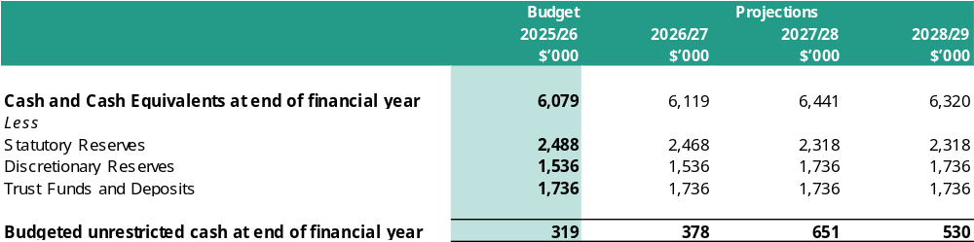

Council has continued to focus on returning its unrestricted cash to a positive position. Unrestricted cash is forecast as a surplus of only $0.32m at June 2026. This is a modest buffer against unforeseen circumstances and leaves little room for discretionary expenditure.
It is important to note that Council adopts a conservative approach in calculating unrestricted cash by including discretionary reserve balances. This approach is taken because Council has committed to the community on the use of these funds, even though there are no legislative restrictions. Reporting by State Government, including that by the Victorian Auditor Generals Officers (VAGO) excludes discretionary reserves. If Council were to use this ratio, the unrestricted cash would be higher, as demonstrated in the above table.
The level of unrestricted cash is manageable but needs constant attention, and is in line with our Financial Vision, with the level being on the lower side early in the 10-years and improving over the medium term.

4.3 Statement of Changes in Equity

4.3.1 Reserves
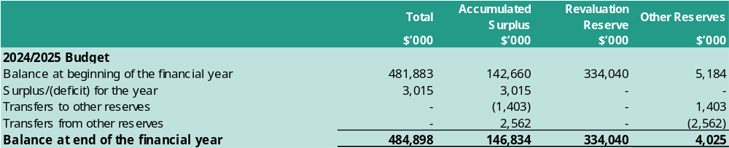

Council has allocated funds to reserves for specific purposes. These reserves are with statutory or discretionary reserves. Statutory reserve funds must be applied for specified statutory purposes in accordance with various legislative requirements. Discretionary reserves have been established by Council regarding the future use of these funds. Net reserve movements for 2025/2026 are forecast to be a transfer from reserves of $1.15m. Each reserve and their forecast balance are shown below, with all ‘other reserves’ cash backed.

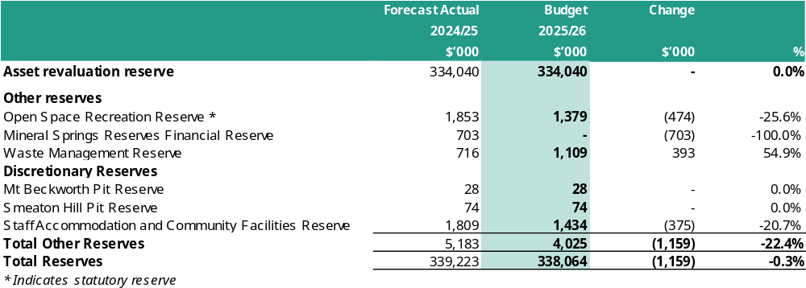

Council has allocated $770,000 in the 2025/2026 capital works budget for repair and renewal of the ceiling at the Bathhouse in Hepburn Springs. This funding is sourced from the Mineral Springs reserve, which accounts for the reduced balance as of June 2026. The reserve will be replenished in the following years. The works commenced in April 2025, and an adjustment will be made after 30 June 2025 to accurately reflect the extent of the works in the 2024/2025 year.

The Daylesford Community Facilities (Detailed Design) will be subject to a further Council report (expected in August) and resolution following community engagement on the concept plans. The project will only proceed based on the council's resolution, and is funded from the Staff Accommodation and Community Facilities Reserve.

4.3.2 Equity
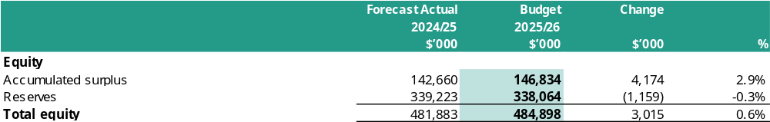

Total equity equals net assets and is made up of the following components:
- Asset revaluation reserve which represents the difference between the previously recorded value of assets and their current valuations.
- Other reserves are funds that Council wishes to separately identify as being set aside to meet a specific purpose in the future and to which there is no existing liability. These amounts are transferred from the surplus of the Council to be separately disclosed.
- Accumulated surplus which is the value of all net assets less reserves that have accumulated over time.

4.4 Statement of Cash Flows

4.4.1 Net cash flows provided by/used in operating activities
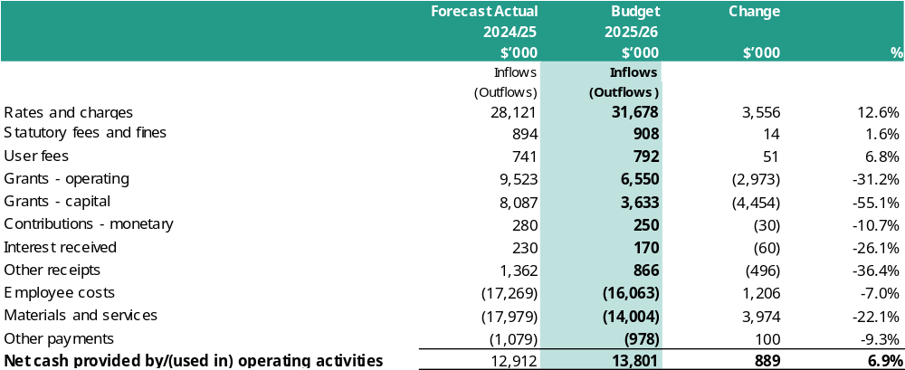
Cash flow from operating activities refers to the cash generated or used in the normal service delivery functions of Council. Cash remaining after paying for the provision of services to the community may be available for investment in capital works, or repayment of debt.

4.4.2 Net cash flows provided by/used in investing activities
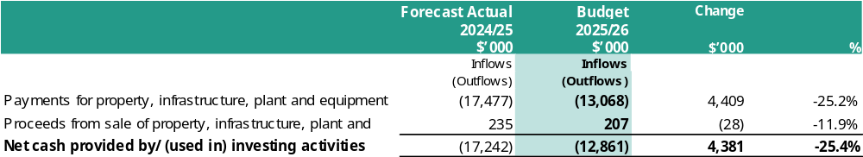
Cash flows from investing activities refers to cash generated or used in the enhancement or creation of infrastructure and other assets. These activities also include the acquisition and sale of other assets such as vehicles, property and other financial assets including term deposits greater than 90 days maturity.
The 2025/2026 budget for net cash used in investing activities is $12.86m, which is $4.38m less than 2024/2025. This is reflective of large-scale capital projects being completed in the current financial year and the focus on a renewal program of capital works in 2025/2026. This excludes any potential carry forward of capital works from 2024/2025 to 2025/2026.

4.4.3 Net cash flows provided by/used in financing activities
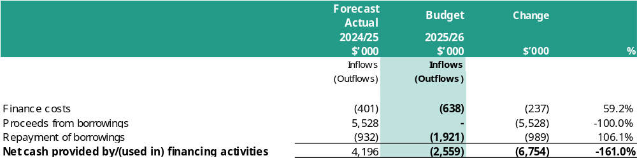
Cash flows from the financing activities refers to cash generated or used in the financing of Council functions and include borrowings from financial institutions and advancing of repayable loans to other organisations. These activities also include repayment of the principal component of loan repayments for the year.
The 2025/2026 budget for cash flows provided by financing activities is a decrease in cash of $6.7m from 2024/2025, as there are no new loans included in the 2025/2026 budget.

4.5 Capital Works Program
This section presents a listing of the capital works projects that will be undertaken for the 2025/2026 year, classified by expenditure type and funding sources.

4.5.1 Summary
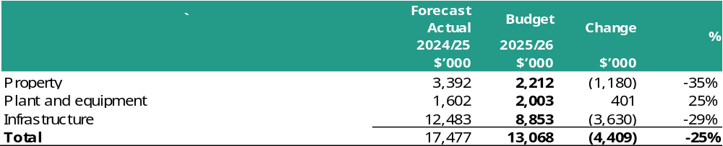

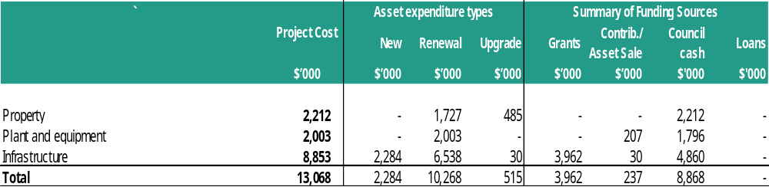

4.5.2 Capital works program
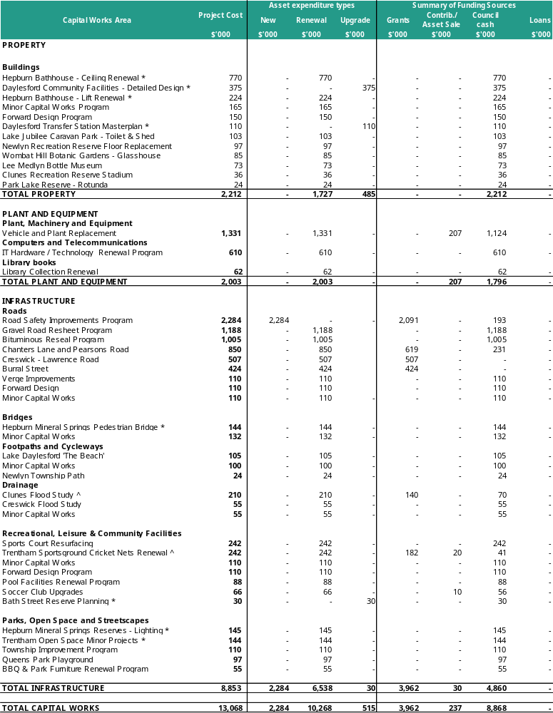

- The Daylesford Community Facilities (Detailed Design) will be subject to a further Council report and resolution following community engagement on the concept plans. The project will only proceed based on the council's resolution.
- Grant funding totalling $321,500 is being sought for the Clunes Flood Study and Trentham Sportsground Cricket Nets, and these projects will proceed only if grant funding is awarded.
- Projects identified with an ‘*’ are fully funded by Council Reserves amounting to a total movement of $1.942m from the reserves.

The capital works program for 2025/2026 highlights that a number of major projects have been completed and reduced grant funding has resulted in a reduction of new projects being included in the budget. Projects funded in 2024/2025 but not yet delivered will continue and funds will be carry-forward if not finalised by 30 June 2025.

4.5.3 Summary of Planned Capital Works expenditure
For the years ended 30 June 2027, 2028, and 2029

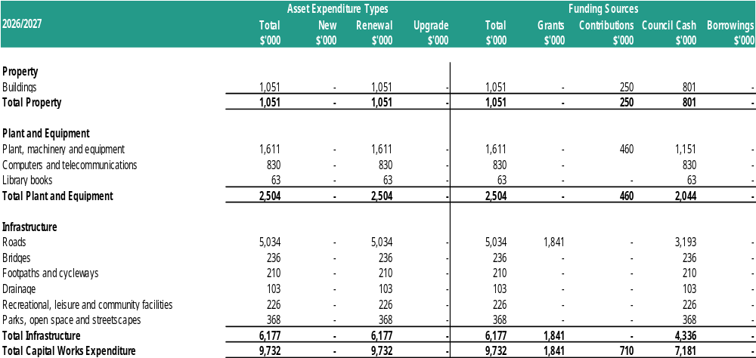

4.5.3 Summary of Planned Capital Works expenditure (cont.)
For the years ended 30 June 2027, 2028, and 2029

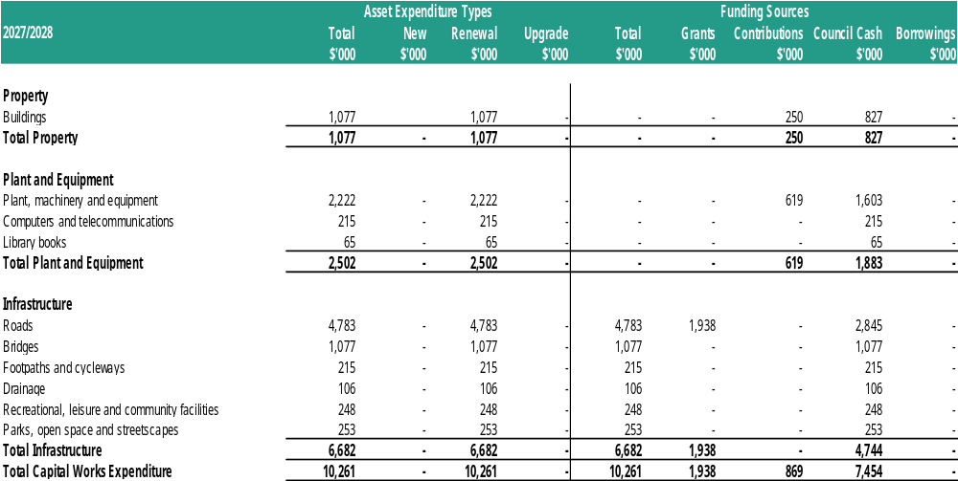

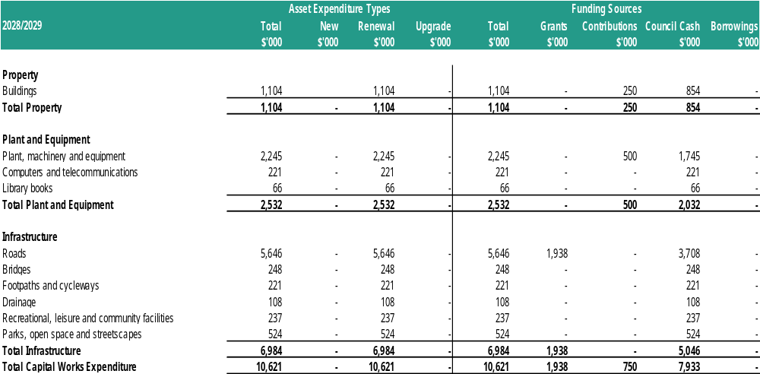

4.6 Non-Capital Projects Program
This section presents a listing of non-capital projects that will be undertaken for the 2025/2026 year. The projects listed below are one-off or cyclical in nature or are additional to funding levels which are ordinarily provided to undertake these activities.

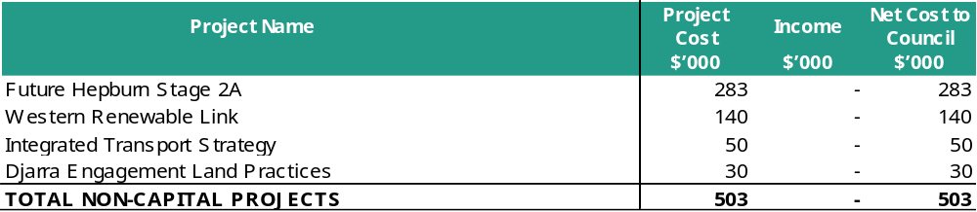

05. Targeted Performance Indicators
The following tables highlight Council’s current and projected performance across a selection of targeted service and financial performance indicators. These indicators provide a useful analysis of Council’s intentions and performance and should be interpreted in the context of the organisation’s objectives.
The targeted performance indicators below are the prescribed performance indicators contained in Schedule 4 of the Local Government (Planning and Reporting) Regulations 2020. Results against these indicators and targets will be reported in Council’s Performance Statement included in the Annual Report.

5.1 Targeted Performance Indicators – Service
Indicator | Measure | Notes | Actual | Forecast | Target | Target Projections |  |  | Trend
Indicator | Measure | Notes | 2023/24 | 2024/25 | 2025/26 | 2026/27 | 2027/28 | 2028/29 | +/o/-
Governance
Consultation and engagement  (Council decisions made and implemented with community input) | Satisfaction with community consultation and engagement  Community satisfaction rating out of 100 with the consultation and engagement efforts of Council | 1 | 52 | 52 | 53 | 53 | 54 | 55 | +
Roads
Condition  (sealed local roads are maintained at the adopted condition standard) | Sealed local roads below the intervention level  Number of kms of sealed local roads below the renewal intervention level set by Council / Kms of sealed local roads | 2 | 98% | 98% | 98% | 98% | 98% | 98% | o
Statutory planning
Service standard  (planning application processing and decisions are in accordance with legislative requirements) | Planning applications decided within the relevant required time  Number of planning application decisions made within the relevant required time / Number of planning application decisions made | 3 | 18% | 20% | 30% | 35% | 40% | 45% | +
Waste management
Waste diversion  (amount of waste diverted from landfill is maximised) | Kerbside collection waste diverted from landfill  Weight of recyclables and green organics collected from kerbside bins / Weight of garbage, recyclables and green organics collected from kerbside bins | 4 | 37.72% | 45% | 50% | 52% | 53% | 54% | +

5.2 Targeted Performance Indicators – Financial
Indicator | Measure | Notes | Actual | Forecast | Target | Target Projections |  |  | Trend
Indicator | Measure | Notes | 2023/24 | 2024/25 | 2025/26 | 2026/27 | 2027/28 | 2028/29 | +/o/-
Liquidity
Working Capital  (sufficient working capital is available to pay bills as and when they fall due) | Current assets compared to current liabilities  Current assets / current liabilities | 5 | 141% | 127% | 103% | 105% | 108% | 105% | +
Obligations
Asset renewal  (assets are renewed as planned) | Asset renewal compared to depreciation  Asset renewal and upgrade expense / Asset depreciation | 6 | 75.3% | 144.2% | 113.8% | 99.0% | 101.1% | 101.7% | -
Stability
Rates concentration  (revenue is generated from a range of sources) | Rates compared to adjusted underlying revenue  Rate revenue / adjusted underlying revenue | 7 | 75.0% | 66.8% | 70.1% | 69.2% | 69.1% | 69.1% | o
Efficiency
Expenditure level  (resources are used efficiently in the delivery of services) | Expenses per property assessment  Total expenses / no. of property assessments | 8 | $4,132 | $3,852 | $3,412 | $3,450 | $3,528 | $3,624 | +

5.3 Financial Performance Indicators
The following table highlights Council’s current and projected performance across a range of key financial performance indicators. These indicators provide a useful analysis of Council’s financial position and performance and should be interpreted in the context of the organisation’s objectives.
The financial performance indicators below are the prescribed financial performance indicators contained in Part 3 of Schedule 3 of the Local Government (Planning and Reporting) Regulations 2020. Results against these indicators will be reported in Council’s Performance Statement included in the Annual Report.

Indicator | Measure | Notes | Actual | Forecast | Budget | Projections |  |  | Trend
Indicator | Measure | Notes | 2023/24 | 2024/25 | 2025/26 | 2026/27 | 2027/28 | 2028/29 | +/o/-
Operating position
Adjusted underlying result  (an adjusted underlying surplus is generated in the ordinary course of business) | Adjusted underlying surplus (or deficit)  Adjusted underlying surplus (deficit) / Adjusted underlying revenue | 9 | -41.4% | -13.5% | 0.9% | 3.6% | 3.9% | 3.4% | +
Liquidity
Unrestricted cash  (sufficient cash that is free of restrictions is available to pay bills as and when they fall due) | Unrestricted cash compared to current liabilities  Unrestricted cash / current liabilities | 10 | 21% | 10% | 21% | 21% | 26% | 25% | +
Obligations
Loans and borrowings  (level of interest bearing loans and borrowings is appropriate to the size and nature of Council's activities) | Loans and borrowings compared to rates  Interest bearing loans and borrowings / rate revenue | 11 | 36.0% | 51.9% | 41.7% | 33.8% | 25.9% | 18.2% | +
Loans and borrowings  (level of interest bearing loans and borrowings is appropriate to the size and nature of Council's activities) | Loans and borrowings repayments compared to rates  Interest and principal repayments on interest bearing loans and borrowings / rate revenue |  | 2.1% | 4.9% | 8.9% | 8.6% | 8.4% | 8.1% | +
Indebtedness  (level of long term liabilities is appropriate to the size and nature of a Council's activities) | Non-current liabilities compared to own-source revenue  Non-current liabilities / own source revenue |  | 30.7% | 41.7% | 32.9% | 25.4% | 18.3% | 11.2% | +
Stability
Rates effort  (rating level is set based on the community's capacity to pay) | Rates compared to property values  Rate revenue / CIV of rateable properties in the municipal district | 12 | 0.3% | 0.3% | 0.3% | 0.3% | 0.3% | 0.3% | o
Efficiency
Revenue level  (resources are used efficiently in the delivery of services) | Average rate per property assessment  General rates and municipal charges / no. of property assessments | 13 | $1,714 | $1,765 | $1,932 | $1,992 | $2,042 | $2,090 | +

Key to Forecast Trend:
+ Forecasts improvement in Council's financial performance/financial position indicator
o Forecasts that Council's financial performance/financial position indicator will be steady
- Forecasts deterioration in Council's financial performance/financial position indicator

Notes To Indicators
1. Satisfaction with community consultation and engagement
The target for this measure has been set taking into consideration an indicator that is included in our Council Plan to continually increase the satisfaction results over the life of the plan.
2. Sealed local roads below the intervention level
Indicator considers past performance and condition data that is currently available. Our roads are traditionally in very good condition, however, have been impacted with recent storm events. Significant expenditure has occurred on maintenance and repair with overall conditions returning to a positive outcome.
3. Planning applications decided within the relevant required time
This is a new measure, and therefore actual data will need to be obtained. Target has been set as a minimum (due to change in measure) with a view to revisit in the future.
4. Kerbside collection waste diverted from landfill
Targets have been set in accordance with past data and reasonable prediction about the future state. This includes the expectation to remove glass, which is a significant weight of current commingled recyclables. A FOGO service has been introduced in quarter 4 of 2023/24.
5. Working Capital
The proportion of current assets allocated to the repayment of current liabilities. The increasing ratio from 2025/2026 onwards demonstrates prudent use of available cash in tight financial environments.
6. Asset renewal
This percentage indicates the extent of Council’s renewal of assets against depreciation charge (an indication of the decline in value of its existing capital base). A percentage greater than 100% indicates there is a lesser risk of insufficient spending on Council’s asset base.
7. Rates concentration
Reflects extent of reliance on rate revenues to fund all Council’s on-going services. The higher the ratio the more reliant Council is on rate revenue compared to all other revenue sources. The rate concentration is steady across the years with 2025/2026 having a permanent increase of 7% to the rates base, over and above the rate cap to improve the financial sustainability of Council.
8. Expenditure level
Expenditure levels increase in line with cost increases from 2025/2026 onwards. There is a reduction across 2023-2025 as service efficiencies are identified for Council that sees significant savings deducted from the expenditure budgets to ensure long-term sustainability of Council.
9. Adjusted underlying result
An indicator of the sustainable operating result to enable Council to continue to provide core services and meet its objectives.
10. Unrestricted Cash
Some cash held by Council is restricted in part, to cover trust deposits and cash reserves, and is not fully available for Council’s operations. This ratio, in particular, is closely monitored by Council.
11. Debt compared to rates
This ratio indicates a spike in 2024/2025 when loans are drawn down with a subsequent reduction as loan repayments exceed expected future borrowings.
12. Rates effort
No material variation and reflects expected rate cap rises.
13. Revenue level
Reflects expected rate cap rises and the inclusion of the permanent 7% rate cap variation for 2025/2026.

Appendix A: Fees and Charges Schedule (refer to following pages)

