
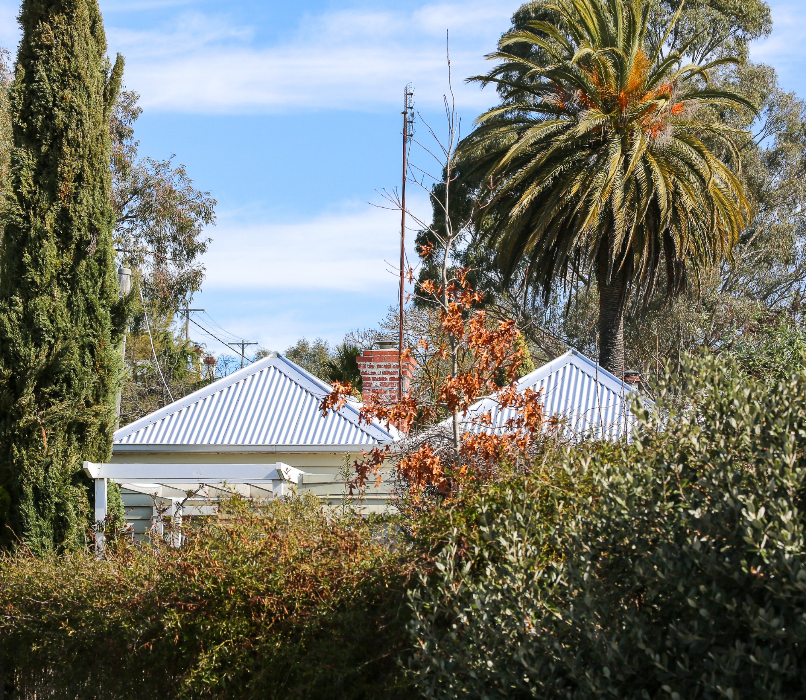
Draft
Revenue & Rating Plan
2025-2029

May 2025



  - Contents
1 Purpose 5
2 Introduction 7
2.1 Revenue Sources 7
2.2 Revenue Requirements 7
2.3 Revenue Balance 8
3 Community Engagement 9
4 Legislative Framework 10
4.1 Local Government Act 2020 10
4.2 Local Government Act 1989 11
4.3 Quantum of Rates and Charges 11
4.4 Local Government Rating System Review 11
4.5 Taxation Principles 12
4.6 Rate Capping 12
4.7 Minister Local Government’s Waste Guidelines 13
5 Rates and Charges 15
5.1 Valuation Method 16
5.2 Rates and Charges 16
5.3 Differential Rates 17
5.4 Municipal Charge 19
5.5 Service Rates and Charges 20
5.6 Special Rates and Charges 21
5.7 Payment of Rates and Charges 21
5.8 Rebates and Concessions 23
5.9 Deferments and Waivers 23
5.10 Financial Hardship 24
5.11 Non-Payment of Rates by Required Dates 24
6 Fees and Charges 25
6.1 Pricing Policy 26
6.2 Statutory Fees and Fines 26
6.3 User Fees 27
7 Other Revenue Sources 29
7.1 Government Grants 29
7.2 Contributions 30
7.3 Other Revenue 31
APPENDIX A: Differential Rate Definitions 33
APPENDIX B: Council Plan Structure 42

Purpose

The Revenue and Rating Plan aims to identify the most suitable revenue and rating strategy for the Hepburn Shire Council. This strategy will ensure adequate funding for the objectives outlined in the Council Plan.

A strategy included within the Council Plan 2025-29 is that Council will actively pursue alternative revenue opportunities.

The Local Government Act 2020 mandates that each council must develop a Revenue and Rating Plan covering at least four years after each council election. This plan sets the revenue and rating framework within which Hepburn Shire Council intends to operate.

The Revenue and Rating Plan is a crucial component of Hepburn Shire Council’s Integrated Strategic Planning Framework. All documents within this framework are designed to achieve the Community Vision and the Council Plan. The strategies outlined in this Revenue and Rating Plan align with the outcomes in the Council Plan and will contribute to Hepburn Shire Council’s budgeting, long-term financial planning, and other strategic planning documents under the Council’s strategic planning framework. The framework is detailed in the below diagram.

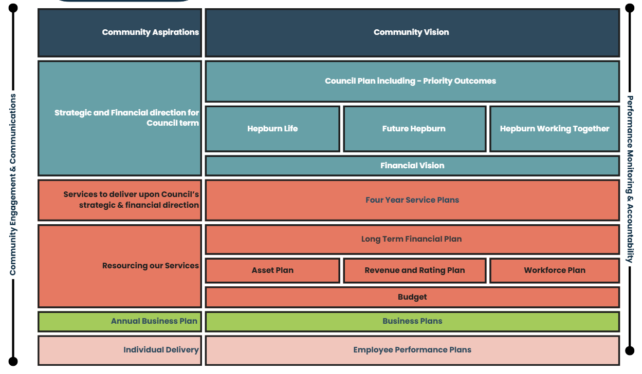

Layer | Description | Documents
Community aspirations | Community aspirations are set out in our Community Vision. | Community Vision
Strategic direction | The strategic and financial direction and priorities across the Council term. | Council Plan and Financial Vision
Council services | Services that will deliver upon Council’s strategic and financial priorities. | Service Catalogue and Service Map
Resourcing | How we will resource our services to deliver Council’s strategic and financial priorities. | Financial Plan, Asset Plan, Revenue and Rating Plan, Workforce Plan and Annual Budget.
Annual business plan | The projects and initiatives funded through the annual Budget that will deliver on Council’s strategic and financial priorities. | Annual Plan
Individual delivery | Individual employee plans that align our Council Officer’s roles and responsibilities to Council’s strategic and financial priorities. | Employee Performance Plans

This plan explains how Hepburn Shire Council apportions and charges the revenue needed to fund its activities, and how the funding burden will be apportioned between ratepayers and other users of Hepburn Shire Council facilities and services. In particular, this plan sets out decisions that Hepburn Shire Council has made in relation to rating options available to it under the Local Government Act 2020 to ensure the fair and equitable distribution of rates across property owners. It also sets out principles that are used in decision making for other revenue sources such as fees and charges.

This plan has been heavily influenced by the findings and recommendations of Council’s Financial Vision adopted in September 2024.

It is important to note that this plan does not set revenue targets for Hepburn Shire Council, it outlines the strategic framework and decisions that inform how Council will go about calculating and collecting its revenue.

Introduction

Hepburn Shire Council provides an extensive range of services and facilities to our local community, and in doing so, must collect revenue to cover the cost of providing these services and facilities.

Hepburn Shire Council’s revenue sources include:
- Rates and charges (including waste charges)
- Government grants
- Fees and charges
- Contributions
- Other revenue

Revenue Sources

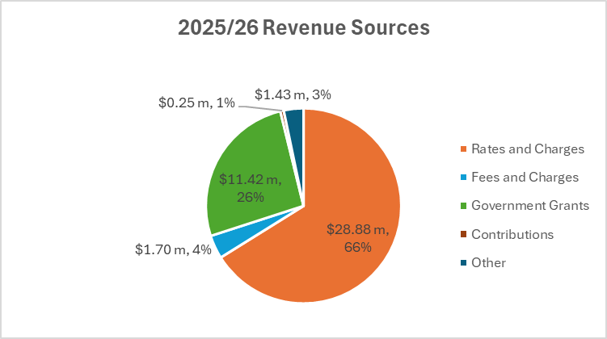
Note: All numbers on the graph are shown in millions of dollars.

The above graph shows a breakup of the revenue Hepburn Shire Council uses to fund services and facilities for the Hepburn Shire community. The total revenue for the 2025-26 year is budgeted to be $43.89 million with the major components being rates and charges (66%), Government grants (26%), fees and charges (4%) and other (3%). Gain on disposal of property, infrastructure, plant and equipment of $207,000 has been excluded for the purposes of the analysis. The budgeted income from general rates is calculated based on the 10% rate cap increase for 2025-26 fiscal year.

Revenue Requirements

The Revenue and Rating Plan is a medium-term plan for how Hepburn Shire Council will generate income to deliver on the Council Plan, program and services and capital works commitments over the next four years. In determining its revenue requirements, the Council has identified what each source of revenue is, how much will be raised in each class, and the policy rationale/assumptions for each. In doing this, Hepburn Shire Council has considered:

- How revenue will be generated through rates on properties (including differential rates [if any] on different property classes)
- Fixed service charges that might be applied on services such as waste or recycling
- Fees and charges for services and programs including cost recovery policies, user charges and means testing
- Recurrent and non-recurrent operational and capital grants from other levels of government
- Developer contributions and other revenue
- Revenue generated from the use or allocation of Council assets (including the application of discounts and waivers)
- Entrepreneurial, business, or collaborative activities established to deliver programs or services and generate income or reduce costs.

Revenue Balance
Hepburn Shire Council provides a range of services and capital works, and in determining if services should be funded through rates and charges or other revenue sources such as user charges, the Council considers whether services are either entirely or partially public goods. That is, where a service provides a broad benefit to the whole community then it will be mostly funded from rates. Where individual or groups of ratepayers receive a particular benefit then the service will be mostly funded from user charges.

In developing the Revenue and Rating Plan, Hepburn Shire Council does take into consideration stakeholders’ capacity to pay and is willing to work with ratepayers to explore payment options. Hepburn Shire Councils Revenue Collection and Financial Hardship Policy describes how Rates and Fees will be collected and how Council may assist persons who are unable to pay rates, fees and debts because they are experiencing financial hardship. All persons who are experiencing financial hardship are provided with reasonable access to appropriate assistance and in relevant circumstances referred to a financial counsellor. All applications for financial hardship are treated in confidence.

- Hepburn Working Together I Outcome 1 I Strategy 1 and 2
- Hepburn Working Together I Outcome 2 I Strategy 2

Community Engagement

The Revenue and Rating Plan details Hepburn Shire Council’s decision-making process for calculating and collecting revenues.

Hepburn Shire Council has engaged the community in reviewing the Community Vision and developing the 2025-2029 Council Plan. Previous engagements on the Financial Vision, Budget, and the previous Rating Strategy, along with other strategies and plans, have informed the development of this plan.
Deliberative community engagement is not prescribed for a Revenue and Rating Plan in either the Local Government Act 2020, or the Local Government (Planning and Reporting) Regulations 2020. However, community engagement on the Revenue and Rating Plan can be an effective way to better involve and educate ratepayers, customers and other stakeholders about the Council’s rating and revenue systems, how income is collected, and how policies are created and applied.

The Revenue and Rating Plan community engagement process will include:
- Review of the Revenue and Rating Plan.
- Draft Revenue and Rating Plan endorsed and available for public comment (13 May 2025)
- Community consultation and engagement (May 2025) through local news outlets, social media and councils website.
- Review of public submissions (June 2025)
- Council Meeting to be held (24 June 2025) to adopt the Revenue and Rating Plan.

Hepburn Shire Council will review, as they become due, revenue policies alongside this Revenue and Rating Plan including:
- Revenue Collection & Financial Hardship Policy
- Treasury Management Policy

- Hepburn Working Together I Outcome 2 I Strategy 2
Hepburn Shire’s financial planning can be found in our Long-term Financial Plan 2025-2034 and Financial Vision 2024-2027

Legislative Framework

The Local Government Act 2020 empowers councils to declare general rates, municipal charges, service rate and charges, and special rates and charges and along with the Valuation of Land Act 1960, is the legislative framework that apply to the raising of revenue via rates as outlined in the specific sections below.

Local Government Act 2020

Section 8 Role of a Council
The role of a Council is to provide good governance in its municipal district for the benefit and wellbeing of the municipal community.

Section 9 Overarching Governance Principles
A Council must in the performance of its role give effect to the overarching governance principles. Relevant overarching governance principles include:
- Priority is to be given to achieving the best outcomes for the municipal community, including future generations
- The economic, social and environmental sustainability of the municipal district is to be promoted
- The municipal community is to be engaged in strategic planning and strategic decision making
- The ongoing financial viability of the Council is to be ensured.

In giving effect to the overarching governance principles, a Council must take into account the financial management principles.

Section 94 The Budget
Council must adopt a budget by 30 June each year (or at another time fixed by the Minister) to include:
- The total amount that the Council intends to raise by rates and charges
- A statement as to whether the rates will be raised by the application of a uniform rate or a differential rate
- A description of any fixed component of the rates, if applicable
- If the Council proposes to declare a uniform rate, the matters specified in section 160 of the Local Government Act 1989
- If the Council proposes to declare a differential rate for any land, the matters specified in section 161(2) of the Local Government Act 1989.

Council must ensure that, if applicable, the budget also contains a statement:
- That the Council intends to apply for a special order to increase the Council’s average rate cap for the financial year or any other financial year; or
- That the Council has made an application to the Essential Services Commission for a special order and is waiting for the outcome of the application; or
- That a special order has been made in respect to the Council and specifying the average rate cap that applies for the financial year or any other financial year.

Section 101 Financial Management Principles
Relevant financial management principles include:
- Revenue, expenses, assets, liabilities, investments and financial transactions must be managed in accordance with a Council's financial policies and strategic plans.
- Financial policies and strategic plans, including the Revenue and Rating Plan, must seek to provide stability and predictability in the financial impact on the municipal community.

Local Government Act 1989

The Local Government Act 1989 continues to be the authority for rating purposes. The legislative framework set out in the Local Government Act 1989 determines Council’s ability to develop a rating system.

Section 155 Charges that Maybe Declared
Section 155 of the Local Government Act 1989 provides that a council may declare the following rates and charges on rateable land:
- General rates under Section 158.
- Municipal charges under Section 159.
- Service rates and charges under Section 162.
- Special rates and charges under Section 163.
The recommended strategy in relation to service rates and charges and special rates and charges are discussed later in this Plan.

Section 157 System of Valuing Land
In raising rates, Council is required to use the valuation of the rateable property to levy rates. Section 157 (1) provides Council with the following options in terms of which valuation to apply:
- Site valuation
- Net Annual Value (NAV)
- Capital Improved Valuation (CIV) - as applied by Hepburn Shire Council
For the purposes of calculating the site value, net annual value or capital improved value of rateable land, a council must use the current valuations made in respect of the land under the Valuation of Land Act 1960 by the Valuer-General.

Quantum of Rates and Charges
This plan outlines the principles and strategic framework that Council will use in calculating and distributing the rating burden to property owners, however, the quantum of rate and charges revenue will be determined in the annual Budget.

Local Government Rating System Review

The Victorian Government has undertaken reviews of the local government rating system with a view to ensuring a good system, and Council is committed to applying the following principles they outlined:
- Provide local governments with the autonomy to raise sufficient tax revenue to meet the needs and capacity of their community.
- Based on a proportion of the value of the property, i.e. higher valued properties usually contribute more in rates than lower valued properties in the same municipality.
- Simple to understand and allows for meaningful community engagement to make informed and transparent decisions about rate distribution and rating levels.
- Provides transparent and flexible ways for councils to treat ratepayers facing financial hardship fairly.
- Set out in primary legislation and is in line with the principles-based approach of the Local Government Act 2020.

Taxation Principles

The Victorian Government’s Local Government Better Practice Guide: Revenue and Rating Strategy 2014 states that when developing a rating strategy, in particular with reference to differential rates, the Council should give consideration to the following key good practice taxation principles:
- Wealth Tax: The “wealth tax” principle implies that the rates paid are dependent upon the value of a ratepayer’s real property and have no correlation to the individual ratepayer’s consumption of services or the perceived benefits derived by individual ratepayers from the expenditures funded from rates.
- Equity: Horizontal equity – ratepayers in similar situations should pay similar amounts of rates (ensured mainly by accurate property valuations, undertaken in a consistent manner, their classification into homogenous property classes and the right of appeal against valuation). Vertical Equity – those who are better off should pay more rates than those worse off (the rationale applies for the use of progressive and proportional income taxation. It implies a “relativity” dimension to the fairness of the tax burden).
- Efficiency: Economic efficiency is measured by the extent to which production and consumption decisions by people are affected by rates.
- Simplicity: How easily a rates system can be understood by ratepayers and the practicality and ease of administration.
- Benefit: The extent to which there is a nexus between consumption/benefit and the rate burden.
- Capacity to pay: The capacity of ratepayers or groups of ratepayers to pay rates.
- Diversity: The capacity of ratepayers within a group to pay rates.

The rating challenge for Council is therefore to determine how to balance competing considerations.

Rate Capping
The Fair Go Rates System (FGRS) sets out the maximum amount councils may increase rates in a year. For the 2024-25 financial year the FGRS cap was set at 2.75%. For the 2025-26 financial year it has been set at 3%. The cap applies to both general rates and municipal charges and is calculated based on Council’s average rates and charges.

From 2019 general revaluations of all properties have been undertaken on an annual basis. As a result, the actual rate increase for an individual rateable property may differ from the rate cap percentage due to changes in its valuation. Where the change in an individual property valuation is higher than the average for all rateable properties, the rate increase for that property may be greater than the cap. Where the change in the property valuation is lower than the average for all properties, the rate increase may be lower than the cap.

Council has applied for an increase to the State Government rate cap for the 2025-2026 financial year. In line with the 2024-2027 Financial Vision for Hepburn Shire Council an application has been made for a variation of 10 per cent, which is inclusive of the 3 per cent rate cap announced by the Minister for Local Government.

Minister Local Government’s Waste Guidelines

Councils have the option of declaring a charge or an ad valorem rate (or a combination of both) for waste, recycling and/or resource recovery service and other prescribed services. Council have opted to declare a service charge.

A Service Charge (as opposed to a Service Rate based on property value) has been adopted for the purposes of waste, recycling and/or resource recovery services (commonly known as kerbside waste collection). It is deemed good practice considering there is a clear nexus between the amount levied on an occupancy and the cost of the service provided to the occupancy.

The Minister for Local Government on Thursday, 21 December 2023 released the Ministers’ Good Practice Guidelines for Service Rates and Charges. These Good Practice Guidelines for Service Rates and Charges are made under Section 87 of the Local Government Act 2020. They set out what constitutes good practice by councils in the determination and declaration of Service Rates and Charges under Section 162 of the Local Government Act 1989 and any other matters related to compliance and accountability by councils.

The objectives of the Good Practice Guidelines are to ensure that Service Rates and Charges:
- are only used to recover the reasonable costs of providing a direct service to an occupancy;
- are calculated and declared in a fair and transparent manner; and
- are subject to public engagement in accordance with a council’s Community Engagement Policy.

The only specified reasons for councils to raise Service Rates and Charges are:
- Waste, recycling or resource recovery services; and
- Any other service prescribed in regulations.

These Guidelines were originally to take effect from 1 March 2024, but with the appointment of a new Minister for Local Government, the guidelines are being reviewed. Waste Charges for the 2025/26 financial year will be set as part of the Budget process and will be based on Councils traditional cost structure.

- Hepburn Working Together I Outcome 2 I Strategy 1 & 2

Rates and Charges

Rates and charges are required by the Local Government Act 1989, Section 158 and the Regulations to be disclosed in Council’s annual budget.
Rates and charges are property taxes that allow the Council to raise revenue to fund essential public services to cater to their municipal population. Importantly, it is a taxation system that includes flexibility for councils to use different tools in its rating structure to accommodate issues of equity and to ensure fairness in rating for all ratepayers.
Property rates as an overall source of revenue will:
- Be reviewed annually;
- Not change dramatically from one year to the next; and
- Be sufficient to fund current expenditure commitments and deliverables outlined in the Council Plan, Budget, Financial Plan and Asset Plan.

Hepburn Shire Council has traditionally been a lower-rating Council than many other councils in Victoria. As per the Victorian Government’s Know Your Council website, it notes that Council’s average rates per property assessment for the 2023/24 financial year was $1,700.66. This compares to $1,733.69 for similar sized Councils and $1,883.14 for all Victorian Councils. The table below from the Victorian Government Know Your Council Comparison illustrates Hepburn Shire Councils Average Rate per property assessment:

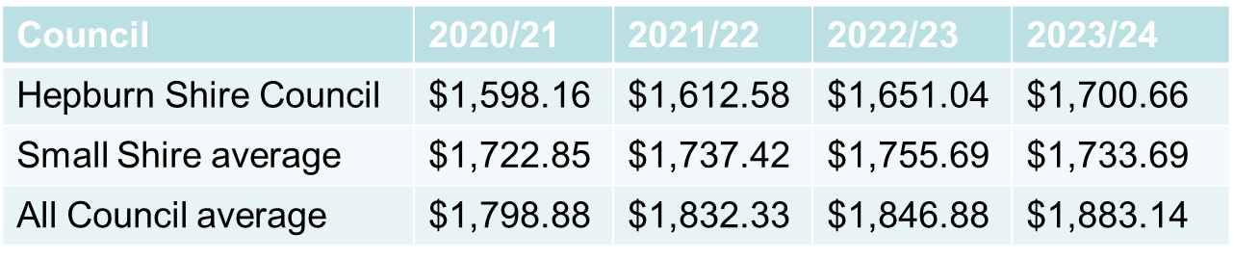

Further details on Council classifications can be found on: Know Your Council comparison dashboard | vic.gov.au
Finding / Recommendation –
Council resolution from adoption of Financial Vision – that Council notes that property-based taxation, such as Council rates, may not be the best taxation system to take into account ratepayers’ capacity to pay and requests that the Mayor and Chief Executive Officer write to the State Government Minister for Local Government calling for a review of the Rating and Revenue systems of Victorian Councils.

Valuation Method

Legislation
Under Section 157 of the Local Government Act 1989 a council may use the site value, net annual value or capital improved value system of valuation. For the purposes of calculating the site value, net annual value or capital improved value of rateable land, a council must use the current valuations made in respect of the land under the Valuation of Land Act 1960 by the Valuer-General.

Policy
Hepburn Shire Council applies the Capital Improved Value (CIV) to all properties within the municipality to reflect the fully developed value of the property. CIV is the most commonly used valuation base by local government with over 90 percent of Victorian councils applying this methodology. Based on the value of both land and all improvements on the land, it is generally easily understood by ratepayers as it equates to the market value of the property.

Utilising CIV is a reasonably assumed price which a landowner may expect at the time of valuation, should they opt to sell the land to a genuine buyer under reasonable sale terms and conditions.

Impact of Revaluations
From 2019 changes made to the Valuation of Land Act 1960 require property valuations to be undertaken by the Valuer General’s Office on an annual basis as opposed to every two years which had previously been the case.

Key Points to be aware of:
- Property revaluations are undertaken annually and do not generate extra revenue for Council. Valuations can, however, have a significant impact on the rates that individual properties are allocated, as the total rates pool is redistributed based on the updated property values.
- Valuations are undertaken as of the 1st of January each year and will be in effect for the rates levied from the 1st of July.
- Ratepayers can object to their property valuation.
Finding / Recommendation –
The valuation method will be CIV (Capital Improved Value), with no change from previous plan.

Rates and Charges

Legislation
Under Section 155 of the Local Government Act 1989, a council may declare the following rates and charges on rateable land:
- General rates
- Municipal charges
- Service rates and charges
- Special rates and charges.

General Rates (Section 158) of the Local Government Act 1989 stipulates:-
At least once within each financial year (by 30 June) a Council must declare:
- The amount which the Council intends to raise by general rates, municipal charges, service rates and charges; and
- Whether the general rates will be raised by the application of:
  - A uniform rate (Section 160);
  - Differential rates (Section 161);
  - Urban farm rates, farm rates or residential use rates (Section 161A).

Policy
The Council’s current policy for rates and charges are set out in the following sections.

Differential Rates

Legislation
Under Section 158 of the Local Government Act 1989, a Council when declaring rates and charges must declare whether the general rates will be raised by the application of a uniform rate or differential rates. Differential rates allow Council to shift part of the rates levied from some groups of ratepayers to others, through different ‘rates in the dollar’ for each class of property.

Under Section 161 of the Local Government Act 1989, a Council may apply differential rates, provided it uses Capital Improved Value as its base for rating. If a Council declares a differential rate for any land, the Council must:
- Specify the objectives of the differential rate including a definition of the types or classes of land which are subject to the rate and a statement of the reasons for the use and level of that rate.
- Specify the characteristics of the land which are the criteria for declaring the differential rate.

A Council must have regard to any Ministerial guidelines before declaring a differential rate for any land. The Minister issued Guidelines in April 2013. These guidelines attempt to spell out clearly what types and classes of land may be considered for differentials and also those that are not appropriate for differentials or need to be “carefully considered”.
The highest differential rate must be no more than four times the lowest differential rate.

When declaring differential rates, Council must explain the objectives of each rate which is to remain consistent with the equitable and efficient carrying out of Council’s functions.

The advantages and disadvantages of a differential rate approach are as follows:
Advantages | Disadvantages
There is greater flexibility to distribute the rate burden between all classes of properties and therefore link rates with the ability to pay and reflecting the tax deductibility of rates for commercial and industrial premises.  Differential rating allows Council to better reflect the investment required by Council to establish infrastructure to meet the needs of the commercial and industrial sector.  Allows Council to reflect the unique circumstances of some rating categories where the application of a uniform rate may create an inequitable outcome (e.g. Farming enterprises).  Allows Council discretion in the imposition of rates to facilitate and encourage appropriate development of its municipal district in the best interest of the community. (i.e. Vacant Commercial properties still attract the commercial differential rate) | The justification of the differential rate can at times be difficult for the various groups to accept giving rise to queries and complaints where the differentials may seem to be excessive.  Differential rates can be confusing to ratepayers, as they may have difficulty understanding the system. Some rating categories may feel they are unfavourably treated because they are paying a higher level of rates than other ratepayer groups.  Differential rating involves a degree of administrative complexity as properties continually shift from one type to another (e.g. residential to commercial,) requiring Council to update its records. Ensuring the accuracy/integrity of Council’s data base is critical to ensure that properties are correctly classified into their right category.  Council may not achieve the objectives it aims for through differential rating. For example, Council may set its differential rate objectives to levy a higher rate on land not developed, however it may be difficult to prove whether the rate achieves those objectives.

Hepburn Shire Council levies general rates via Differential Rates to acknowledge the diversity of the individual property and uses across the municipality.

Council recognises the need to review the differential rates as the need arises.

Policy and Charges
The Hepburn Shire Council rating structure comprises nine differential rates. These rates are structured in accordance with the requirements of Section 161 ‘Differential Rates’ of the Local Government Act 1989, and the Ministerial Guidelines for Differential Rating 2013.
The formula for calculating General Rates, excluding any additional charges, arrears or additional supplementary rates is:

Property Valuation (Capital Improved Value) x Rate in the Dollar (Differential Rate Type).

The definition of each differential rate is set out in Appendix A. Details of the types/classes of land and the level of rate applicable to each differential is as follows:

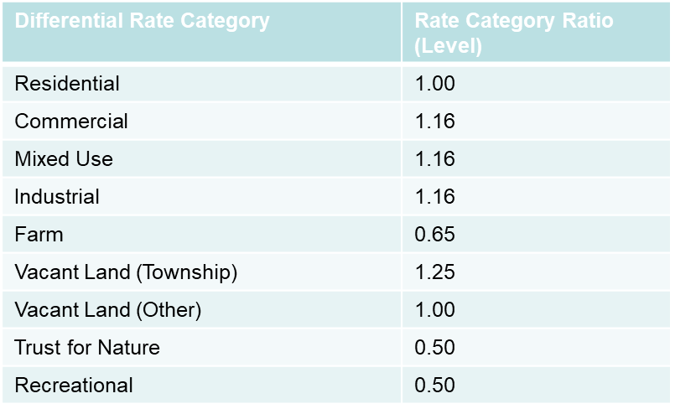

Finding / Recommendation –
There are no changes to rating differentials proposed in the Revenue and Rating Plan 2025-29

Municipal Charge

Legislation
A municipal charge may be levied (Local Government Act 1989 Section 158) on all rateable properties within a municipality “to cover some of the administrative costs of the Council”. The legislation is not definitive on what comprises administrative costs and does not require Council to specify what is covered by the charge.

The application of a municipal charge represents a choice to raise a portion of the rates by a flat fee for all properties, rather than the sole use of the Capital Improved Value method.
Under the Local Government Act 1989, Section 159 a council’s total revenue from municipal charge in a financial year must not exceed 20 percent of the combined sum total of the Council’s total revenue from the municipal charge and the revenue from general rates (total rates).

The municipal charge applies equally to all properties and is based on the recovery of a fixed cost of providing administrative services irrespective of valuation.

The argument against a municipal charge is that the charge is regressive in nature and would result in lower-valued properties paying higher overall rates and charges than they do at present. The equity objective in levying rates against property values is lost in a municipal charge as it is levied uniformly across all assessments.

Policy and Charges
Council does not levy a municipal charge due to its regressive nature, in that it impacts lower-valued properties which have a lesser capacity to pay.

A municipal charge is regressive in nature, impacting lower value properties which are likely to have a reduced capacity to pay. As part of future Rating Strategy reviews, council will consider all options to achieve the most equitable distribution of the rates burden, including the option of a municipal charge should it be deemed suitable.
Finding / Recommendation –
There is no introduction of a Municipal Charge proposed in the Revenue and Rating Plan 2025-29

Service Rates and Charges

Policy and Charges
The Council has the following service rates and charges:
- Kerbside landfill – township (120L) - fortnightly
- Kerbside landfill – rural (140L) - fortnightly
- Kerbside mixed recycling (240L) - fortnightly
- Kerbside food and garden organics (120L) - weekly
- Kerbside landfill – commercial (240L) - weekly
- Waste management improved charge
- Waste management unimproved charge

Council’s policy regarding service rates and charges for waste disposal is that the costs of the waste services are fully recovered. Services and costing structures will be reviewed on an ongoing basis.

- Future Hepburn I Outcome 2 I Strategy 5
Finding / Recommendation –
Council will undertake a review of the kerbside food and garden organics service following its 12-months implementation, with a report presented to Council in early 2025-26.
Finding / Recommendation –
There are no proposed changes to the type of service charges proposed in the Revenue and Rating Plan 2025-29. Council will review waste service charges when the Minister Local Governments issues updated guidelines.

Special Rates and Charges

Legislation
The Local Government Act 1989 recognises that councils need help to provide improved infrastructure for their local communities. The Act allows councils to pass on the cost of capital infrastructure to the owner of a property that generally receives a unique benefit from the construction works. The purposes for which special rates and special charges may be used include road construction, kerb and channelling, footpath provision, drainage, and other capital improvement projects.

Under Section 163 of the Local Government Act 1989, a Council council may declare a special rate or charge for the purposes of:
- Defraying any expenses; or
- Repaying (with interest) any advance made to or debt incurred or loan raised by the Council.

Policy
Special rates and charges schemes are raised in accordance with the requirements of the Local Government Act 1989.

Council will look at applying special rates and charges to reduce the burden on the ratepayer as well as implementing a user pays system to assist the interested party reaching the desired outcome
Finding / Recommendation –
Councillors will receive a briefing paper that considers the possible options for special rate and charge schemes, including for possible road upgrades.

Payment of Rates and Charges

Legislation
Pursuant to Section 167 of the Local Government Act 1989, Council must allow rates and charges to be pain in four instalments. Council may also allow rates and charges to be paid in a lump sum.

Policy
In accordance with Section 167 of the Local Government Act 1989, ratepayers have the option of paying rates and charges by way of four instalments. Payments are due on the prescribed dates below:
- First Instalment: 30 September
- Second Instalment: 30 November
- Third Instalment: 28 February
- Fourth Instalment: 31 May
Under Section 168 of the Local Government Act 1989, a council may also provide incentives for prompt payment. At this point in time Council does not offer incentive for early payment of rates.

Council offers a range of payment options including:

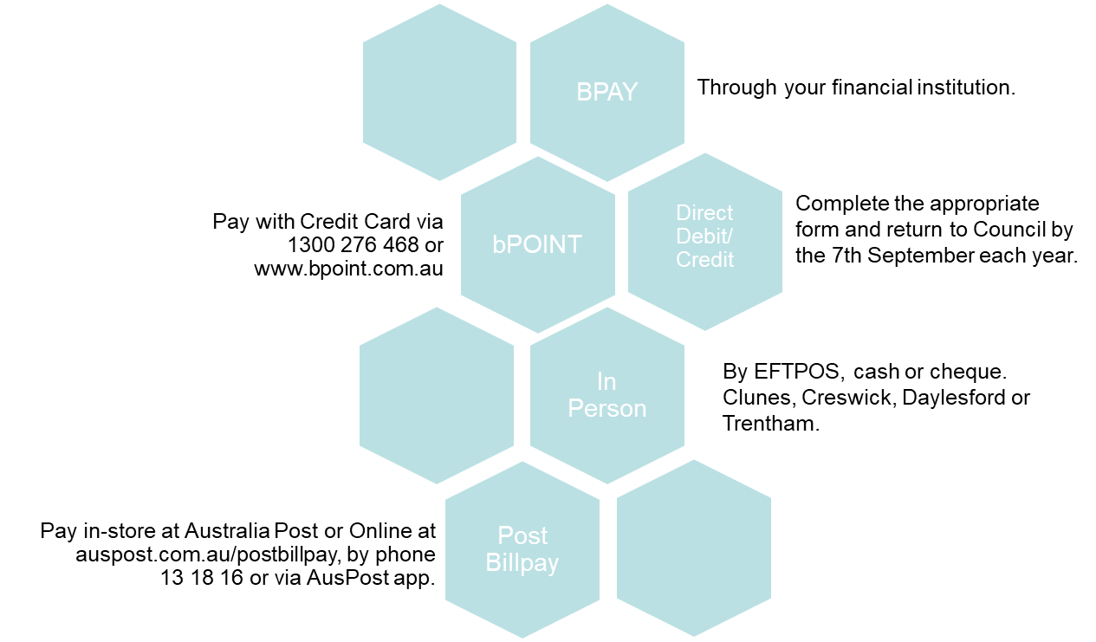

Interest on Arrears and Overdue Rates
There is a disincentive for late payments to council. Ratepayers who neglect to pay their rates or charges at the time they fall due may incur interest per the Local Government Act 2020 Section 120. The penalty interest percentage rate on Rates is fixed under section 2 of the Penalty Interest Rates Act 1983 as applied on 1st of July each year.
Per the Revenue Collection and Financial Hardship 2021 Policy 6 (C) Council require a ratepayer to pay penalty interest on Rates:
- Which the ratepayer is liable to pay
- Which have not been paid by the applicable due date

Penalty interest is calculated and charged from the date on which the Rates payment was due and will continue to accrue until the Rates are paid.

Council is willing to work with ratepayers who are proactive in resolving their outstanding balances.
Finding / Recommendation –
There are no proposed changes to payment timeframes in this plan.

- Hepburn Working Together I Outcome 1 I Strategy 1

Rebates and Concessions

Legislation
Under Section 169 of the Local Government Act 1989, a Council may grant a rebate or concession in relation to any rate or charge to:
- Assist the proper development of the municipal district; or
- Preserve buildings or places in the municipal district which are of historical or environmental interest; or
- Restore or maintain buildings or places of historical, environmental, architectural or scientific importance in the municipal district; or
- Assist the proper development of part of the municipal district.

A Council resolution granting a rebate or concession must specify the benefit to the community as a whole resulting from the rebate or concession.

Policy
Ratepayers who hold an eligible pensioner concession card may be entitled to receive a State Government-funded concession on their rates and charges for their principal place of residence. The pensioner concession is set at half the rates and charges levied up to a maximum amount and is fully funded by the State Government. Eligible pensioners are also entitled to receive a concession on the Fire Services Property Levy in the sum of $50.

Ratepayers who are eligible to receive the pensioner concession, are also eligible to receive an additional concession to accommodate the financial difficulties experienced by pensioners. The additional pensioner concession is set at $21.00 and is fully funded by Council. It should be noted that an additional pensioner concession is offered by few Victorian Councils. Hepburn Shire has offered a pensioner concession since 2013 and currently costs Council $35,000 per annum. The rebate will rise to $42.00 subject to a successful rate cap application.
Finding / Recommendation –
Given the successful rate cap variation, Councils additional pension concession will increase to $42 (from $21).

Deferments and Waivers

Legislation
Under Section 170 of the Local Government Act 1989, a council may defer in whole or in part any rate or charge if the payment would cause hardship to the person.

Section 171 of the Local Government Act 1989, a council may waive the whole or part of any rate or charge or interest in relation to:
- An eligible recipient
- Any other class of persons determined by the Council for the purpose of waiving rates or charges on the grounds of financial hardship.

Policy
Council has a Revenue Collection and Hardship Policy designed to provide financial relief for rates and other debts. Ratepayers experiencing financial hardship, or those who would face hardship by paying the full amount of rates and charges, can apply for a payment arrangement initially or proceed to hardship policies by deferring the payment of rates, charges, and interest. Consideration will also be given to waiving current and future interest charges. As part of the hardship application process, the Council may refer ratepayers to a financial counsellor. The Council strives to work collaboratively with ratepayers to resolve any outstanding balances.

Financial Hardship

It is acknowledged that various ratepayers may experience financial hardship for a range of reasons. Meeting rate obligations is just one of many challenges that may be faced, which is why the Council has defined the financial hardship provisions available to our ratepaying community, as documented in the Revenue Collection and Financial Hardship Policy.

Ratepayers experiencing financial hardship may apply for assistance and be referred to a financial counsellor. The counsellor will work with the ratepayer to review their entire financial situation and make a recommendation to the Council regarding their capacity to maintain a payment arrangement or suggest a deferral.

Non-Payment of Rates by Required Dates
Where a ratepayer fails to meet their obligation to pay rates and charges in accordance with the legislative or Council offered payment dates, penalty interest may be applied. This is in accordance with the legislative framework, where an account may be referred to Council’s appointed Debt Collection Agency.

Further information regarding the actions Council may take to collect outstanding Rates and Charges can be found in Council’s Revenue Collection and Financial Hardship Policy.

Penalty Interest
Section 172 of the Local Government Act 1989 enables Council to charge interest on unpaid rates and charges. The interest rate applied is fixed under Section 2 of the Penalty Interest Rates Act 1983, which is determined by the Minister and published by notice in the Government Gazette.

Debt Recovery
Council makes every effort to contact ratepayers at their correct registered mail address, but it is the ratepayers’ responsibility to properly advise Council of their contact details. The Local Government Act 1989 Section 230 and 231 requires both the vendor and buyer of property, or their agents (e.g. solicitors and or conveyancers), to notify Council by way of notice of acquisition and a notice of disposition of an interest in land. If an account becomes overdue, Council will proceed with actions as detailed in the Revenue Collection and Financial Hardship Policy.

Payment Arrangement
Council offers payment arrangements under the Local Government Act 1989 Section 171B to eligible ratepayers and debtors to assist in resolving outstanding balances.

Payment arrangements are useful for eligible applicants to ensure penalty interest is not accrued on overdue balances and make the outstanding balance more manageable.

New State Government Hardship Guidelines
Guidelines for rate payment, hardship, and payment arrangements are expected from the Minister Local Government in 2025/26.
Finding / Recommendation –
Council to review its processes and policies in relations to rate payments, hardship and payment arrangements in line with Government guidelines, when they are released.

Victorian Government Levies
Council has legislative requirements to collect levies and taxes on behalf of the State Government.

Such charges include the landfill levy, which is incorporated in the calculation of waste service charges and the Fire Services Property Levy, which once legislated will be renamed the Emergency Services and Volunteers Fund from 1 July 2025.

The Fire Services Property Levy will be renamed the Emergency Services and Volunteers Fund effective from 1 July 2025. The new levy is expanded to fund the State Emergency Service, Tripple Zero Victoria, the State Control Centre, Forest Fire Management Victoria and Emergency Recovery Victoria.

Short Stay Levy
At this point in time Council has not sought to introduce a Short Stay Levy or Local Law considering the Victoria State Government have opted to recently introduce a Short Stay Levy facilitated through the State Revenue Office. Council will review the impact of the State Government before any further fee or regulation of short stay accommodation occurs.

Vacant Residential Land Tax
From 1 January 2025, Vacant Residential Land Tax (VRLT) applies to residential land anywhere in Victoria if the land is vacant in the preceding calendar year. This means that if you own residential land anywhere in Victoria that was vacant in 2024, you may be liable for VRLT in 2025. This may affect properties under the Short Stay Levy and is serviced by the State Revenue Office.

Fees and Charges
Fees and charges consist of statutory fees and fines and user fees. Statutory fees and fines relate mainly to those levied in accordance with legislation and include animal registrations, Public Health and Wellbeing Act 2008 registrations and parking fines. User fees relate to the recovery of service delivery costs through the charging of fees to users of the Council’s services. The use of leisure, entertainment and other community facilities, and the provision of human services such as childcare and home and community care services all represent user fees.

Pricing Policy
The Council has developed a Fees and Charges Schedule that provides guidance for its approach in setting appropriate levels of fees and charges. This schedule applies to all fees and charges that are listed in the Fees and Charges Schedule, which is published in the Annual Budget. The policy seeks to ensure that the following key service performance principles under Section 106 of the Act are met:
- Services should be provided in an equitable manner and be responsive to the diverse needs of the municipal community
- Services should be accessible to the members of the municipal community for whom the services are intended
- Quality and costs standards for services set by the Council should provide good value to the municipal community.

The Council must also comply with the government’s Competitive Neutrality Policy for significant business activities it provides and adjust service prices to neutralise any competitive advantages when competing with the private sector.

Statutory Fees and Fines

Policy
Statutory fees and fines are those which the Council collects under the direction of legislation or other government directives. The rates used for statutory fees and fines are advised by the state government department responsible for the corresponding services or legislation, and the Council has limited discretion in applying these fees.

Fees and Fines
A summary of statutory fees and fines by major service area is as follows:
- Planning
- Registrations
- Infringements
- Permits

Penalty and fee units are used in Victoria’s Acts and Regulations to describe the amount of a fine or a fee.

Council collaborates with council advocacy bodies such as Finance Professionals, Municipal Association of Victoria and the Revenue Management Association to advocate for reviews into funding levels.
Finding / Recommendation –
Council will collaborate with advocacy bodies to request State Government undertake reviews and make adjustment to statutory fees and fine to improve the alignment between costs and revenue.

User Fees

Policy
For user fees not regulated by statute, Council determines the extent of cost recovery on a particular service consistent with the level of both individual and collective benefit that the service provides and in line with the community’s expectations. The three types of non-statutory pricing are as follows:

The schedule of Fees and Charges in the Budget includes around 360 individual fees and charges which are reviewed annually as part of the Budget process. The Financial Plan has user fees increasing at a rate of 4.50 per cent per annum.

User Fees
Hepburn Shire Council provides a range of services, for which users pay a fee or charge which covers at least part of the cost of supply. The level of some fees and charges are statutorily set, however many are at the discretion of Council. Legislation provided for local governments to levy fees and charges. User fees and charges are those that Council will charge for the delivery of services and use of community infrastructure.

Examples of user fees and charges include:
- Waste management fees
- Leases and facility hire fees
- Building fees
Finding / Recommendation –
As Council undertakes Service Reviews, review the user fees and charges with an aim to benchmark Councils cost base, compare against other Councils and actively look for new fee types​.

- Hepburn Working Together I Outcome 2 I Strategy 3

Other Revenue Sources
Other revenue sources that Council uses to fund services and facilities include government grants, contributions and other revenue.

Government Grants

Policy
Grant revenue represents income usually received from other levels of government. Some grants are singular and attached to the delivery of specific projects, whilst others can be of a recurrent nature and may or may not be linked to the delivery of projects.

The Council pro-actively advocates to other levels of government for grant funding support to deliver important infrastructure and service outcomes for the community. The Council demonstrates strong advocacy and may use its own funds to leverage higher grant funding and maximise external funding opportunities. Council recognises Government Grants as an area to prioritise for community benefit.

As part of the Financial Vision 2024-2027 Council will adopt the creation of a ‘grant funding reserve’ which will mean funds will be available to allocate to government grant applications as ‘matching’ funds.

When preparing its financial plan, the Council considers its project proposal pipeline, advocacy priorities, upcoming grant program opportunities, and co-funding options to determine what grants to apply for. The Council will only apply for and accept external funding if it is consistent with the Community Vision and does not lead to the distortion of Council Plan priorities. Grant assumptions are then clearly detailed in the Council’s budget document. No project that is reliant on grant funding will proceed until a signed funding agreement is in place.

Government Grants
A summary of government grants by type is as follows.

Operating
- Financial assistance grants
- Libraries
- Maternal and child health
- Emergency
- Information technology
- School crossings
- Recreation
- Transport
- Waste and environment
- Youth

Capital
- Roads to recovery
- Community infrastructure
- Recreation
- Buildings
- Tourism
- Waste and environment

- Hepburn Life I Outcome 2 I Strategy 2
Finding / Recommendation –
Include a ‘Grant Funding Reserve’, as noted and discussed as part of the development of Councils Financial Vision, to support Council’s co-contribution towards grant funding opportunities.​

Contributions

Policy
Contributions represent funds received by the Council, usually from non-government sources, and are often linked to projects. Contributions can be made to the Council in the form of either cash payments or physical assets. Contributions are always linked to a planning or funding agreement and the Council will not undertake any work on a contribution-funded project until a signed agreement outlining the contribution details is in place. Contributions linked to developments can be received well before any expenditure occurs. In this situation, the funds are identified and held separately in a reserve for the specific works identified in the agreements.

Types of Contributions
A summary of contributions by type is as follows.
- Open spaces fund – when land is subdivided, a contribution is made towards public open space by providing land, making a monetary contribution or a combination of both. Consideration will be given to how other councils levy the open spaces fund.
- Infrastructure / Developer contributions - All development creates increased demand on infrastructure like roads, footpaths and stormwater drains, through planning scheme amendments increased financial (or in-kind) contributions could be considered.
- Community group contributions to projects.
Finding / Recommendation –
Consider expanding Councils approach to and the application of developer contributions in conjunction with the work to be completed to implement Future Hepburn.

Other Revenue

Policy
Hepburn Shire Council earns other sources of revenue from sale of assets, leases and licensing, interest on investments and interest on rate arrears. The amount of revenue earned from these sources fluctuates from year-to-year, such as level of cash and investments, and outstanding rates and charges balances.

Finding / Recommendation –
Council resolution from adoption of Financial Vision – that Council continues to explore options that diversifies funding sources by exploring partnerships and other models with values-aligned organisations, and additionally, examines opportunities for shared service models with neighbouring councils and other entities to increase operational efficiency.

Sale of Assets
Under the Disposal and Acquisition of Land Policy 93 (C) Council responds to the needs of the community by selling surplus land and strategically acquiring additional properties. The Disposal and Acquisition of Land Policy provides a framework to guide decision making in relation to the sale and acquisition of land.

Hepburn Shire Council manages an extensive property portfolio. Council owned land is a valuable public asset, and it is essential that it is used to maximise the social, environmental, and economic benefits to the Hepburn Shire community. All property considered for disposal will undergo an evaluation based on both financial and community benefit factors. Existing holdings or strategic acquisitions must meet existing needs, new identified needs or adopted strategies. To enhance community benefit opportunities for the alternative use of property (including asset realisation) will be investigated. Regular reviews of asset holdings will be conducted to identify opportunities for asset realisation and consolidation.
Finding / Recommendation –
Council will actively review its Land and Buildings to review possible properties for sale, subject to community engagement.
Finding / Recommendation –
Council resolution from adoption of Financial Vision – that Council continues to explore the leasing or sale, of available land, if any, to obtain social benefits (including social and affordable housing land use opportunities) and/or financial returns for Hepburn Shire, ensuring compliance with Councils acquisition and disposal of land policy.

Leasing and Licensing

Hepburn Shire Council provides a range of assets for use by the public, community groups and other organisations to contribute to the achievement of Council’s strategic objectives and desired service delivery. Sources of income may be received from leasing and licensing arrangements managed through Hepburn Shire Council’s Leases and Licences Policy 09 (C).

The Policy applies to all Council-managed assets, including Council-owned, Crown Land (where Council is the appointed Committee of Management) and any other land Council has control over, where an occupancy agreement is to be offered to a community group or other organisation. The Policy outlines what occupancy agreements are covered.
Finding / Recommendation –
In 2025/26 Council officers prepare a briefing for Councillors that reviews the implementation of the Leases and Licences policy to ensure compliance is fast-tracked across the shire.

Interest on Investments
Hepburn Shire Council receives interest on funds managed as part of its investment portfolio, where funds are held in advance of expenditure, or for special purposes. The investment portfolio is manged per Council’s Treasury Management Policy 50 (C), which seeks to provide maximum returns for ratepayers with consideration of an acceptable risk.

- Future Hepburn I Outcome 2 I Strategy 4
See also: Asset Plan 2025-2034

APPENDIX A: Differential Rate Definitions

Residential Land
Definition | Residential Land is land, which is used solely for residential purposes and the balance of land defined by exception to the general rate.
Objectives | The objective of this differential rate is to ensure that all rateable land makes an equitable financial contribution to the cost of carrying out the functions of the Hepburn Shire Council, including (but not limited to) the:  - Construction and maintenance of infrastructure assets.  - Development and provision of health and community services.  - Provision of general support services
Characteristics | The characteristics of planning scheme zoning are applicable to the determination of vacant land which will be subject to the rate applicable to residential land.  The vacant land affected by this rate is that which is zoned residential under the Hepburn Shire Planning Scheme.  The classification of land which is improved will be determined by the occupation of that land and have reference to the planning scheme zoning
Types and classes | The types and classes of rateable land within this rate are those having the relevant characteristics described above
Use of rate | The money raised by this rate will be applied to the items of expenditure described in the Budget by Council.  The level of the rate for land in this category is considered to provide for an appropriate contribution to Council’s budgeted expenditure, having regard to the characteristics of the land
Level of rate | 100 per cent of the general rate
Use of land | Is any use permitted under the Hepburn Shire Planning Scheme
Geographic location | This rate is applicable to land within the municipal district
Planning scheme zoning | The zoning applicable to each rateable land within this category, as determined by consulting maps referred to in the relevant Planning Scheme
Types of buildings | The types of buildings on the land within this rate are all buildings already constructed on the land or which will be constructed prior to the expiry of the financial year

Commercial Land
Definition | Commercial land is land, which is used solely for commercial purposes. Includes rateable land which is used for short term accommodation which does not qualify as Residential under the Residential Tenancies Act 1997 characterised by stays of greater than 60 days and the existence of a tenancy agreement to which the Residential Tenancy Act 1997 applies.
Objectives | The objective of this differential rate is to ensure that all rateable land makes an equitable financial contribution to the cost of carrying out the functions of the Hepburn Shire Council, including (but not limited to) the:  - Construction and maintenance of infrastructure assets.  - Development and provision of health and community services.  - Provision of general support services
Characteristics | The characteristics of planning scheme zoning are applicable to the determination of vacant land which will be subject to the rate applicable to residential land.  The vacant land affected by this rate is that which is zoned residential under the Hepburn Shire Planning Scheme.  The classification of land which is improved will be determined by the occupation of that land and have reference to the planning scheme zoning
Types and classes | The types and classes of rateable land within this rate are those having the relevant characteristics described above
Use of rate | The money raised by this rate will be applied to the items of expenditure described in the Budget by Council.  The level of the rate for land in this category is considered to provide for an appropriate contribution to Council’s budgeted expenditure, having regard to the characteristics of the land
Level of rate | 116 per cent of the general rate
Use of land | Is any use permitted under the Hepburn Shire Scheme
Geographic location | This rate is applicable to land within the municipal district
Planning scheme zoning | The zoning applicable to each rateable land within this category, as determined by consulting maps referred to in the relevant Planning Scheme
Types of buildings | The types of buildings on the land within this rate are all buildings already constructed on the land or which will be constructed prior to the expiry of the financial year

Industrial Land
Definition | Industrial Land is land, which is used solely for industrial purposes.
Objectives | The objective of this differential rate is to ensure that all rateable land makes an equitable financial contribution to the cost of carrying out the functions of the Hepburn Shire Council, including (but not limited to) the:  - Construction and maintenance of infrastructure assets.  - Development and provision of health and community services.  - Provision of general support services
Characteristics | The characteristics of planning scheme zoning are applicable to the determination of vacant land which will be subject to the rate applicable to residential land.  The vacant land affected by this rate is that which is zoned residential under the Hepburn Shire Planning Scheme.  The classification of land which is improved will be determined by the occupation of that land and have reference to the planning scheme zoning
Types and classes | The types and classes of rateable land within this rate are those having the relevant characteristics described above
Use of rate | The money raised by this rate will be applied to the items of expenditure described in the Budget by Council.  The level of the rate for land in this category is considered to provide for an appropriate contribution to Council’s budgeted expenditure, having regard to the characteristics of the land
Level of rate | 116 per cent of the general rate
Use of land | Is any use permitted under the Hepburn Shire Planning Scheme
Geographic location | This rate is applicable to land within the municipal district
Planning scheme zoning | The zoning applicable to each rateable land within this category, as determined by consulting maps referred to in the relevant Planning Scheme
Types of buildings | The types of buildings on the land within this rate are all buildings already constructed on the land or which will be constructed prior to the expiry of the financial year

Mixed Use Land
Definition | Mixed Use Land is land, which is not used solely for residential, commercial, industrial, farm land or recreational land but is a combination of residential and at least one other category.
Objectives | The objective of this differential rate is to ensure that all rateable land makes an equitable financial contribution to the cost of carrying out the functions of the Hepburn Shire Council, including (but not limited to) the:  - Construction and maintenance of infrastructure assets.  - Development and provision of health and community services.  - Provision of general support services
Characteristics | The characteristics of planning scheme zoning are applicable to the determination of vacant land which will be subject to the rate applicable to residential land.  The vacant land affected by this rate is that which is zoned residential under the Hepburn Shire Planning Scheme.  The classification of land which is improved will be determined by the occupation of that land and have reference to the planning scheme zoning
Types and classes | The types and classes of rateable land within this rate are those having the relevant characteristics described above
Use of rate | The money raised by this rate will be applied to the items of expenditure described in the Budget by Council.  The level of the rate for land in this category is considered to provide for an appropriate contribution to Council’s budgeted expenditure, having regard to the characteristics of the land
Level of rate | 116 per cent of the general rate
Use of land | Is any use permitted under the Hepburn Shire Planning Scheme
Geographic location | This rate is applicable to land within the municipal district
Planning scheme zoning | The zoning applicable to each rateable land within this category, as determined by consulting maps referred to in the relevant Planning Scheme
Types of buildings | The types of buildings on the land within this rate are all buildings already constructed on the land or which will be constructed prior to the expiry of the financial year

Farm Land
Definition | Farm Land is land, which is identified and defined as farmland and which is used solely for the purpose of farming as defined in section 2(1) of the Valuation of Land Act 1960 and is deemed to be a property for primary production purposes as accepted by the Australian Taxation Office
Objectives | The objective of this differential rate is to ensure that all rateable land makes an equitable financial contribution to the cost of carrying out the functions of the Hepburn Shire Council, including (but not limited to) the:  - Construction and maintenance of infrastructure assets.  - Development and provision of health and community services.  - Provision of general support services
Characteristics | The characteristics of planning scheme zoning are applicable to the determination of vacant land which will be subject to the rate applicable to residential land.  The vacant land affected by this rate is that which is zoned residential under the Hepburn Shire Planning Scheme.  The classification of land which is improved will be determined by the occupation of that land and have reference to the planning scheme zoning
Types and classes | The types and classes of rateable land within this rate are those having the relevant characteristics described above
Use of rate | The money raised by this rate will be applied to the items of expenditure described in the Budget by Council.  The level of the rate for land in this category is considered to provide for an appropriate contribution to Council’s budgeted expenditure, having regard to the characteristics of the land
Level of rate | 65 per cent of the general rate
Use of land | Is any use permitted under the Hepburn Shire Planning Scheme
Geographic location | This rate is applicable to land within the municipal district
Planning scheme zoning | The zoning applicable to each rateable land within this category, as determined by consulting maps referred to in the relevant Planning Scheme
Types of buildings | The types of buildings on the land within this rate are all buildings already constructed on the land or which will be constructed prior to the expiry of the financial year

Vacant Land (township)
Definition | Vacant Land (township) is land within township boundaries, which does not form part of a commercial, industrial, farming enterprise or recreational purpose or upon which a residence is erected
Objectives | The objective of this differential rate is to ensure that all rateable land makes an equitable financial contribution to the cost of carrying out the functions of Hepburn Shire Council, including (but not limited to) the:  - Construction and maintenance of infrastructure assets.  - Development and provision of health and community services.  - Provision of general support services
Characteristics | The characteristics of planning scheme zoning are applicable to the determination of vacant land which will be subject to the rate applicable to residential land.  The vacant land affected by this rate is that which is zoned residential under the Hepburn Shire Planning Scheme.  The classification of land which is improved will be determined by the occupation of that land and have reference to the planning scheme zoning
Types and classes | The types and classes of rateable land within this rate are those having the relevant characteristics described above
Use of rate | The money raised by this rate will be applied to the items of expenditure described in the Budget by Council.  The level of the rate for land in this category is considered to provide for an appropriate contribution to Council’s budgeted expenditure, having regard to the characteristics of the land
Level of rate | 125 per cent of the general rate
Use of land | Is any use permitted under the Hepburn Shire Planning Scheme
Geographic location | This rate is applicable to land within the municipal district
Planning scheme zoning | The zoning applicable to each rateable land within this category, as determined by consulting maps referred to in the relevant Planning Scheme
Types of buildings | Not applicable

Vacant Land (other)
Definition | Vacant Land (other) is land, which does not form part of a commercial, industrial, farming enterprise or recreational purpose or upon which a residence is erected and doesn’t meet the definition of Vacant Land (township)
Objectives | The objective of this differential rate is to ensure that all rateable land makes an equitable financial contribution to the cost of carrying out the functions of Hepburn Shire Council, including (but not limited to) the:  - Construction and maintenance of infrastructure assets.  - Development and provision of health and community services.  - Provision of general support services
Characteristics | The characteristics of planning scheme zoning are applicable to the determination of vacant land which will be subject to the rate applicable to residential land.  The vacant land affected by this rate is that which is zoned residential under the Hepburn Shire Planning Scheme.  The classification of land which is improved will be determined by the occupation of that land and have reference to the planning scheme zoning
Types and classes | The types and classes of rateable land within this rate are those having the relevant characteristics described above
Use of rate | The money raised by this rate will be applied to the items of expenditure described in the Budget by Council.  The level of the rate for land in this category is considered to provide for an appropriate contribution to Council’s budgeted expenditure, having regard to the characteristics of the land
Level of rate | 100 per cent of the general rate
Use of land | Is any use permitted under the Hepburn Shire Planning Scheme
Geographic location | This rate is applicable to land within the municipal district
Planning scheme zoning | The zoning applicable to each rateable land within this category, as determined by consulting maps referred to in the relevant Planning Scheme
Types of buildings | Not applicable

Trust for Nature Land
Definition | Trust for Nature Land is land, which has a Trust for Nature Covenant applying to the land. A Trust for Nature Covenant enables the permanent protection of significant areas of natural bush land.
Objectives | The objective of this differential rate is to ensure that all rateable land makes an equitable financial contribution to the cost of carrying out the functions of the Hepburn Shire Council, including (but not limited to) the:  - Construction and maintenance of infrastructure assets.  - Development and provision of health and community services.  - Provision of general support services  It is also to encourage landowners to voluntarily place conservation covenants on their land
Characteristics | The characteristics of planning scheme zoning are applicable to the determination of vacant land which will be subject to the rate applicable to residential land.  The vacant land affected by this rate is that which is zoned residential under the Hepburn Shire Planning Scheme.  The classification of land which is improved will be determined by the occupation of that land and have reference to the planning scheme zoning
Types and classes | The types and classes of rateable land within this rate are those having the relevant characteristics described above
Use of rate | The money raised by this rate will be applied to the items of expenditure described in the Budget by Council.  The level of the rate for land in this category is considered to provide for an appropriate contribution to Council’s budgeted expenditure, having regard to the characteristics of the land
Level of rate | 50 per cent of the general rate
Use of land | Is any use permitted under the Hepburn Shire Planning Scheme
Geographic location | This rate is applicable to land within the municipal district
Planning scheme zoning | The zoning applicable to each rateable land within this category, as determined by consulting maps referred to in the relevant Planning Scheme
Types of buildings | The types of buildings on the land within this rate are all buildings already constructed on the land or which will be constructed prior to the expiry of the financial year

Recreational Land
Definition | Cultural and Recreational Land is land as defined under the Cultural and Recreational Lands Act 1963
Objectives | The objective of the rate is to recognise the large contribution that these community organisations and the volunteers make to the Municipality in the provision of sporting, cultural and recreational activities
Characteristics | Is cultural and recreational land and:  - Occupied by a body which exists for cultural or recreational purposes and applies its profits in promoting the furthering of this purpose  - Owned by the body, by the Crown or by Council  - Not agricultural showgrounds
Types and classes | The types and classes of rateable land within this rate are those having the relevant characteristics described above
Use of rate | The money raised by this rate will be applied to the items of expenditure described in the Budget by Council.  The level of the rate for land in this category is considered to provide for an appropriate contribution to Council’s budgeted expenditure, having regard to the characteristics of the land
Level of rate | 50 per cent of the general rate
Use of land | Is any use permitted under the Hepburn Shire Planning Scheme
Geographic location | This rate is applicable to land within the municipal district
Planning scheme zoning | The zoning applicable to each rateable land within this category, as determined by consulting maps referred to in the relevant Planning Scheme
Types of buildings | The types of buildings on the land within this rate are all buildings already constructed on the land or which will be constructed prior to the expiry of the financial year

APPENDIX B: Council Plan Structure

Domain: Hepburn Life
Outcome 1 | “Connected communities that are resilient, adaptable, and empowered - able to respond to and recover from climate-related impacts, emergencies, and other community challenges.”
Strategies | - Enhance community preparedness and resilience for changing conditions through community partnerships, education, support and advocacy.  - Work with partners to ensure timely and coordinated access to essential resources and services during and post-emergencies to preserve the safety and recovery of all residents.  - Enhance community preparedness and resilience for changing conditions through community partnerships, education, support and advocacy.  - Work with partners to ensure timely and coordinated access to essential resources and services during and post-emergencies to preserve the safety and recovery of all residents.
Outcome 2 | “A healthy and inclusive community, where all people regardless of background or stage of life have the opportunity to participate and thrive.”
Strategies | - Provide access to, and support local formal and informal recreation opportunities to increase diversity of participation, promote wellbeing and nurture social connections  - Municipal Public Health and Wellbeing priority: Improving Active Living  - Work with communities and partners to deliver and advocate for equitable, inclusive access to programs and resources that support wellbeing across all life stages  - Municipal Public Health and Wellbeing priority: Improving Mental Wellbeing  - Actively involve First Nations voices, perspectives, and leadership to shape Council policies and initiatives, empowering self-determination and promoting reconciliation through decision-making, education, and community engagement.  - Innovate: Reconciliation Action Plan 2025-2027  - Maintain public spaces, gardens and recreational areas, fostering environments that encourage physical activity, relaxation and community connection.
Outcome 3 | “An informed and engaged community.”
Strategies | - Provide timely, accurate information through a variety of platforms, ensuring all residents are informed and have the ability to participate in Council activities and decision making through a variety of accessible platforms.  - Details can be found within our Community Engagement Policy  - Facilitate and promote safe, collaborative and welcoming community places, spaces and initiatives that promote social connection and volunteerism.

Domain: Future Hepburn
Outcome 1 | “Preserve the unique character of our towns and communities, plan for future growth and protect our productive rural landscape.”
Strategies | - Encourage development and design that prioritises the wellbeing of the community, enhances township character, protects heritage and elevates environmentally sustainable development.  - Future Hepburn Structure Plans Objective: Urban design  - Strive for access to diverse, affordable and sustainable housing options that enhance security and quality of life for residents  - Future Hepburn Structure Plans Objective: Housing  - Facilitate diverse, safe, and accessible public and active transport and movement options that support connection within towns and to surrounding areas for all ages and abilities  - Future Hepburn Structure Plans Objective: Movement and access  - Protect and enhance productive agricultural land, significant landscapes, biodiversity and water catchments  - Rural Hepburn Strategy Principle  Sustainable Hepburn Objective: Biodiversity and Natural Environment
Outcome 2 | “Responsible management of infrastructure and environment to support wellbeing now and for future generations.”
Strategies | - Deliver capital renewal programs that align with long-term planning and priorities, and are adaptive to community needs  - Long-term planning can be found in our Asset Plan 2025-2034  - Advocate and plan for capital projects and ensure that all planning and infrastructure decisions consider long-term impacts on community and the environment.  - Provide inclusive, adaptable community infrastructure that strengthens local connections, adapts to changing climates, and incorporates high-quality design principles.  - Future Hepburn Objective: Community and cultural infrastructure  - Review and manage a portfolio of assets that is financially responsible  - Our asset portfolio including the health of our assets can be found in our Asset Plan 2025-2034  - Prioritise sustainable waste, resource management and circular economy to ensure a clean, safe and liveable environment  - Sustainable Hepburn Objective: Low waste
Outcome 3 | “A dynamic, vibrant, and resilient economic environment”.
Strategies | - Enable a thriving and diverse local economy by supporting local business, industry growth, retention and attraction of businesses and jobs.  - Strengthen the visitor economy by collaborating with partners to elevate experiences, drive visitation and dispersal across the Shire.  - Support a year-round calendar of diverse and inclusive events that attract visitors and deliver significant social, cultural and economic benefits to our community.

Domain: Hepburn Working Together
Outcome 1 | “Future focused services that are easy to use and inclusive”.
Strategies | - Design and deliver services that are accessible, consistent and responsive to community needs, ensuring a smooth experience that supports community.  - Foster continuous improvement across Council operations by using data, feedback and innovation to optimise service delivery models to ensure services align with the evolving needs of the community  - Integrate principles of climate mitigation, violence prevention, gender equity, and inclusion into Council processes and policies to create a safer and more equitable community  - Sustainable Hepburn Objectives: Beyond Zero Emissions and Climate Resilience
Outcome 2 | “Maintain corporate governance to enable good Council decision making and to ensure long-term financial viability.”
Strategies | - Maintain compliance with relevant legislation, uphold strong governance and project management frameworks that support transparent, accountable decision-making for the benefit of the community.  - Ensure clear and transparent financial decision making and strengthen reporting to build public trust and ensure accountability in Council’s financial performance.  - Hepburn Shire’s financial planning can be found in our Long-term Financial Plan 2025-2034 and Financial Vision 2024-2027  - Actively pursue alternative revenue opportunities
Outcome 3 | “An engaged, safe, and skillful workforce”.
Strategies | - Ensure an engaged workforce, the promotes a positive workplace culture, recognises employees for their contributions and delivers positive outcomes for community.  - Ensure a safe and healthy work environment that actively supports the wellbeing of all employees.  - Develop our employees' capabilities to ensure we attract and retain talent.

Dot points throughout the document denote the alignment with Council Plan domains, outcomes and strategies as detailed in Appendix B.

