
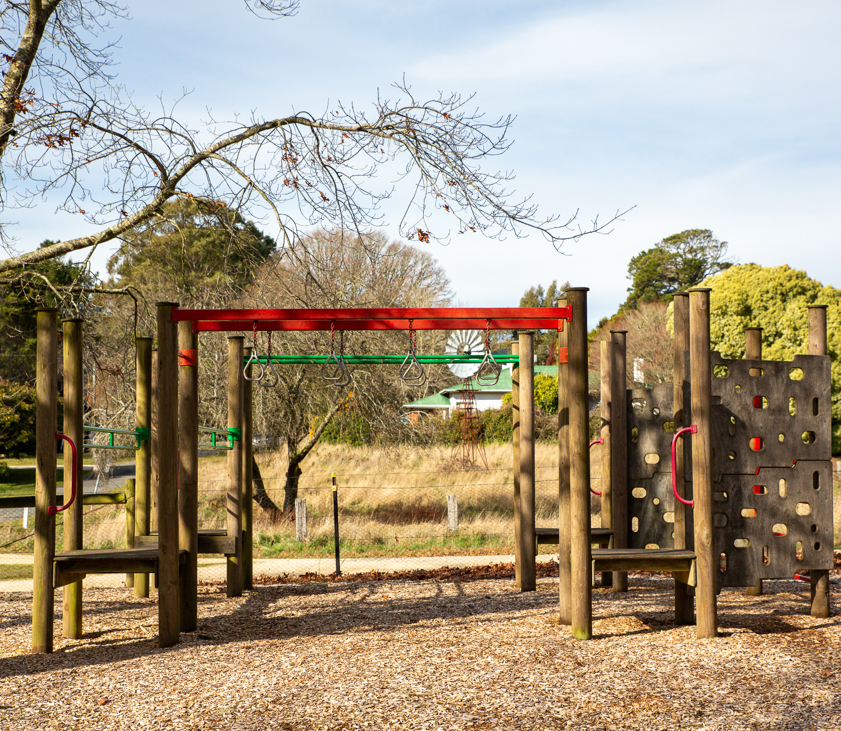
Asset Plan 2025-2035

May 2025

Acknowledgement of Country
Hepburn Shire Council acknowledges the Dja Dja Wurrung as the Traditional Owners of the lands and waters on which we live and work.
On these lands, Djaara have performed age-old ceremonies of celebration, initiation and renewal.
We recognise their resilience through dispossession, and it is a testament to their continuing culture and tradition, which is strong and thriving.
We also acknowledge the neighbouring Traditional Owners, the Wurundjeri to our south-east and the Wadawurrung to our south-west and pay our respect to all Aboriginal peoples, their culture, and lore.
We acknowledge their living culture and the unique role they play in the life of this region.
Contents
Introduction 5
Our assets on a page 6
Overview 7
The purpose of the plan 7
Integrated Strategic Planning and Reporting Framework 8
What is asset management? 9
Why is asset management important? 9
Strategic context 11
Links with Council Plan 11
Asset management planning 13
Lifecycle approach to asset management 13
Our community’s role 15
Asset plan engagement 15
Our engagement commitment 15
Community engagement outcomes 16
How we manage our assets 18
Our assets support our services 18
What assets are covered in this plan? 18
Levels of service 19
Asset condition 19
The state of our assets 21
Funding for the future 23
Integration with the Long-Term Financial Plan 23
Demand management 23
Our asset investment strategies 24
Asset investment categories 24
Lifecycle Investment Profile 25
Asset class details 27
Bridges and major culverts 27
Buildings and structures 29
Recreation and open space 31
Roads, paths and kerb 33
Stormwater and drainage 35
Monitoring and improvement 37
Plan review 37
Reporting 37
Continuous improvement 37
Appendices 39
Appendix 1: Long Term Investment Plan (Maintenance and Renewal) 39
Appendix 2: Asset Management Maturity Improvement Plan 40
Appendix 3 Our Asset Story 42

Introduction
Hepburn Shire Council manages public assets with a total replacement value of over $500m, for the benefit of its community. As our Shire grows and changes, our existing infrastructure ages and demands change for services.
To determine what we can afford, we must understand how population growth and challenges like climate change impact long term maintenance and renewal. As assets degrade and community expectations change, we must balance economic, social, cultural and environmental factors, all within a finite budget.
This ensures our assets support the services and amenities that our community needs both now and in the future, providing sustainable benefits for all residents.
For the purpose of this plan, ‘assets’ refers to the portfolio of public assets that Council is responsible for managing, grouped as follows:
- Bridges and major culverts
- Buildings and structures
- Recreation and open space
- Roads, paths and kerb
- Water and drainage
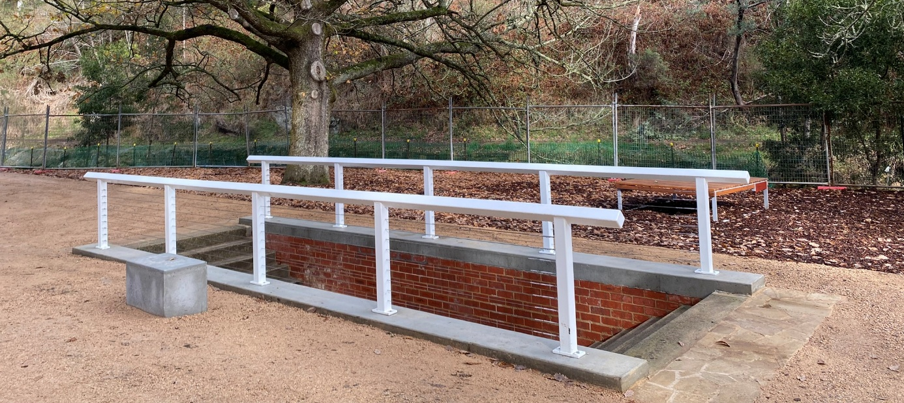

Our assets on a page
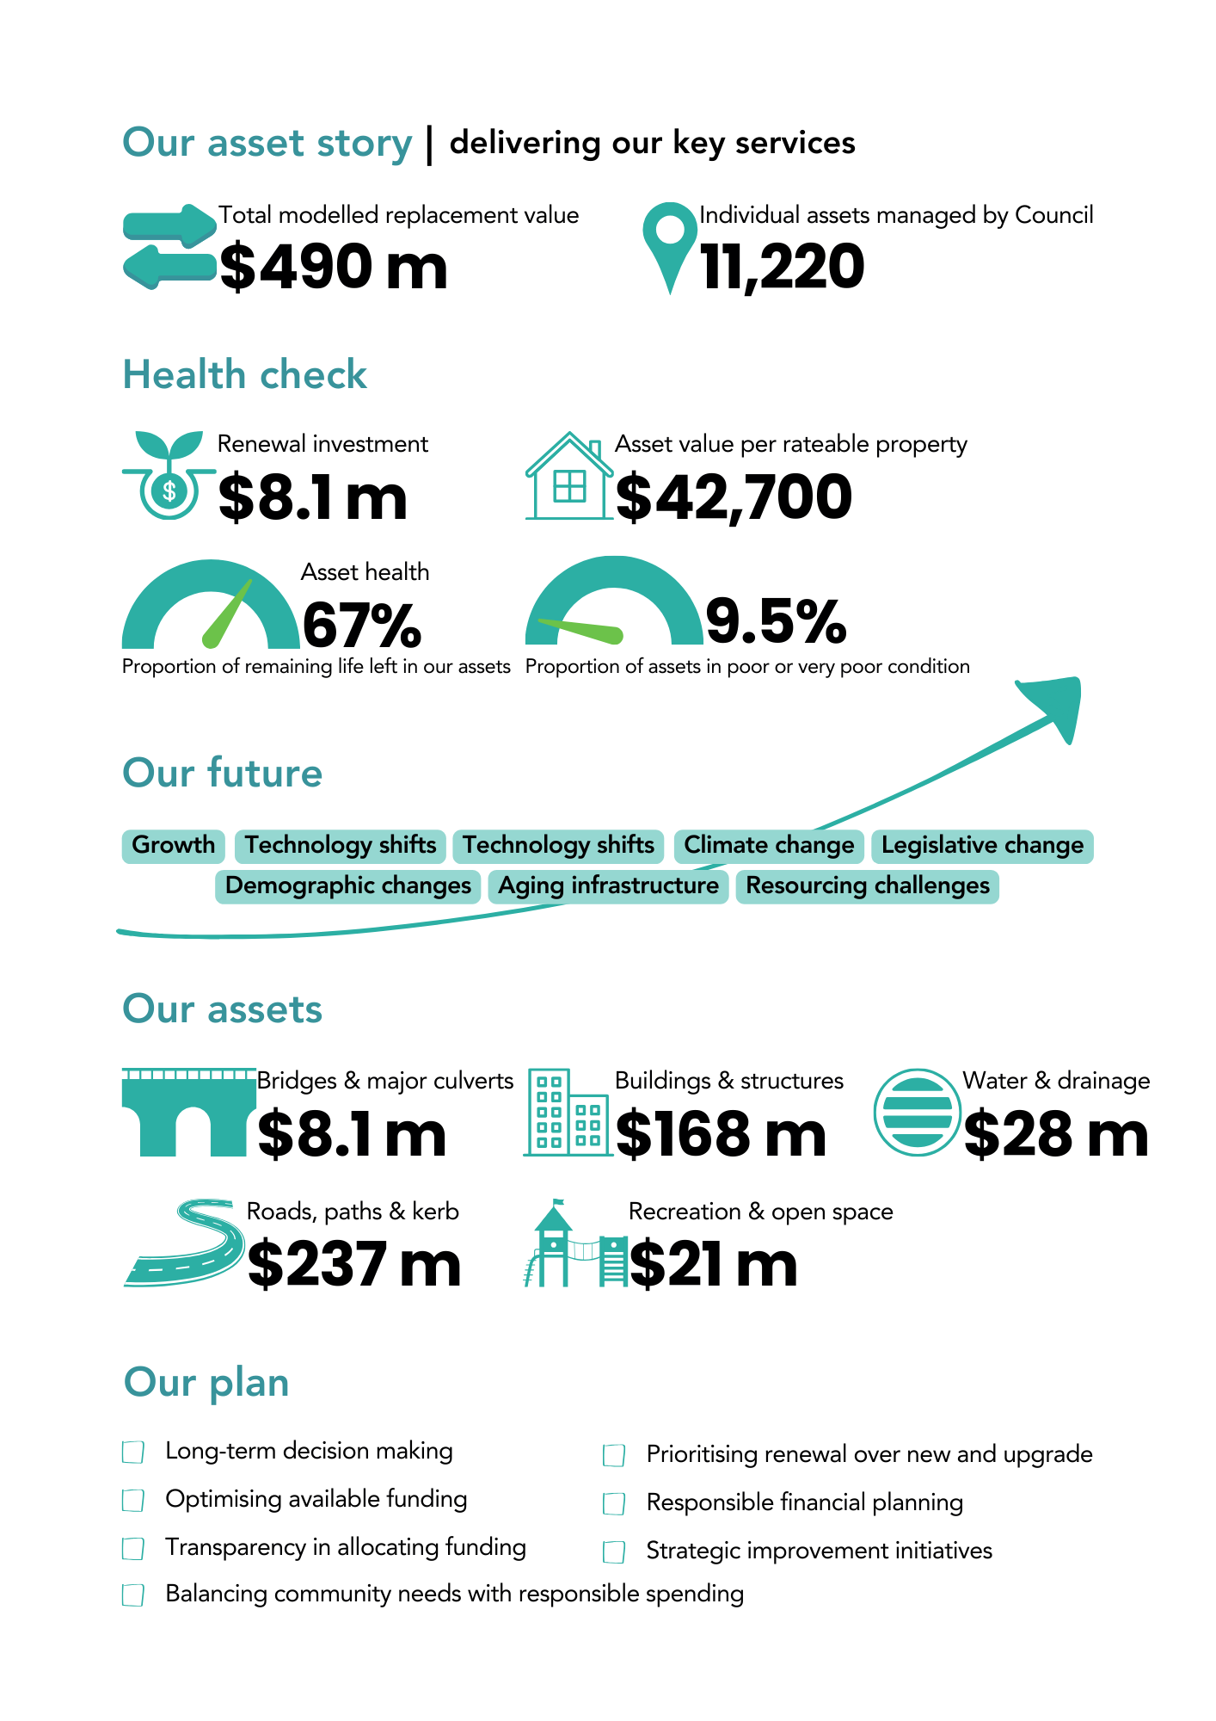
Figure 1. Our asset story – Converted to text version available in Appendix 3.

Overview

The purpose of the plan
The purpose of this Asset Plan is to outline Hepburn Shire Council’s commitment to best practice asset management and provide principles for sound asset investment decision making.
The Asset Plan provides a comprehensive strategy for managing public assets over the next decade and beyond, ensuring sustainable stewardship for current and future generations. It is a public facing document which informs the community on how Council will manage assets to achieve the Community Vision.
‘An inclusive rural community located in the Dja Dja Wurrung Country where all people are valued, partnerships are fostered, environment is protected, diversity is supported, and innovation embraced.’
The plan details how we will optimise capital and maintenance requirements, balance new assets and growth, with current infrastructure, to deliver services in line with evolving community needs and expectations.
Our aim is to support consistent, evidence-based decision-making, engage community and Council is asset management performance reporting, improve links between costs and levels of service, articulate our challenges and risks – all of which will result in more informed community engagement and best use of Council assets, in the interests of the community.
The Asset Plan addresses the challenges of balancing economic, social, cultural and environmental factors, within a finite budget.
The plan provides expenditure forecasts that will guide future maintenance and renewal programs, and the delivery of capital projects, impacting long-term financial planning and annual budgets.
Council’s Financial Vision, Financial Plan and this Asset Plan are developed on the following financial principles:
- Capital investment will prioritise and focus on the renewal, management, and maintenance of existing assets.
- A ‘grant funding reserve’ will be created and funded to support the Council’s co-contribution towards grant funding aimed at community infrastructure.
- Council will continue to plan appropriately for larger, generational infrastructure, noting that funding of these assets would be considered on a case-by-case basis and will likely require significant government grant funding.

Integrated Strategic Planning and Reporting Framework
The Integrated Planning and Reporting Framework sets out the range of strategic documents Council is required to adopt under the Local Government Act 2020. The framework sets out Hepburn Shire’s integrated approach to planning, monitoring, and performance reporting.

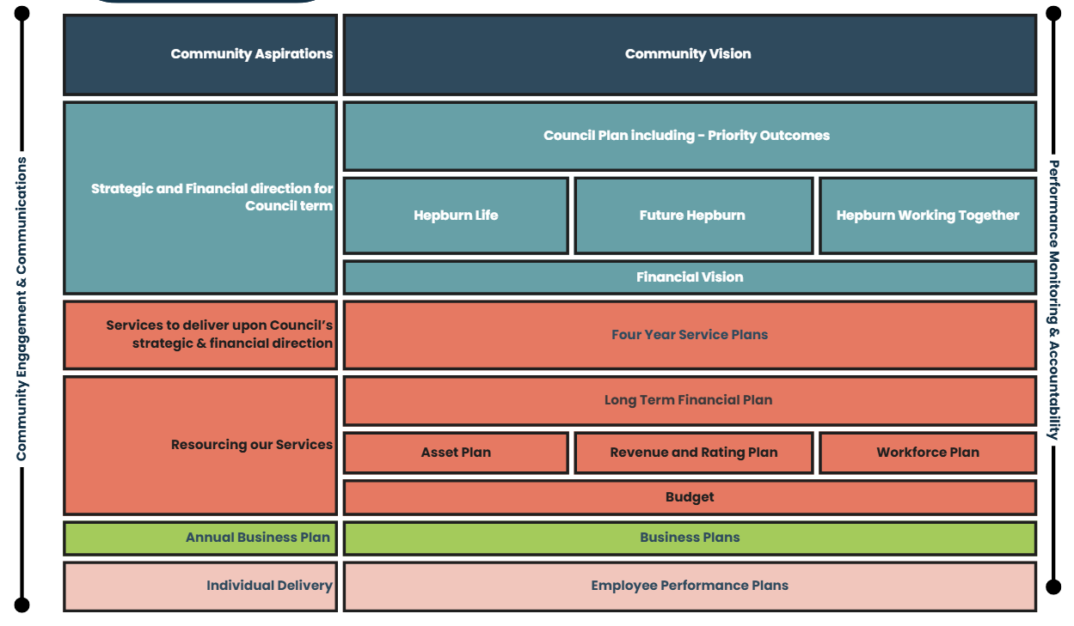

Layer | Description | Documents
Community aspirations | Community aspirations are set out in our Community Vision. | Community Vision
Strategic direction | The strategic and financial direction and priorities across the Council term. | Council Plan and Financial Plan
Council services | Services that will deliver upon Council’s strategic and financial priorities. | Service Catalogue and Service Map
Resourcing | How we will resource our services to deliver Council’s strategic and financial priorities. | Financial Plan, Asset Plan, Workplace Plan and Annual Budget
Annual business plan | The projects and initiatives funded through the annual budget, which will deliver on Council’s strategic and financial priorities. | Annual Plan
Individual delivery | Budget that will deliver on Council’s strategic and financial priorities. Individual employee plans that align our Council officer’s role and responsibilities to Council’s strategic and financial priorities. | Employee Performance Plans

What is asset management?
A systematic approach to guide the planning and design, creation and acquisition, maintenance and operations, renewal, and rationalisation and disposal of assets to balance available funds with community needs and service delivery.

Why is asset management important?
Our community expects assets to be provided to a standard that ensures public safety, amenity and accessibility, and to support the delivery of quality services and programs. Over time, our community needs and expectations change, with demographics, climate and technology constantly evolving.
We need to balance delivering what our community needs and expects with what we can afford. With a finite budget for investment in assets, a planned and measured approach to asset management is necessary to ensure long-term outcomes and a fiscally prudent financial plan.

‘We are focused on making well-informed decisions by using the data available to us and really listening to our community. Being open, accountable and always looking for ways to do better are key to how we work.’
Cr Don Henderson, Mayor

‘We are creating a long-term investment plan, to ensure our assets meet the needs of the current and future community, and support the delivery of the key services that our people rely on.’
Bradley Thomas, CEO
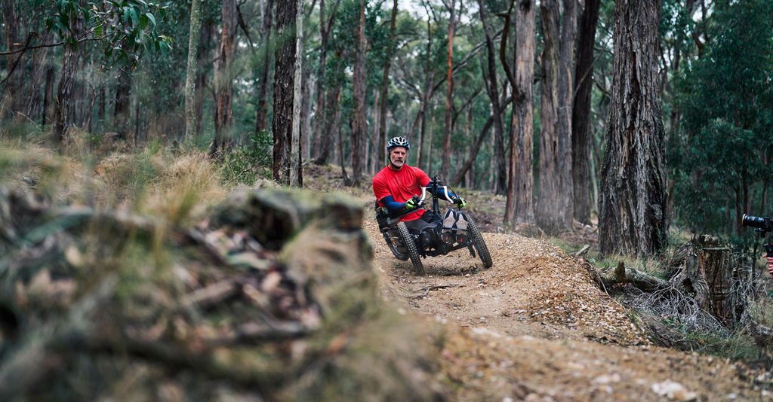

Strategic context

Links with Council Plan
The Council Plan provides the strategic framework that guides Council’s planning and decision-making over the current Council term. It sets a clear direction for how the Council will work towards delivering long-term community aspirations while responding to current priorities and challenges.
The framework of the Council Plan is structured around five key components:
- Community Vision: a long-term vision that outlines the aspirations of the Hepburn Shire community.
- Domains: broad areas outlining the strategic direction and priorities across the Council term.
- Outcomes: the outcomes Council is seeking to achieve across the Council term, reflecting the change or benefit to community, environment or organisation.
- Strategies: key approaches, actions and initiatives that will drive progress towards achieving the outcomes. These strategies guide projects, policies, decision making and the budget across the Council term
- Indicators: How we will monitor progress across the Council term in achieving the outcomes.
Each element of the Council Plan plays a vital role in shaping the future of the Shire. Together, they provide a roadmap for meaningful action and measurable progress.

The Council Plan 2025-29 is developed around three domains and nine strategies. The Domains and Strategies are included below:

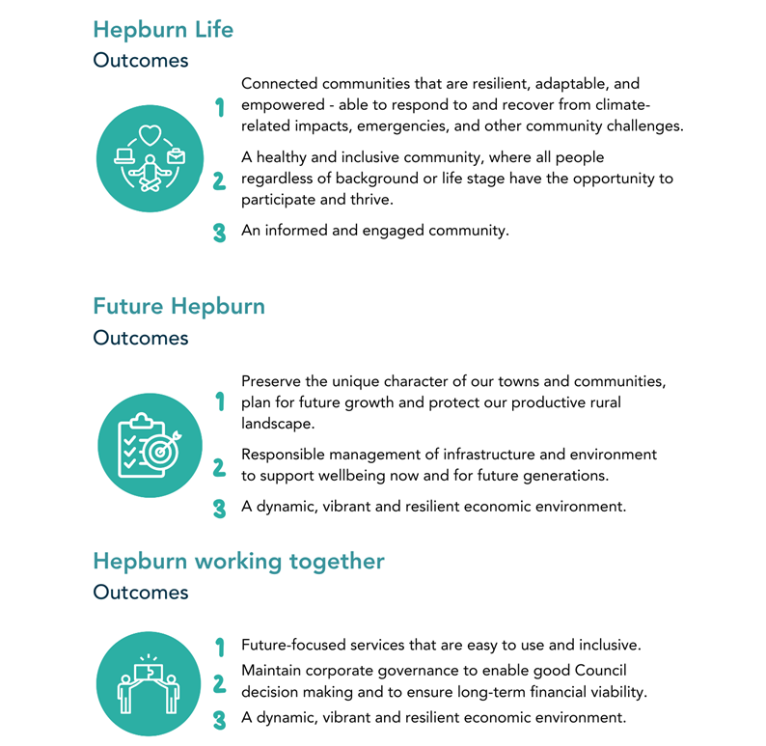

The Asset Plan links across all focus areas but is particularly aligned with the strategy responsible management of infrastructure and environment to support wellbeing now and for future generations, which includes the following:
- Deliver capital renewal programs that align with long-term planning and priorities and are adaptive to community needs.
- Advocate and plan for capital projects and ensure that all planning and infrastructure decisions consider long-term impacts on community and the environment.
- Provide inclusive, adaptable community infrastructure that strengthens local connections, adapts to changing climates, and incorporates high-quality design principles.
- Review and manage a portfolio of assets that is financially responsible.

Asset management planning
To ensure we get the best possible return on our asset spending, we take a lifecycle approach to asset management that considers the costs of an asset over its useful life – that is, from the time a new asset is built or acquired, to the time it is replaced or disposed of. This approach allows us to get the most out of our assets by meeting agreed levels of service in the most cost-effective way.
Council’s asset management practices are also governed internally by the Asset Management Policy and supporting documents. The process is further supported by enablers such as technology, data, processes and people, and is informed by key corporate and strategic documents. Council’s Asset Management Framework is outlined below.
<Add infographic here, summarising the Asset Management Framework>

Lifecycle approach to asset management
- Planning and design

Identifying community requirements, assessing options, and developing asset solutions that align with long-term service goals and other factors such as sustainability, equity, accessibility, maintenance and operational costs.

- Creation and acquisition

Assets are constructed, purchased, or otherwise acquired to meet planned service requirements and support community infrastructure. Alternative service delivery or strategic partnerships should also be considered in the early lifecycle phases.

- Maintenance and operation

Assets are actively used to deliver services with ongoing maintenance to ensure they remain safe, functional and cost effective. A program of proactive inspections, maintenance and servicing is undertaken to minimise ongoing costs and risk, and to better understand the changing state of our assets.

- Renewal and upgrade

Once they have reached their intervention state – that is, that they no longer support the required level of service delivery – existing assets are refurbished, replaced or enhanced to extend their life, improve performance, or meet changing service demands.

- Rationalisation and disposal

Assets that are no longer needed, are underperforming, or are beyond repair are decommissioned, sold, or repurposed to optimise value and reduce costs.

<Add infographic here, summarising the asset lifecycle>

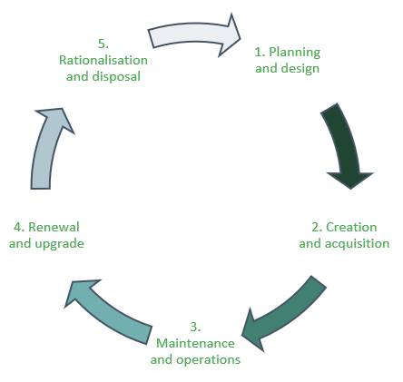

Our community’s role

Asset plan engagement
We are committed to transparent decision-making and actively involve the community in shaping the services and assets that support Hepburn Shire now and into the future. In line with the Local Government Act 2020, we seek community feedback at key points in our planning processes.
To support this, Council launched the Hepburn Together initiative to update the Community Vision, Financial and Asset Plans, and develop a new four-year Council Plan. Delivered in partnership with Conversation Co, the initiative included four community workshops held between March and April 2025, one with a primary focus on asset management and Council’s Asset Plan.
A Deliberative Engagement Panel was appointed, representing the diversity in the Hepburn community. The panel met and workshopped a range of asset management scenarios and provided their views and feedback.

A broader online survey was also conducted, with responses received from 301 community members.

Our engagement commitment
These guiding principles are applied at each point in our asset management planning process, in line with our commitment to a best practice approach to community engagement and Council’s Community Engagement Policy.
Hepburn Shire promises to:
- Ensure community access to engagement processes is as broad as possible
- Use simple and clear language when we communicate
- Actively listen without judgement to what people say
- Respect diverse views and request mutual respect between all parties
- Value the creativity and expertise of the community in our decision making and problem solving
- Ensure all contributions are recorded
- Report back to the community on what we heard
- Base the engagement framework on community recommendations to the greatest extent possible
- Provide feedback on where input has not been incorporated into the outcome and explain the reasons for our decision
- Measure and assess the effectiveness of our community engagement practices and commit to ongoing continuous improvement and innovation
There are many opportunities for members of the community to inform and influence decisions about our assets and services, including:
- Annual community satisfaction survey
- Annual budget consultation and public exhibition processes
- Specific project or strategy consultation processes
- Council meetings
- Community forums
- Digital platforms
- Customer service requests (multiple channels)

Community engagement outcomes
As part of the deliberation workshops, the community panel was asked to participate in various activities and responded to a series of questions relating to asset management. These same questions were replicated in the wider community survey.
The detailed results can be viewed on Council’s Participate Hepburn page, however the key themes have been summarised below.
<Add infographic here, summarising the engagement outcomes>
- Most respondents supported reducing some services to improve others.
- The majority would like to see Council build in line with best practice, considering environmental and sustainability factors, rather than using the most cost-effective method. Some responses supported a mix of both methods, however there was little support for priortising cost savings over best practice.
- Most supported investing in assets where it is needed, rather than evenly across the Shire, with some preferring a mix of both methods.
- Most supported a mix of prioritising assets that are used by many people, with assets that support specific activities, even if they are only used by a few.
- The majority agreed that Council should prioritise its existing assets, and that it should only consider building new assets if one or more of the following applied:
  - There was significant grant funding available.
  - The new build led to a reduction in ongoing costs.
  - The new asset would support the delivery of multiple existing services.
  - The new asset fills an asset gap or service need.
- A range of principles should be considered when rationalising assets, with the major consideration being that the asset is not fit for purpose and/or renewal could be cost prohibitive.
- The top five assets ranked as most important were:
  - Sealed roads
  - Passive parks
  - Unsealed roads
  - Footpaths
  - Trees

How we manage our assets

Our assets support our services
Our assets—both natural and built, old and new—are essential to the services and quality of life in our community. They support safe, vibrant places to live, work, and play. As these assets age or become outdated, we must carefully manage resources to maintain them, ensuring they continue to benefit current and future generations while supporting long-term financial sustainability.

What assets are covered in this plan?
For the purpose of this plan, ‘assets’ refers to the portfolio of public assets that Council is responsible for managing. The table below provides an overview of those assets, grouped according to their services and functions for ease of management.
Bridges & Major Culverts | Buildings & Structures | Recreation & Open Space | Roads, Paths & Kerb | Water & Drainage
Structures that facilitate the flow of vehicular or pedestrian traffic over an obstruction such as a road or body of water. | The locations that provide safe, functional and accessible spaces to support the delivery of recreational, cultural or social activities. | The locations and environments we frequent while enjoying the natural surroundings or engaging in recreational activities. | The infrastructure needed for movement, within and between our townships and beyond, whether by vehicle, bike or as a pedestrian. | The infrastructure we need to direct stormwater run-off, mitigate flooding and improve water quality.
Includes road bridges, pedestrian bridges, jetties, boardwalks, and major culverts. | Includes community centres, municipal offices, libraries, preschools, sports pavilions and other buildings that house community services, public toilets, sheds and shelters. | Includes elements located within parks and open space areas such as garden beds, fences, playgrounds, sporting fields, playing surfaces, lighting, irrigation, and aquatics. | Includes sealed roads, unsealed roads, carparks, footpaths and shared paths, trails, kerb and channel. | Includes pits, pipes, major channels, culverts, end walls, and gross pollutant traps.

Levels of service
Our levels of service are defined by our expectation of the standards at which an asset needs to perform. This considers Technical Levels of Service (i.e., performance-based standards set by asset engineers and asset managers), Community Levels of Service (i.e., service standards that are in line with community expectations) and Legislative Requirements (i.e., mandatory compliance standards set by laws, regulations or industry codes). We define our service levels with respect to asset health (condition), utilisation and criticality of the service.

Asset condition
Council undertakes a program of proactive inspections for assets, typically between 3 and 5 years for all asset classes, and apply a 1 to 5 rating system (IPWEA, 2015) as shown below.
<Add infographic here, summarising the condition rating system>
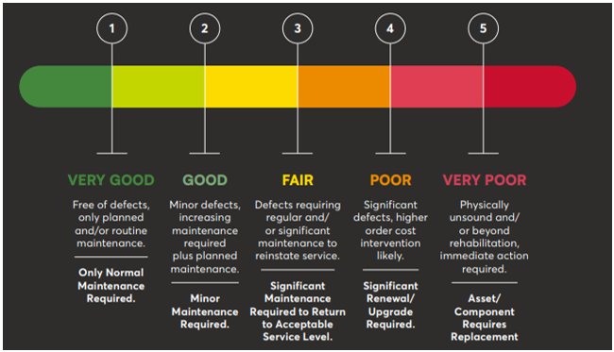

Figure: Asset Condition Assessment Rating Scale

The state of our assets
Asset health is a measure of the remaining useful life of each asset portfolio. The below provides an overview of the current health by asset class for Hepburn’s assets, based on the data currently available.
<Add infographic here, summarising asset health by class>
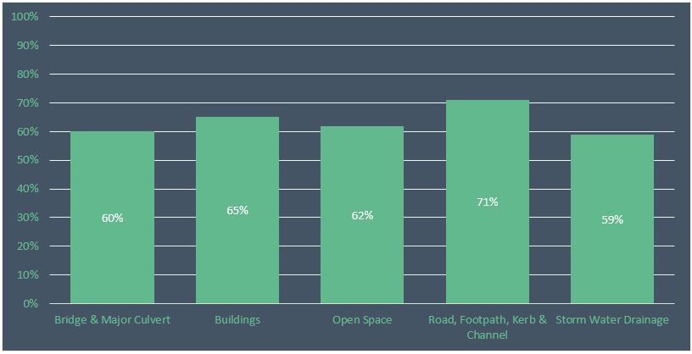

Figure: Asset Health (% Remaining Life) by Asset Class as at 30 June 2024

The overall health of Council’s asset portfolio is 67%, which is above the national average of 65% (taken from the 2024 National State of the Assets Report by the Australian Local Government Association).
Within each asset class, there is a distribution of assets in very good, through to very poor condition. The current distribution is shown below.
<Add infographic here, summarising condition distribution by asset class>

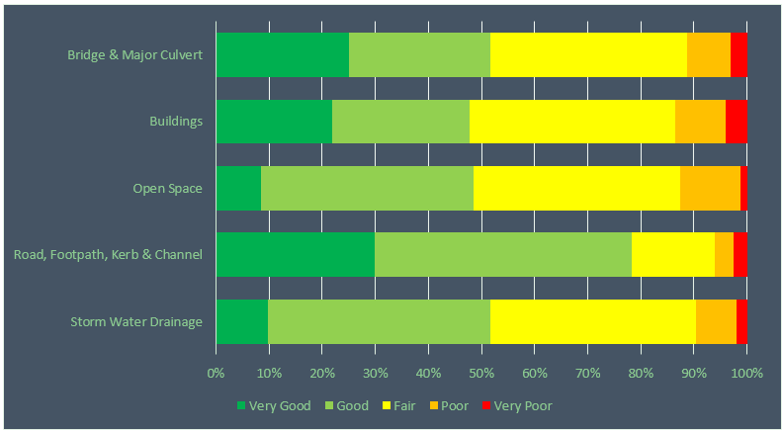

Figure: Condition distribution as a % of replacement cost as at 30 June 2024

The majority of Council assets are in Good or Very Good condition (63%). The percentage of assets in Poor or Very Poor condition is currently 9.5%. This is slightly higher than the national average of 8% (taken from the 2024 National State of the Assets Report by the Australian Local Government Association).

Funding for the future
To ensure responsible and sustainable stewardship of our assets, we are committed to balancing our community’s needs and aspirations with what is affordable for ratepayers.
Making decisions about funding requires ongoing balancing of service levels, risk and the need to adequately maintain and renew assets. Our aim is to achieve long-term asset sustainability.

Integration with the Long-Term Financial Plan
The balance between maintaining and renewing our assets and accommodating funding for improvement and growth is a constant challenge – underfunding asset renewal can lead to lower levels of service, increased risk, and deferring important upgrades can result in assets that are no longer fit for purpose.
Maintaining integration between our Asset Plan and Long-Term Financial Plan is key to ensuring that future funding is allocated in a way that supports service delivery and effective asset management.
The funding requirements identified for each asset class have been allocated in Council’s Long Term Financial Plan. Forecasts included in this Asset Plan for projected asset expenditure are consistent with our financial plan and cover the planned asset activities over the next ten years. This will require future monitoring and further analysis as new asset information becomes available, such as updated asset condition data. Where funding requirements change, this will be reflected in both this Asset Plan and the Long-Term Financial Plan.

Demand management
Forecasting future demand is essential in determining lifecycle management for assets. The management of Council assets is directly affected by both growth in the number of assets and growth in the resident as well as visiting populations. Drivers affecting asset demand include factors such as population change, changes in demographics, technological changes and environmental changes. Council’s infrastructure assets must continue to serve both the needs of the local resident population as well as the needs of business industries, tourism, commuters and visitors.

Our asset investment strategies
Looking ahead to the next ten years, our approach is to be prudent in our investment decisions, using a holistic lifecycle approach, and prioritising asset renewal.
Investment in asset maintenance and renewal will be balanced by investment in new and upgraded assets when Council’s investment can be leveraged against external funding opportunities or provide a substantial outcome.
Our asset investment strategies align with our asset management and financial planning principles. We aspire to:
- Optimise asset life through timely and effective intervention
- Continue to place a high priority on renewing our ageing assets
- Manage the impacts of growth and change by being strategic in how we plan for our future asset needs
- Comply with our obligations by actioning legislated standards in asset planning
- Provide affordable services by balancing community needs and aspirations with available resources
- Build resilient assets that not only deliver the best outcome for our community, but also the best outcome for the environment

Asset investment categories
For the purpose of this plan, our asset spending is categorised in a way that supports planning budgets and monitors how we spend money on assets and services.
Expenditure Type | Asset Management Activity | Description | Spend Type
Recurrent costs | Maintenance | Ongoing expenditure required to keep an asset performing at the required level of service. | Non-discretionary
Recurrent costs | Operating | Ongoing expenditure required to provide a service from/using an asset. | Non-discretionary
Renewal costs | Renewal | Expenditure required to return the condition of an asset to near its original state. | Non-discretionary
Growth costs | Upgrade | Expenditure required to make improvements to an existing asset to enable a higher service level. | Discretionary
Growth costs | Expansion | Expenditure required to extend or expand an existing asset to provide a service to a new group of users at the standard currently as existing users. | Discretionary
Growth costs | New | Expenditure required to create a new asset, to provide a service that does not currently exist at this location. | Discretionary

Lifecycle Investment Profile
A detailed breakdown of what we expect to spend on each asset class over the next ten years is outlined within the individual class profiles further in this plan and are summarised across the portfolio in detail in Appendix 1.
The table below summarises the adopted 10-year expenditure by asset class for 2025-35.
Asset Class | Maintenance  $’000 | Renewal  $’000 | Total  $’000
Bridges & Major Culverts | 586 | 4,407 | 4,993
Buildings & Structures | 5,437 | 12,671 | 18,108
Recreation & Open Space | 25,028 | 9,066 | 34,094
Roads, Paths & Kerb | 37,729 | 58,888 | 96,617
Water & Drainage | 782 | 1,344 | 2,126
Total | 69,562 | 86,376 | 155,938

Asset class details

Bridges and major culverts
<Add infographic here summarising details below>

Assets included: Road bridges, pedestrian bridges, jetties, boardwalks, and major culverts.
Level of confidence in our data: Medium-High
Our work involves:
Recurrent | Renewal | Growth
- Maintenance and repair  - Operational servicing such as cleaning  - Safety, compliance and condition inspections | - Replacement of components to an equivalent current day standard | - Newly constructed or gifted assets (development)  - Widening and/or extension of existing

How is funding prioritised?
This funding is informed by strategic modelling that predicts the deterioration of our bridge assets and the impacts of various funding scenarios on future asset conditions. Other recurrent costs such as inspections and maintenance are determined by other policies and operational plans.
Detail on proposed future projects can be found in Council’s annual and long-term Capital Works Programs.
How much do we plan to spend over the next ten years?
Projected expenditure ($’000)
Expenditure | ‘25 | ‘26 | ‘27 | ‘28 | ‘29 | ‘30 | ‘31 | ‘32 | ‘33 | ‘34 | Total
Recurrent | 52 | 54 | 55 | 56 | 58 | 59 | 61 | 62 | 64 | 65 | 586
Renewal | 276 | 236 | 1,077 | 248 | 255 | 261 | 267 | 1,218 | 281 | 288 | 4,407
Total | 328 | 290 | 1,132 | 304 | 313 | 320 | 328 | 1,280 | 345 | 353 | 4,993

Table: Projected expenditure 2025-35.

Future challenges and opportunities
Population | Increased use | Environment | Legislation
- Increased demand on bridges due to population and traffic growth | - Faster deterioration of bridges due to increased traffic, particularly heavy vehicles | - Increased damage due to extreme weather events  - Consideration of resilience in design | - Compliance with legislative requirements and adherence with safety standards  - Rapid advancement in safety standards

Buildings and structures
<Add infographic here summarising details below>
Assets included: Community centres, municipal officers, libraries, preschools, sports pavilions, public toilets, sheds and shelters.
Level of confidence in our data: Medium
Our work involves:
Recurrent | Renewal | Growth
- Maintenance and repair due to fault, failure or vandalism  - Operational servicing such as cleaning  - Safety, compliance and condition inspections | - Major structural repairs  - Replacement of components such as cladding or systems  - Kitchen or bathroom replacement | - Building extensions  - Sustainability improvements  - New building construction

How is funding prioritised?
This funding is informed by strategic modelling that predicts the deterioration of our building assets and the impacts of various funding scenarios on future asset conditions. Growth is driven by strategic objectives and external funding opportunities. Other recurrent costs such as inspections and maintenance are determined by other policies and operational plans.
Detail on proposed future projects can be found in Council’s annual and long-term Capital Works Programs.
How much do we plan to spend over the next ten years?
Projected expenditure ($’000)
Expenditure | ‘25 | ‘26 | ‘27 | ‘28 | ‘29 | ‘30 | ‘31 | ‘32 | ‘33 | ‘34 | Total
Recurrent | 485 | 497 | 510 | 523 | 536 | 549 | 563 | 577 | 591 | 606 | 5,437
Renewal | 2,212 | 1,051 | 1,077 | 1,104 | 1,131 | 1,160 | 1,189 | 1,218 | 1,249 | 1,280 | 12,671
Total | 2,697 | 1,548 | 1,587 | 1,627 | 1,667 | 1,709 | 1,752 | 1,795 | 1,840 | 1,886 | 18,108

Table: Projected expenditure 2025-35.

Future challenges and opportunities
Population | Financial | Environment | Legislation
- The need to improve accessibility for all communities  - The need to meet diverse and often competing demand for facilities | - The need to maximise the use of existing facilities and manage assets that are surplus to need  - Unplanned maintenance liability associated with facilities that community groups are no longer able to manage | - Increased damage due to extreme weather events  - Challenge of meeting net zero targets  - Ageing infrastructure and heritage considerations | - Compliance with legislative requirements and adherence with safety standards

Recreation and open space
<Add infographic here summarising details below>
Assets included: Garden beds, fences, playgrounds, sporting fields and playing surfaces, reserve lighting, irrigation, aquatics.
Level of confidence in our data: Low-Medium
Our work involves:
Recurrent | Renewal | Growth
- Hazard and defect inspections  - Mowing, vegetation control and garden maintenance  - Litter collection and cleaning  - Graffiti removal | - Replacement of playground equipment, parks furniture, sporting assets such as goals  - Renovation of playing courts or fields | - Playing court extension  - Expansion of a playground  - Development of a park of reserve

How is funding prioritised?
This funding is informed by strategic modelling that predicts the deterioration of our open space assets and the impacts of various funding scenarios on future asset conditions. Growth is driven by strategic objectives, external funding opportunities and development. Other recurrent costs such as maintenance are determined by other policies and operational plans.
Detail on proposed future projects can be found in Council’s annual and long-term Capital Works Programs.
How much do we plan to spend over the next ten years?
Projected expenditure ($’000)
Expenditure | ‘25 | ‘26 | ‘27 | ‘28 | ‘29 | ‘30 | ‘31 | ‘32 | ‘33 | ‘34 | Total
Recurrent | 2,234 | 2,290 | 2,347 | 2,406 | 2,466 | 2,527 | 2,591 | 2,655 | 2,722 | 2,790 | 25,028
Renewal | 1,439 | 594 | 501 | 761 | 586 | 1,034 | 753 | 1,411 | 981 | 1,006 | 9,066
Total | 3,673 | 2,884 | 2,848 | 3,167 | 3,052 | 3,561 | 3,344 | 4,066 | 3,703 | 3,796 | 34,094

Table: Projected expenditure 2025-35.

Future challenges and opportunities
Population | Provision | Environment | Participation
- Increased demand for open spaces within close proximity to where people live | - Increased expectation for the provision of more spaces | - Need to ensure future open space assets are designed to utilise sustainable materials and practices | - Increased demand for specific recreation facilities

Roads, paths and kerb
<Add infographic here summarising details below>
Assets included: Sealed roads, unsealed roads, car parks, footpaths and shared paths, trails, kerb and channel.
Level of confidence in our data: High
Our work involves:
Recurrent | Renewal | Growth
- Maintenance and repairs to roads such as patching potholes, crack sealing and path grinding  - Operational servicing such as street sweeping, vegetation management and weed spraying  - Routine grading of unsealed surfaces | - Resurfacing of existing roads  - Road reconstruction or major patching of road failures  - Replacement of sections of existing pathways to an equivalent standard | - New constructed and gifted assets by developers  - Widening or duplication of existing roads  - Traffic calming treatments such as construction of roundabouts, installation of speed humps, etc  - Extension of existing pathway network to address gaps in connectivity

How is funding prioritised?
This funding is informed by strategic modelling that predicts the deterioration of our road assets and the impacts of various funding scenarios on future asset conditions. The model incorporates factors such as hierarchy, use, and criticality to ensure that most important assets are maintained at a high level of service, which helps reduce risk and improve safety for the community.
Growth is driven by strategic objectives, external funding opportunities and development. Other recurrent costs such as maintenance are determined by other policies and operational plans.
Detail on proposed future projects can be found in Council’s annual and long-term Capital Works Programs.
How much do we plan to spend over the next ten years?
Projected expenditure ($’000)
Expenditure | ‘25 | ‘26 | ‘27 | ‘28 | ‘29 | ‘30 | ‘31 | ‘32 | ‘33 | ‘34 | Total
Recurrent | 3,368 | 3,452 | 3,538 | 3,627 | 3,717 | 3,810 | 3,905 | 4,003 | 4,103 | 4,206 | 37,729
Renewal | 6,589 | 5,034 | 4,783 | 5,646 | 4,888 | 5,061 | 5,239 | 6,623 | 7,438 | 7,587 | 58,888
Total | 9,957 | 8,486 | 8,321 | 9,273 | 8,605 | 8,871 | 9,144 | 10,626 | 11,541 | 11,793 | 96,617

Table: Projected expenditure 2025-35.

Future challenges and opportunities
Population | Freight | Environment | Legislation
- Increased demand on local roads and their connections with arterial networks due to population growth and increased dwelling density | - Increased deterioration of the road network due to increased heavy vehicle traffic | - Lack of availability of sustainable transport options, including public transport  - Increased damage to assets due to more frequent and extreme weather events  - Need to consider resilience in design | - The need to ensure compliance with current day legislation  - Need to meet the requirements of our Road Management Plan

Stormwater and drainage
<Add infographic here summarising details below>
Assets included: Pits, pipes, major channels, culverts, end walls, and gross pollutant traps.
Level of confidence in our data: Medium
Our work involves:
Recurrent | Renewal | Growth
- Pit cleaning  - Pipe cleansing and removal of debris, sediment, etc.  - Removal of litter from gross pollutant traps  - Programmed inspections | - Replacement of pits and pipes | - Replacement of pipes to a higher hydraulic capacity  - Extension of the storm water drainage network  - Installation of storm water quality improvement devices, such as rain gardens, litter traps, etc.  - Storm water harvesting initiatives

How is funding prioritised?
This funding is informed by strategic modelling that predicts the deterioration of our water assets and the impact of various funding scenarios on future asset conditions. The model incorporates factors such as criticality to ensure that most important assets are maintained at a high level of service, which helps reduce risk across the network.
Growth is driven by strategic objectives, external funding opportunities and development. Other recurrent costs such as maintenance are determined by other policies and operational plans.
Detail on proposed future projects can be found in Council’s annual and long-term Capital Works Programs.
How much do we plan to spend over the next ten years?
Projected expenditure ($’000)
Expenditure | ‘25 | ‘26 | ‘27 | ‘28 | ‘29 | ‘30 | ‘31 | ‘32 | ‘33 | ‘34 | Total
Recurrent | 70 | 72 | 73 | 75 | 77 | 79 | 81 | 83 | 85 | 87 | 782
Renewal | 320 | 103 | 106 | 108 | 111 | 114 | 116 | 119 | 122 | 125 | 1,344
Total | 390 | 175 | 179 | 183 | 188 | 193 | 197 | 202 | 207 | 212 | 2,126

Table: Projected expenditure 2025-35.

Future challenges and opportunities
Development | Financial | Environment | Sustainability
- The need to upgrade the capacity of our existing drainage network to mitigate flooding  - The need to implement storm water quality improvement initiatives to protect receiving waterways affected by continued urban consolidation | - The need to upgrade some of our older drainage assets that are currently under capacity to improve flood immunity  - The ability to fund the timely renewal and upgrade of drainage assets that are in poor condition | - The need to deal with more frequent and extreme flooding events  - The increase in rainfall intensity | - The increased need to provide infrastructure for the capture, treatment and reuse of storm water to enable us to make use of storm water run-off as a sustainable resource

Monitoring and improvement
Asset planning is not a set and forget process. It needs to be flexible to ensure our assets and services levels are responsive to change, can capitalise on emerging trends, and continue to meet agreed requirements as priorities change over time.

Plan review
This Asset Plan will be formally reviewed and updated every four years in line with the Local Government Act, to provide opportunities for the new Council to make any required adjustments.
Interim reviews may be undertaken to provide the opportunity to reflect improvements achieved, major financial decisions made, the impact of any external factors or changes to long-term capital works programs, to ensure the plan is responsive to our available financial resources over time.

Reporting
Reporting on service levels and other performance measures is undertaken as part of Council’s Annual Report.
The following measures are included in the Council Plan 2024-29:
- Complete at least 85% of annual capital works projects (number of projects).
- Implementation of asset management improvement actions in accordance with Council’s adopted Asset Plan.

Continuous improvement
The financial analysis and projections in this plan are based on existing data, processes, systems and standards. Council is committed to identifying ways to achieve more robust evidence base and to improving our practices to achieve this. Critical to this will be continued engagement with our community to establish optimised service levels that are affordable over the long term.
We acknowledge that significant annual expenditure is required to manage and maintain our existing infrastructure. This highlights the importance of maintaining high-level practices to ensure services are delivered economically and sustainably, and Council is committed to continuously working to improve our knowledge, skills and operational practices in line with sector wide best practice.
An Asset Management Maturity Audit has been conducted to assess the current state of asset management at Hepburn Shire and identify any competency gaps. The improvement actions from this audit are outlined in Appendix 2.

Appendices

Appendix 1: Long Term Investment Plan (Maintenance and Renewal)

 |  | Projected Recurrent Expenditure ($’000)
 |  | Maintenance
LTFP Group | Asset Class | 25/26 | 26/27 | 27/28 | 28/29 | 29/30 | 30/31 | 31/32 | 32/33 | 33/34 | 34/35
Infrastructure | Bridges & Major Culverts | 52 | 54 | 55 | 56 | 58 | 59 | 61 | 62 | 64 | 65
Buildings | Buildings & Structures | 485 | 497 | 510 | 523 | 536 | 549 | 563 | 577 | 591 | 606
Infrastructure | Recreation & Open Space | 2,234 | 2,290 | 2,347 | 2,406 | 2,466 | 2,527 | 2,591 | 2,655 | 2,722 | 2,790
Infrastructure | Roads, Paths & Kerb | 3,368 | 3,452 | 3,538 | 3,627 | 3,717 | 3,810 | 3,905 | 4,003 | 4,103 | 4,206
Infrastructure | Water & Drainage | 70 | 72 | 73 | 75 | 77 | 79 | 81 | 83 | 85 | 87
 | TOTAL | 6,209 | 6,365 | 6,523 | 6,687 | 6,854 | 7,024 | 7,201 | 7,380 | 7,565 | 7,754

 |  | Projected Renewal Expenditure ($’000)
 |  | Renewal
LTFP Group | Asset Class | 25/26 | 26/27 | 27/28 | 28/29 | 29/30 | 30/31 | 31/32 | 32/33 | 33/34 | 34/35
Infrastructure | Bridges & Major Culverts | 276 | 236 | 1,077 | 248 | 255 | 261 | 267 | 1,218 | 281 | 288
Buildings | Buildings & Structures | 2,212 | 1,051 | 1,077 | 1,104 | 1,131 | 1,160 | 1,189 | 1,218 | 1,249 | 1,280
Infrastructure | Recreation & Open Space | 1,439 | 594 | 501 | 761 | 586 | 1,034 | 753 | 1,411 | 981 | 1,006
Infrastructure | Roads, Paths & Kerb | 6,589 | 5,034 | 4,783 | 5,646 | 4,888 | 5,061 | 5,239 | 6,623 | 7,438 | 7,587
Infrastructure | Water & Drainage | 320 | 103 | 106 | 108 | 111 | 114 | 116 | 119 | 122 | 125
 | TOTAL | 10,836 | 7,018 | 7,544 | 7,867 | 6,971 | 7,630 | 7,564 | 10,589 | 10,071 | 10,286

Appendix 2: Asset Management Maturity Improvement Plan
Improvement Action Description | Success Criteria | Proposed Timeframe | Priority
Update Council’s Asset Plan as processes and data continue to be improved | - The Asset Plan is a living document that remains current within at least one year |  | Ongoing, formalised annually via the budget process |  | Medium
Implement an electronic Asset Management System (AMS), integrated with Council’s finance system | - An integrated AMS is implemented, functional and utilised  - The AMS is fully integrated with Council’s finance system  - All existing data within spreadsheets is migrated to and managed within the AMS | 2025/26 | Very high
Establish and maintain a single source of truth for all asset data through integration of the Asset Management System, Council’s Geographic Information System and Finance System | - The AMS, financial system and GIS platforms are integrated, with a single source of truth endorsed for asset information  - Asset data is not being maintained in multiple systems and/or locations | 2025/26 – 2026/27 | Very high
Implement an electronic Maintenance Management System (MMS) with in-field capability | - An MMS is implemented, functional and utilised for asset inspections, proactive and reactive maintenance works  - The system can be accessed and used in the field via mobile device |  | 2026/27 – 2027/28 |  | High
Update Council’s financial asset management policy, which provides guidance on financial transactions such as valuations/revaluations, capitalisation, useful lives, and includes a long-term condition assessment plan, covering all asset types | - Council has a documented approach to financial asset management  - Data is managed in accordance with the relevant Accounting Standards  - All assets are inspected on a cyclical basis  - Council maintains and improves data relating to its assets (currency, accuracy, completeness) |  | 2026/27 |  | Medium
Review and document Council’s Asset Handover Process | - The asset handover workflow is reviewed, updated and documented as an end-to-end process  - Staff are training in the process and use of any template documents |  | 2026/27 |  | Medium
Prepare an evaluation guideline which outlines Council’s process for prioritising future capital works (new, upgrade and renewal) | - The model currently used for capital works development is reviewed, updated and endorsed  - The model is implemented as part of the capital program development process |  | 2025/26 |  | High
Explore opportunities for collaboration with other Councils | - Opportunities for joint procurement are actively explored  - Opportunities for information sharing are actively explored  - Opportunities for sharing other resources are actively explored |  | Ongoing |  | Medium

Appendix 3 Our Asset Story
Total modelled replacement value | $490M
Individual assets managed by Council | 11,220K
Health Check
Renewal Investment | $8.1M | Projected average annual renewal allocation
Asset value per rateable property | $42.7K
Asset health | 67% | Proportion of remaining life left in our assets
Poor condition | 9.5% | Proportion of assets in poor or very poor condition

Our Future Ahead
- Growth
- Demographic changes
- Technology shift
- Aging infrastructure
- Climate change
- Resourcing challenges
- Legislative change

Our Assets
Bridges & Major Culverts (add icon) $34M*
Buildings & Structures (add icon) $168M*
Recreation & Open Space (add icon) $21M*
Roads, Paths & Kerb (add icon) $237M*
Water & Drainage (add icon) $28M*
*Modelled replacement value

Our Plan
- Long term decision making
- Balancing community need with responsible spending
- Optimising available funding
- Transparency in allocating funding
- Prioritising renewal against new and upgrade
- Responsible financial planning
- Strategic improvement initiative

