
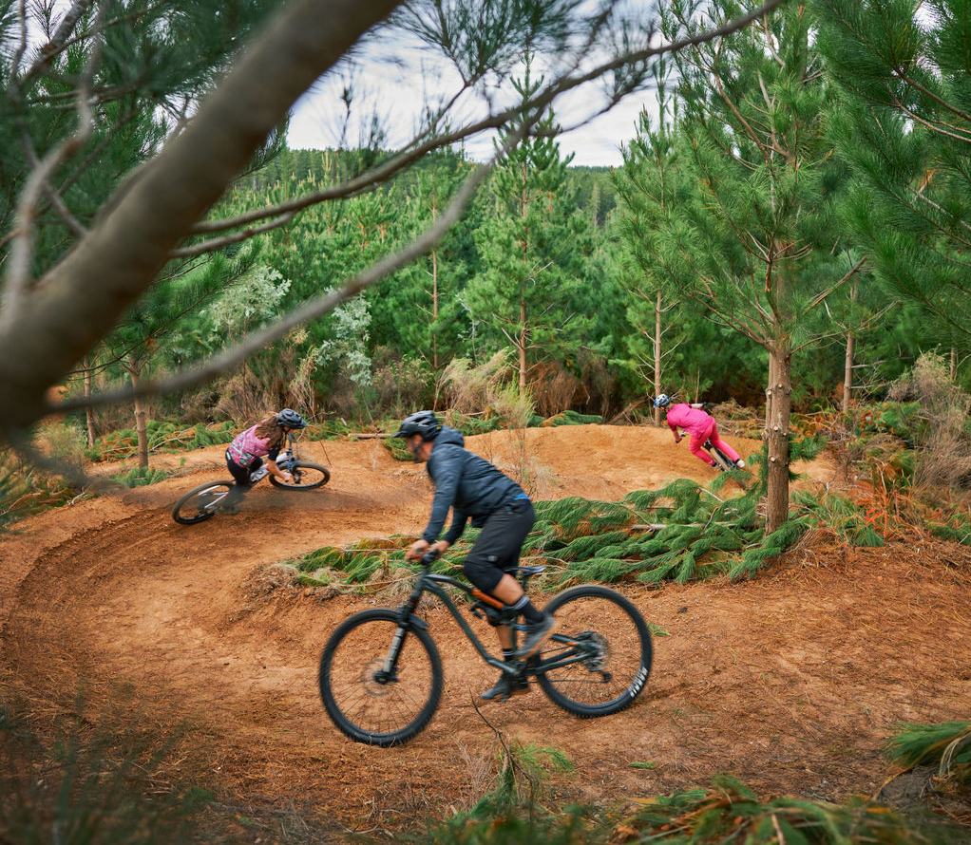
Draft Council Plan 2025-2029
Including the Municipal Public Health and Wellbeing Plan
May 2025

Figure 1 Djuwang Baring

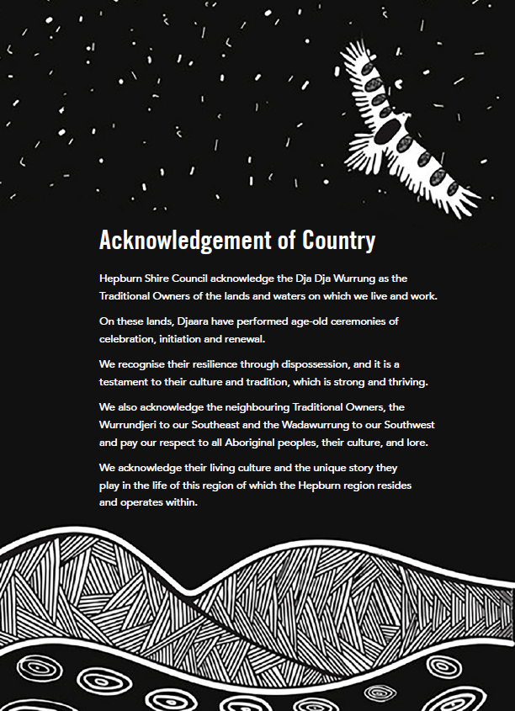

Contents
Welcome 4
Message from the Mayor and Chief Executive Officer 5
Your Councillors 7
Plan on a Page 8
Levels of government in Australia 9
Partnerships and advocacy 9
Our vision for Reconciliation 10
Hepburn Shire Council service map 11
Domain strategies alignment with Council services 12
Integrated Strategic Planning and Reporting Framework 13
Community engagement 15
Structure of the Council Plan 17
Our community 18
Council’s approach to health and wellbeing 21
Hepburn Life 24
Future Hepburn 26
Hepburn working together 29
Indicators 31
Funding Allocation 34
Monitoring and reporting 34
Glossary 36
Appendix A – Alignment of Community Feedback to the Council Plan 38
Appendix B - Our community 49
Appendix C – Plan on a Page 58

Community Vision
Council adopted its 10-year Community Vision in 2021 as a result of extensive engagement activities undertaken with a broad cross-section of our community. The engagement activities brought the voice of community to Council.
Our community’s goals, aspirations and priorities have been captured and used to develop the Community Vision and help shape the long-term direction of the Shire.
Given the significant engagement undertaken in 2021, and the long-term nature of the Community Vision Council has not proposed any changes to the vision in 2025.
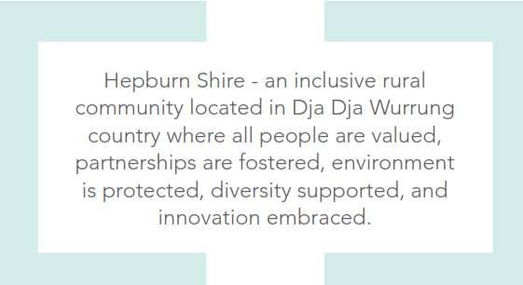

Welcome
The Hepburn Shire Council Plan 2025-2029 (the Plan) sets the strategic direction of Hepburn Shire Council (Council) for the Council term. The Plan details the outcomes and strategies Council will focus its efforts and resources on for the four-year Council term to be able to achieve the aspirations in the Community Vision.
The Community Vision is a statement that captures the community’s goals for the next ten years. The Community Vision is:
Hepburn Shire – an inclusive rural community located on Dja Dja Wurrung Country where all people are valued, partnerships are fostered, environment is protected, diversity is supported, and innovation embraced.
The Plan and Community Vision are required strategic documents under the Local Government Act 2020 (the Act). These plans, along with other strategic documents required under the Act, including the Long-Term Financial and Asset Plans, were developed in conjunction with the community and acknowledge ongoing financial pressures.
The Plan focuses on financial responsibility to ensure we can meet the required needs of the community now, while planning and advocating for future generations.
The Plan includes Council’s requirements under the Victorian Public Health and Wellbeing Act 2008 for the delivery of a Municipal Public Health and Wellbeing Plan. Council and key stakeholders are required to examine Shire health data and health determinants and identify goals and strategies for ensuring the community can achieve maximum health and wellbeing. Council has chosen to incorporate the Municipal Public Health and Wellbeing Plan into its Council Plan to ensure that the health and wellbeing of our community is prioritised over the Council term and integrated into Council’s services, processes, and policies.

Message from the Mayor and Chief Executive Officer
Hepburn Shire Council is entering a new chapter, one defined by a strong commitment to our community, improving our customer responsiveness and ensuring our financial sustainability.
Financial sustainability is at the core of our plan for the future. Challenging finances is not something unique to Hepburn Shire, it is an outlook being repeated across many of the 79 councils in Victoria. We need strong economic foundations to allow us to meet the challenges ahead. By making the difficult but important decisions today, we will be protecting our ability to deliver for our community tomorrow.
Our Council Plan 2025–2029 (including the Health and Wellbeing Plan) is focused on getting back to the basics. We are laying the groundwork for a strong future by focusing on maintaining our roads, enhancing our parks, planning for our community’s future and delivering customer-centred services. Our vision is to build a future where services are accessible and connected to the needs of our community. We will focus on three domains (strategic objectives), Hepburn Life, Future Hepburn and Hepburn Working Together:
- Hepburn Life is about building a vibrant, resilient, and inclusive community where every person feels connected, informed, and supported to thrive.
- Future Hepburn strives to honour the distinctive character of our towns and rural landscapes while fostering sustainable growth, infrastructure, and economic vitality.
- Hepburn Working Together is guided by a commitment to delivering high-quality services, ensuring strong governance, and fostering a positive and skilled workforce.
The Plan is outcomes focused – we have detailed the outcomes Council is seeking to achieve across the Council term, reflecting the change or benefit to community, environment or organisation.
To ensure that we put words into action, the specific work that Council will do to deliver this Council Plan is contained in an action plan of initiatives released annually as part of the Budget. This ensures we have the resources to deliver on our commitments and will be accountable to you, our community.
Our Council Plan is a shared vision. A vision that incorporates the voices of residents and ratepayers collected through community feedback and a Deliberative Engagement Panel made up of community representatives. Appendix A details how we have responded to community input. Working together has helped us shape a Council Plan that reflects the hopes and needs of those who call our Shire home, in a financially sustainable manner.
We are focused on delivering projects that matter and ensuring that every decision we make reinforces a positive future for our organisation and our community.

Cr Don Henderson Bradley Thomas
Mayor Chief Executive Officer

Your Councillors
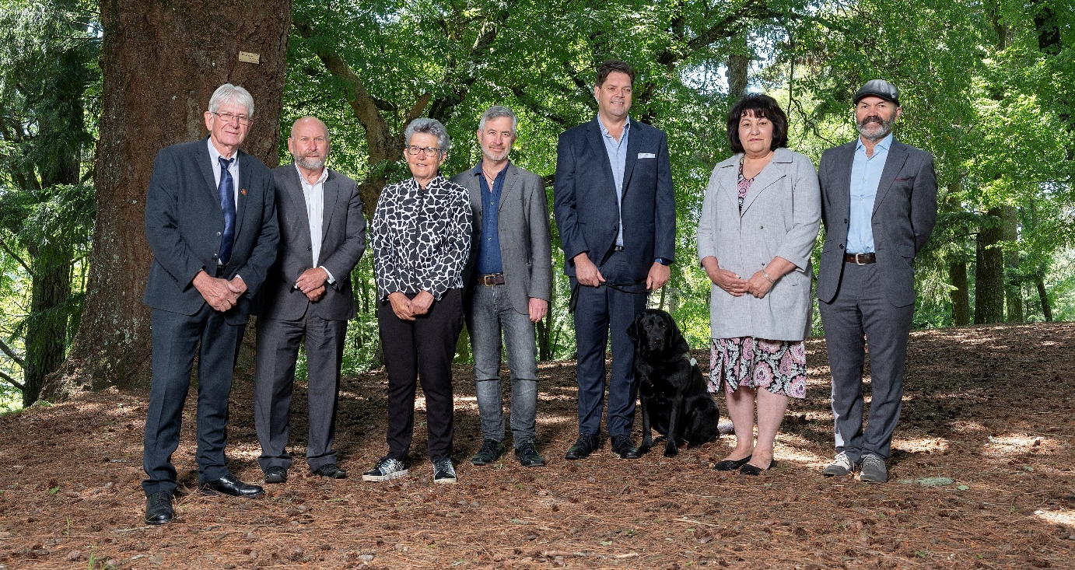
Figure 1 Hepburn Shire Council Councillors, L-R: Mayor, Cr Don Henderson, Cr Brian Hood, Deputy Mayor, Cr Lesley Hewitt, Cr Tim Drylie, Cr Tony Clark, Cr Shirley Cornish, Cr Pat Hockey
Hepburn Shire Council has seven Councillors elected every four years by the community to represent them on local public issues.
Every year Councillors elect a Mayor and Deputy Mayor to serve for 12 months.
You can find detailed descriptions of the Councillors on Council’s website.

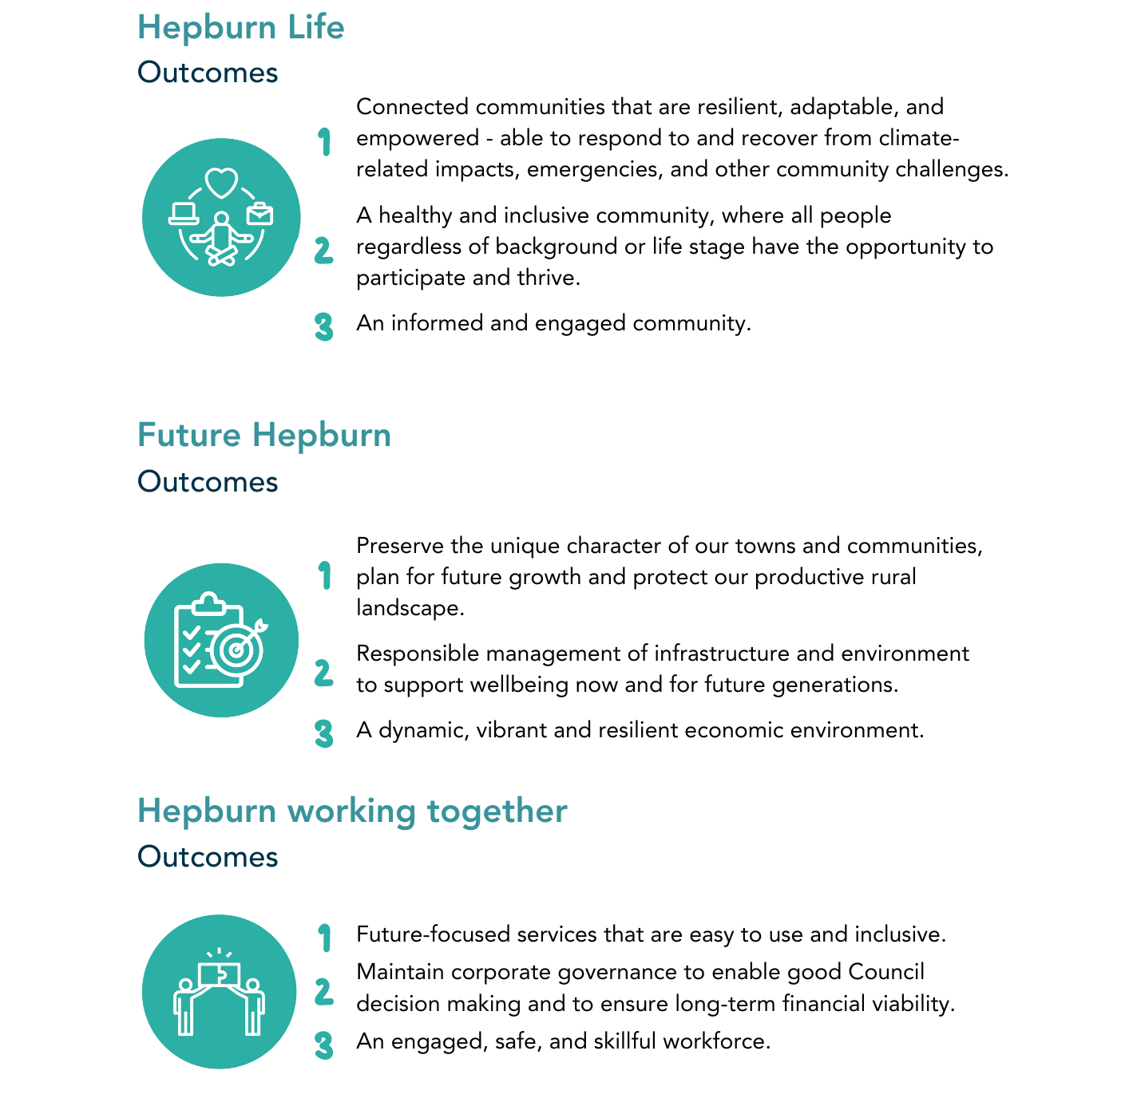
Plan on a Page

Levels of government in Australia
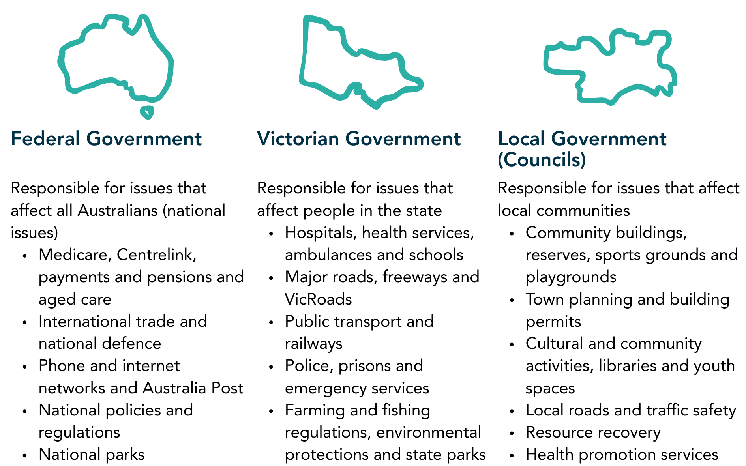To learn more visit www.peo.gov.au

Partnerships and advocacy
Advocacy is where we publicly voice our support for projects and policies to other levels of government, peak bodies, industry and non-government groups, and community advocacy groups.
Council is committed to actively advocating for the local projects and policies that matter to our community, providing better outcomes for our Shire through service improvements and capital investment.
We partner with other councils, peak bodies such as MAV (Municipal Association of Victoria), Rural Councils Victoria, Greater Ballarat Alliance of Councils and Loddon Campaspe Councils, Traditional Owners and community advocacy groups to collaborate on issues important to the community, where the reforms required go beyond our municipal boundary.
Our local community partners provide invaluable expertise and knowledge in their respective fields enabling us to put forward compelling submissions.
The Hepburn Shire actively advocates to both the Victorian and Australian Governments for projects, funding, services and infrastructure that will enhance the wellbeing of our residents and businesses. Often, this includes items that may be beyond the scope of what local government can deliver.

Our vision for Reconciliation
Council has recently had endorsed its second Reconciliation Action Plan (RAP) to continue the important work achieved in the previous plan. Our new Innovate RAP will drive our vision for reconciliation through this Council Plan.
Our relationships with Traditional Owners are built on respect, understanding and acknowledgement of Truth-telling [RA1] in our shared history, and through our Innovate RAP we will build on our commitment to reconciliation, demonstrated in our previous [RA2] Reflect RAP, to ensure all members of the Hepburn Shire community are united by respect.
We aim for all community members to be provided the same, highest quality services from our organisation and for all staff, aspiring towards a just equitable and reconciled Australia.
Through our Innovate Reconciliation Action Plan (RAP), Council seeks to ensure reconciliation is at the core of our organisation and a foundation to all our services.
Our council seeks to recognise and promote the collections of stories that make up the shared history of the Shire.
Our Council issues the following statement to respectfully acknowledge the Aboriginal and Torres Strait Islander history within our Shire.
"We commit to working positively today and in the future with the Dja Dja Wurrung peoples and other Aboriginal and Torres Strait Islander community members to learn, acknowledge and reconcile together with the whole Hepburn Shire community."

Hepburn Shire Council service map
The below service map gives an overview of the services delivered by Council and how they are connected. This document was prepared as part of the Financial Vision project in September 2024 and will be reviewed and updated along with the Hepburn Shire Council Service Catalogue, following adoption of the Council Plan. This is part of our ongoing service review process, ensuring that our service delivery remains responsive to the changing needs of our community and aligned with annual budget allocations.
For detailed information about what and how Council delivers services as well as associated costs, view the: Hepburn Shire Council Service Catalogue
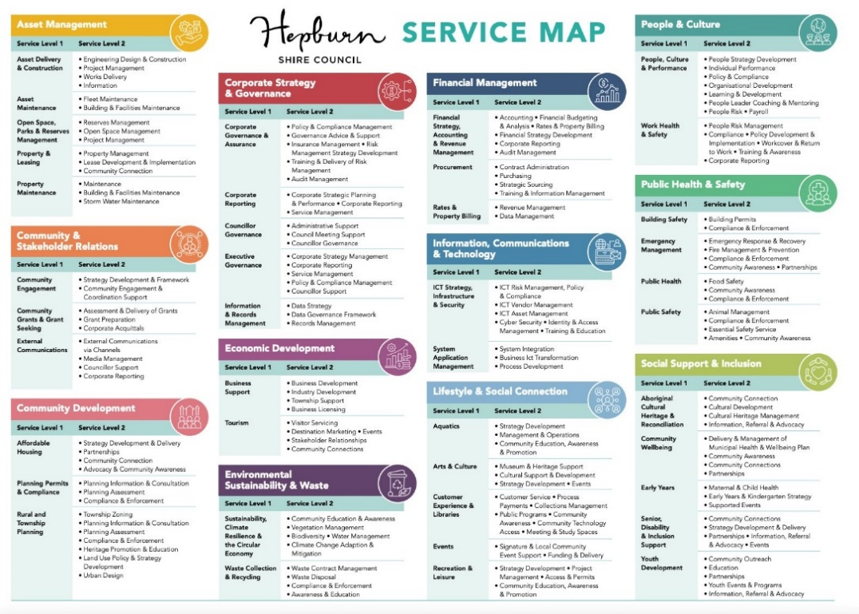

Domain strategies alignment with Council services

Hepburn Life
Aboriginal cultural heritage & reconciliation | Economic Development
Aquatics | Events
Communications | Libraries
Community engagement | Recreation & leisure
Community grants & grant seeking | Senior, disability & inclusion support
Community wellbeing | Visitor economy
Early years | Youth Development

Future Hepburn
Affordable housing | Property & leasing
Arts & culture | Public health
Asset delivery & construction | Public safety
Asset maintenance | Property maintenance
Building safety | Rural & township planning
Emergency management | Sustainability, climate resilience & the circular economy
Open space, parks & reserves management | Waste collection & recycling
Planning permits & compliance

Hepburn Working Together
Corporate governance & assurance | ICT – Information, Communications & Technology
Corporate reporting | People & Culture
Councillor governance | Procurement
Customer experience | Rates & property billing
Financial strategy, accounting & revenue management | Work, health and safety
Information & records management

Integrated Strategic Planning and Reporting Framework
The Integrated Planning and Reporting Framework sets out the range of strategic documents Council is required to adopt under the Local Government Act 2020. The framework sets out Hepburn Shire’s integrated approach to planning, monitoring, and performance reporting.
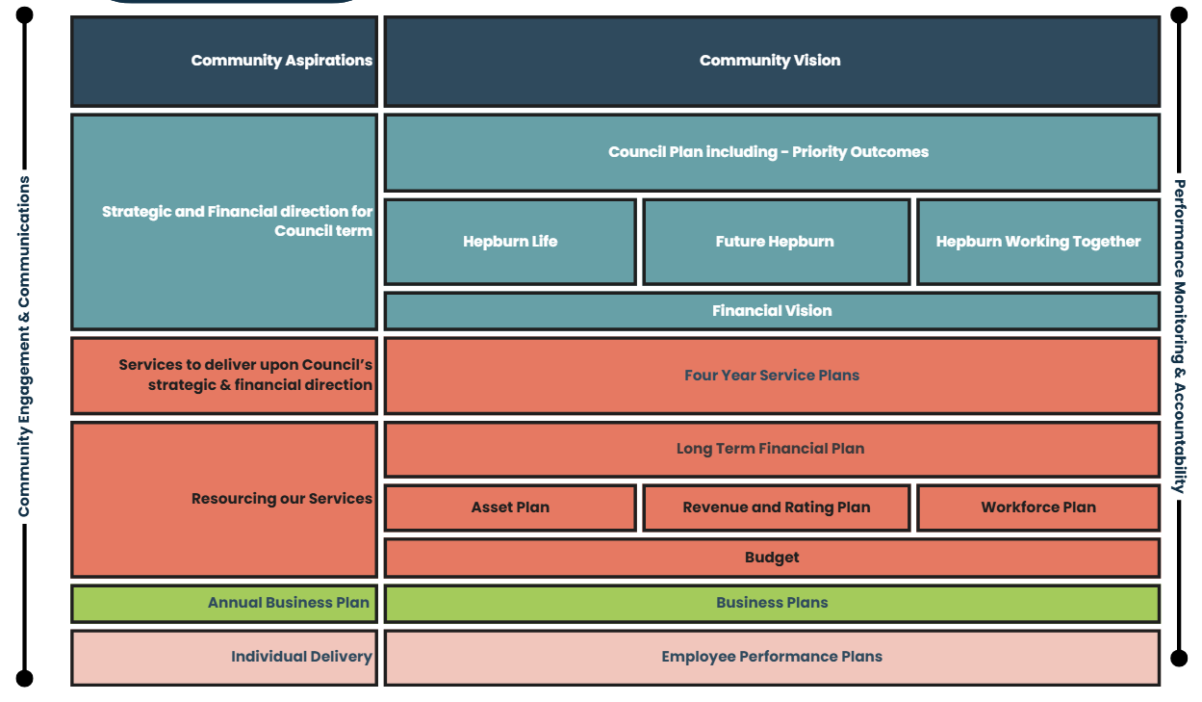
Layer | Description | Documents
Community aspirations | Community aspirations are set out in our Community Vision. | Community Vision
Strategic direction | The strategic and financial direction and priorities across the Council term. | Council Plan and Financial Vision
Council services | Services that will deliver upon Council’s strategic and financial priorities. | Service Catalogue and Service Map
Resourcing | How we will resource our services to deliver Council’s strategic and financial priorities. | Financial Plan, Asset Plan, Workforce Plan and Annual Budget.
Annual business plan | The projects and initiatives funded through the annual Budget that will deliver on Council’s strategic and financial priorities. | Annual Plan
Individual delivery | Individual employee plans that align our Council Officers roles and responsibilities to Council’s strategic and financial priorities. | Employee Performance Plans

Community engagement
A range of engagement factors have been considered in the drafting of the Council Plan, including:
- Previous engagement activities, especially associated with Future Hepburn (Township Structure Plans and Rural Strategy), previous Council Plan input and the Financial Vision.
- Councillor and Officer insights.
- A community-based deliberative engagement panel.
- A shire-wide community survey.
- Seeking community feedback on the draft document.
As core inputs to the Council Plan, Appendix A includes details on how the results and recommendations of the community based deliberative engagement panel and shire-wide community survey have influenced the Plan, along with a table that shows the alignment of community feedback to the Council Plan.
Deliberative engagement
Consultancy group Conversation Co was contracted to develop and manage a Deliberative Engagement Panel process to ensure community views and input were considered and included in the Council Plan.
Community members were invited to participate via an expression of interest on the Hepburn Together project page. A total of 82 expressions of interest were received and 44 residents were randomly selected as a stratified sample to reflect the demographic makeup of Hepburn Shire. Of the invited 44 residents, 35 were able to participate.
Demographically, the panel was consistent with the shire demographics when taking into account gender, age and location. Just under 22.5 per cent of participants were from the LGBTIQ+ community and nearly 13 per cent were people with a disability.
Panel members attended four workshops: two in person and two online.
The first workshop focused on the Council, financial management and tiers of government. Panellists were asked to explore an assessment criteria to adjust service levels, and to consider current council services.
The second workshop focussed on the Long-Term Asset Plan and the third workshop about community health and wellbeing, and economic development.
The final workshop focussed on environmental sustainability and waste. Panel members were also asked to develop a summary of recommendations and future steps as well as feedback about the Deliberative Engagement Panel process.
Shire-wide community survey
To broaden engagement with the community, a survey was launched the week commencing 31 March and distributed through Participate Hepburn, social media and local newsletters. The survey asked community members about the Council services they value the most. People were able to complete the survey online or in hard copy format.
There were 409 responses to the survey, a fantastic number for our size population.
Health and wellbeing
In June 2024, the Health and Wellbeing survey was conducted and received 152 responses.
Seven workshops were held with the external Health and Wellbeing Working Group from July 2024 to April 2025. The workshops explored local data, key stakeholder objectives, resources, potential future funding opportunities and shared priorities.
Other Groups
Council’s extensive Advisory Committees were engaged in early consultation through targeted sessions, and further engagement will take place during the feedback period.
DJARRA has been engaged for cultural consultation sessions to reflect the joint alignment of aspirations in the country plan throughout the documents.

Structure of the Council Plan
This document outlines the strategic framework that guides Council’s planning and decision-making over the current Council term. It sets a clear direction for how the Council will work towards delivering long-term community aspirations while responding to current priorities and challenges.
The framework is structured around five key components:
- Community Vision
  - A long-term vision that outlines the aspirations of the Hepburn Shire community.
- Domains
  - Broad areas outlining the strategic direction and priorities across the Council term.
- Outcomes
  - The outcomes Council is seeking to achieve across the Council term, reflecting the change or benefit to community, environment or organisation.
- Strategies
  - Key approaches, actions and initiatives that will drive progress towards achieving the outcomes. These strategies guide projects, policies, decision making and the budget across the Council term.
- Where applicable we have provided links to our other key strategies.
- Indicators
  - How we will monitor progress across the Council term in achieving the outcomes.
Each element of the Council Plan plays a vital role in shaping the future of the Shire. Together, they provide a roadmap for meaningful action and measurable progress.

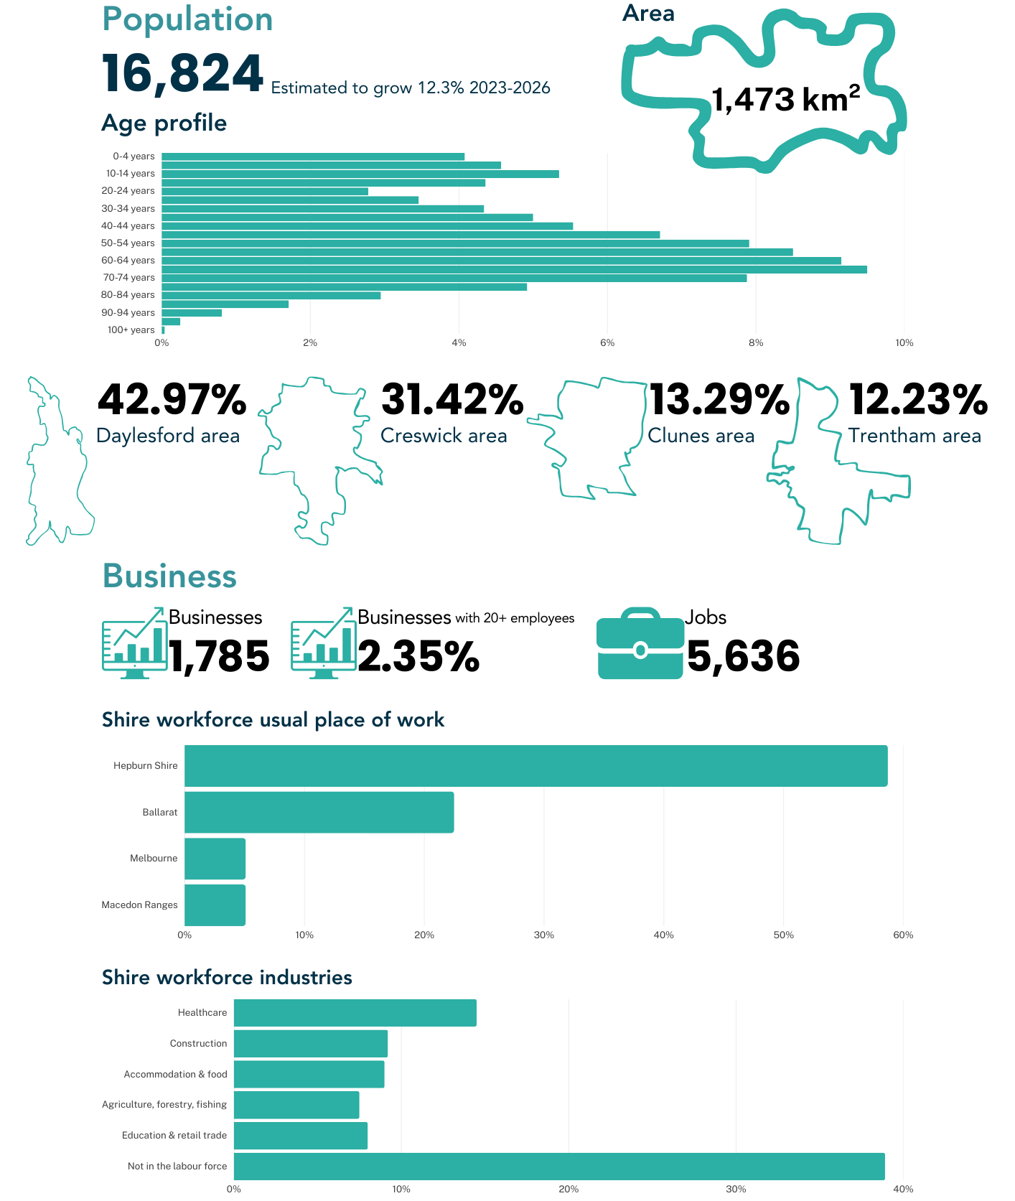
Our community

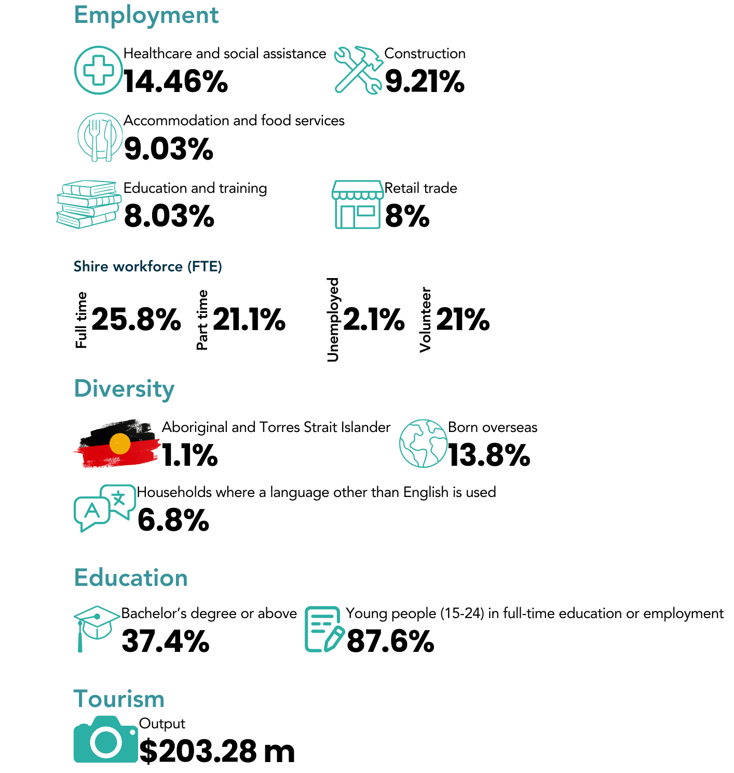
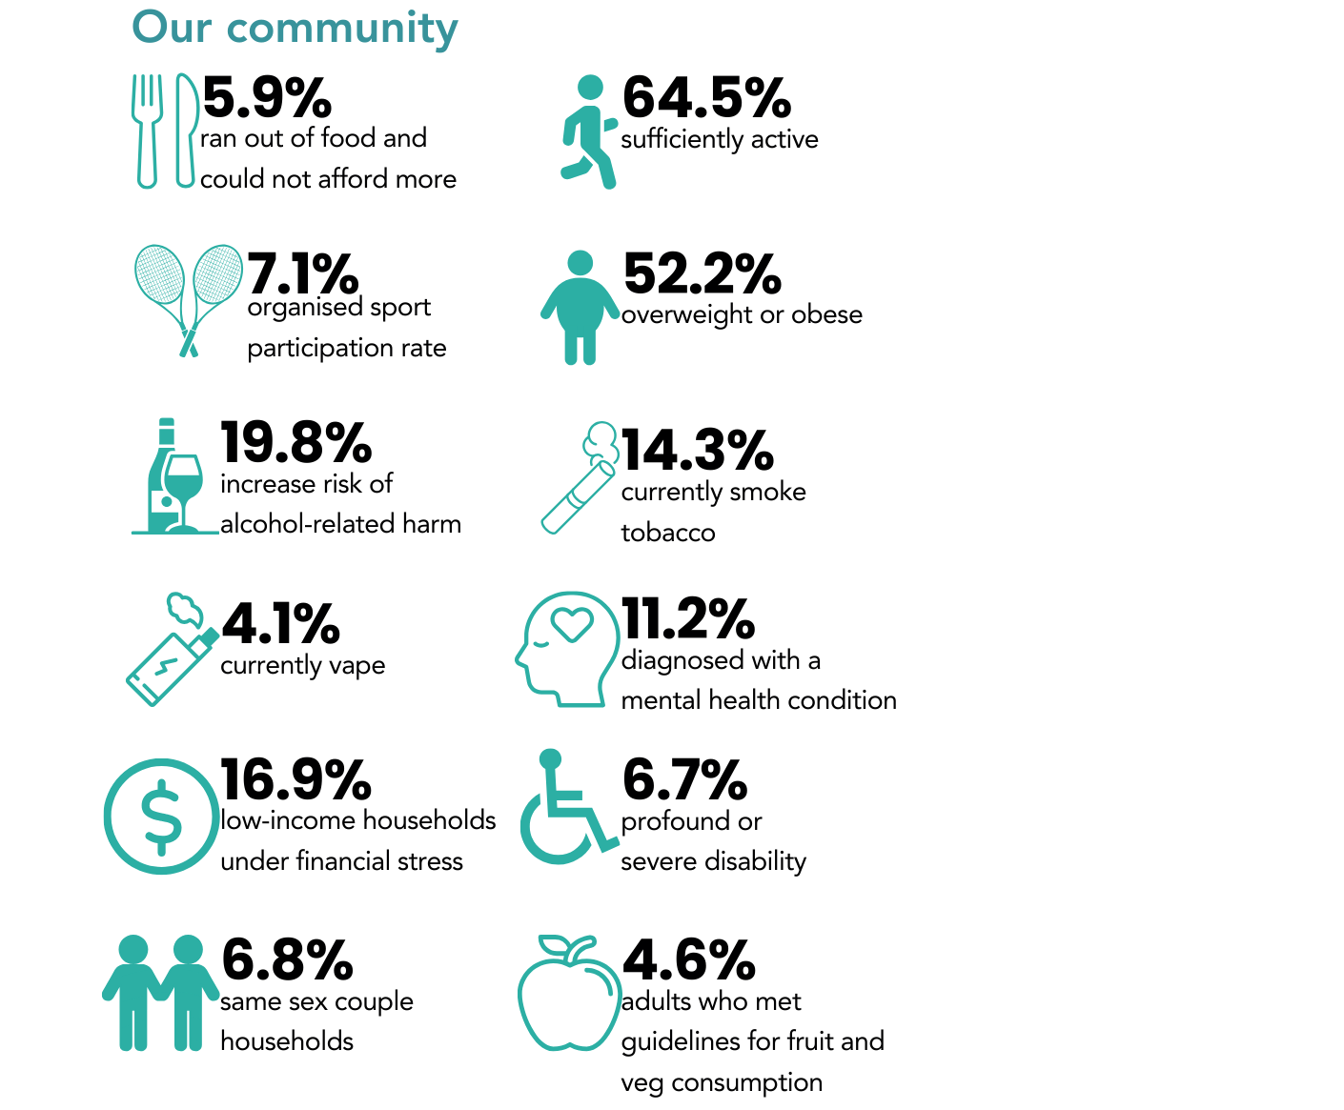

Council’s approach to health and wellbeing
The Victorian Public Health and Wellbeing Act 2008 requires all local governments to prepare a Municipal Public Health and Wellbeing Plan (MPHWP) within 12 months of a council election. The Hepburn Shire Council Municipal Public Health and Wellbeing Plan 2025-2029 has been integrated into the Community Vision and Council Plan 2025-2029.
The MPHWP identifies the health priorities of the municipality for the next four years. To inform health and wellbeing planning, Council has:
- reviewed the priorities outlined in the Victorian Public Health and Wellbeing Plan 2023-2027.
- completed a municipal scan to assess the health status of the Shire.
- considered relevant legislation, including the Public Health and Wellbeing Act 2008, Local Government Act 2020, Gender Equality Act 2020, Climate Change Act 2017, and the Victorian Disability Act 2006.
- reviewed the actions and achievements of the Council Plan 2021-2025.
- engaged with Council Officers and external partners to identify emerging priorities and community needs.
- analysed community consultation data.
The two priority areas selected for Municipal Public Health and Wellbeing Plan are:
- increasing active living
- increasing mental wellbeing
The health and wellbeing of communities are influenced by complex social factors, “including the circumstances in which people are born, grow, live, work and age, and the systems put in place to deal with illness”.
Our key health and wellbeing partners
The Hepburn Shire Council Health and Wellbeing Working group was formed in 2019 to ensure that we work together to achieve outcomes in the community. Council would like to acknowledge and thank the members for their commitment.
- Central Highland Rural Health
- Western Public Health Unit
- Women's Health Grampians
- Live4Life: Daylesford College
- Grampians Public health Network
- Clunes Neighbourhood House and Creswick, Daylesford and Trentham Neighbourhood Centres
- Springs Medical
- Ochre Health
- Ballarat and District Aboriginal Cooperative
- Sports Central
- Headspace
- Health Futures Australia
- The Orange Door
- Victorian Department of Health
Health Equity
Council is committed to providing services, programs, policies, and supports that serve everyone in our community, with a particular focus on those who are most vulnerable. We recognise that not everyone has the same opportunities for good health and that various health determinants can influence outcomes, both positively and negatively. As a result, some groups experience poorer health outcomes and face barriers in accessing the care they need. To achieve health equity, Council must focus on the broader municipal population, with particular attention to these identified priority groups:
• Aboriginal and Torres Strait Islanders
• Older people
• Children, youth, and families
• Culturally and linguistically diverse
• People with a disability
• LGBTIQA+
Commitment to violence prevention
Hepburn Shire Council has been a proud member of the Communities of Respect & Equality (CoRE) alliance since 2016 and collaborated closely with local stakeholders in gender equality and prevention of violence, including Women’s Health Grampians who led the regional CoRE alliance. This alliance of organisations, businesses and sporting clubs in the Grampians region share a vision for safe, equitable and respectful communities.
Council has an adopted Leadership Statement for the Prevention of Violence Against Women and Children, visit our Family violence webpage.

Hepburn Life
Hepburn Life is about building a vibrant, resilient, and inclusive community where every person feels connected, informed, and supported to thrive. Through strong partnerships, education, and advocacy, we will enhance community resilience to changing environmental conditions, emergencies, and evolving community needs. By ensuring access to essential resources before, during, and after crises, we are committed to safeguarding the wellbeing of all residents.
We are equally focused on nurturing a healthy, inclusive community where people of all ages, backgrounds, and abilities can participate fully in Shire life. By supporting active living, mental wellbeing, reconciliation, maintaining welcoming public spaces, and strengthening First Nations perspective, we aim to create a community where everyone feels a true sense of belonging.
Outcome 1
Connected communities that are resilient, adaptable, and empowered - able to respond to and recover from climate-related impacts, emergencies, and other community challenges.
Strategies
- Enhance community preparedness and resilience for changing conditions through community partnerships, education, support and advocacy.
- Work with partners to ensure timely and coordinated access to essential resources and services during and post-emergencies to preserve the safety and recovery of all residents.
Outcome 2
A healthy and inclusive community, where all people regardless of background or stage of life and have the opportunity to participate and thrive.
Strategies
- Provide access to, and support local formal and informal recreation opportunities to increase diversity of participation, promote wellbeing and nurture social connections.
  - Municipal Public Health and Wellbeing priority: Improving Active Living
- Work with communities and partners to deliver and advocate for equitable, inclusive access to programs and resources that support wellbeing across all life stages.
  - Municipal Public Health and Wellbeing priority: Improving Mental Wellbeing
- Actively involve First Nations voices, perspectives, and leadership to shape Council policies and initiatives, empowering self-determination and promoting reconciliation through decision-making, education, and community engagement.
  - Innovate: Reconciliation Action Plan 2025-2027
- Maintain public spaces, gardens and recreational areas, fostering environments that encourage physical activity, relaxation and community connection.
Outcome 3
An informed and engaged community.
Strategies
- Provide timely, accurate information through a variety of platforms, ensuring all residents are informed and have the ability to participate in Council activities and decision making through a variety of accessible platforms.
  - Details can be found within our Community Engagement Policy.
- Facilitate and promote safe, collaborative and welcoming community places, spaces and initiatives that promote social connection and volunteerism.

Future Hepburn
Hepburn Shire Council is committed to shaping a future that honours the distinctive character of its towns and rural landscapes while fostering sustainable growth, infrastructure, and economic vitality.
This strategic framework outlines three key outcomes designed to guide the region’s development, while preserving the uniqueness of our communities and natural environment, ensuring responsible infrastructure and environmental management, and cultivating a resilient and vibrant local economy. Through integrated planning, inclusive design, and environmentally conscious strategies, we aim to enhance the wellbeing of our residents today and for generations to come.
Outcome 1
Preserve the unique character of our towns and communities, plan for future growth and protect our productive rural landscape.
Strategies
- Encourage development and design that prioritises the wellbeing of the community, enhances township character, protects heritage and elevates environmentally sustainable development.
  - Future Hepburn Structure Plans Objective: Urban design
- Strive for access to diverse, affordable and sustainable housing options that enhance security and quality of life for residents.
  - Future Hepburn Structure Plans Objective: Housing
- Facilitate diverse, safe, and accessible public and active transport and movement options that support connection within towns and to surrounding areas for all ages and abilities.
  - Future Hepburn Structure Plans Objective: Movement and access
- Protect and enhance productive agricultural land, significant landscapes, biodiversity, natural environment and waterways.
  - Rural Hepburn Strategy Principle
  - Sustainable Hepburn Objective: Biodiversity and Natural Environment
Outcome 2
Responsible management of infrastructure and environment to support wellbeing now and for future generations.
Strategies
- Deliver capital renewal programs that align with long-term planning and priorities, and are adaptive to community needs.
  - Long-term planning can be found in our Asset Plan 2025-2034.
- Advocate and plan for capital projects and ensure that all planning and infrastructure decisions consider long-term impacts on community and the environment.
- Provide inclusive, adaptable community infrastructure that strengthens local connections, adapts to changing climates, and incorporates high-quality design principles.
  - Future Hepburn Objective: Community and cultural infrastructure
- Review and manage a portfolio of assets that is financially responsible.
  - Our asset portfolio including the health of our assets can be found in our Asset Plan 2025-2034.
- Prioritise sustainable waste, resource management and circular economy to ensure a clean, safe and liveable environment.
  - Sustainable Hepburn Objective: Low waste
Outcome 3
A dynamic, vibrant, and resilient economic environment.
Strategies
- Enable a thriving and diverse local economy by supporting local business, industry growth, retention and attraction of businesses and jobs.
- Strengthen the visitor economy by collaborating with partners to elevate experiences including cultural tourism, drive sustainable visitation and dispersal across the Shire.
- Support a year-round calendar of diverse and inclusive events that attract locals and visitors and deliver significant social, cultural and economic benefits to our community.

Hepburn working together
Hepburn Shire Council is committed to building an inclusive and sustainable community. Our strategic focus is guided by a commitment to delivering high-quality services, ensuring strong governance, and fostering a positive and skilled workforce.
This plan outlines key outcomes and strategies designed to meet the evolving needs of our community while maintaining financial sustainability and enhancing community wellbeing. By integrating principles of equity, climate resilience, innovation, and accountability, we aim to create a more connected, transparent, and empowered Hepburn Shire. Each outcome reflects our commitment to delivering on community aspirations while preparing for the challenges and opportunities in the future.
Outcome 1
Future focused services that are easy to use and inclusive.
Strategies
- Design and deliver services that are accessible, consistent and responsive to community needs, ensuring a smooth experience that supports community.
- Foster continuous improvement across Council operations by using data, feedback and innovation to optimise service delivery models to ensure services align with the evolving needs of the community.
- Integrate principles of climate mitigation, violence prevention, gender equity, and inclusion into Council processes and policies to create a safer and more equitable community.
  - Sustainable Hepburn Objectives: Beyond Zero Emissions and Climate Resilience
Outcome 2
Maintain corporate governance to enable good Council decision making and to ensure long-term financial viability.
Strategies
- Maintain compliance with relevant legislation, uphold strong governance and project management frameworks that support transparent, accountable decision-making for the benefit of the community.
- Ensure clear and transparent financial decision making and strengthen reporting to build public trust and ensure accountability in Council’s financial performance.
  - Hepburn Shire’s financial planning can be found in our Long-term Financial Plan 2025-2034 and Financial Vision 2024-2027.
- Actively pursue alternative revenue opportunities.
Outcome 3
An engaged, safe, and skillful workforce.
Strategies
- Ensure an engaged workforce, the promotes a positive workplace culture, recognises employees for their contributions and delivers positive outcomes for community.
- Ensure a safe and healthy work environment that actively supports the wellbeing of all employees.
- Develop our employees' capabilities to ensure we attract and retain talent.

Indicators
Hepburn Life
Council-led indicators | Facilitate at least 8 emergency management community education and engagement workshops per year.
Council-led indicators | Percentage of actions achieved in Innovate: Reconciliation Action Plan 2025-2027.
Community-led, Council supported, indicators | Number of participants in Council supported mental health initiatives.
Community-led, Council supported, indicators | Maintain or improve ‘How Council has performed on the appearance of public areas?’ (2024 rating: 64) Community Satisfaction Survey.
Community-led, Council supported, indicators | Increase the numbers of subscribers (2024: 3,861) to Hepburn Life (Council’s eNewsletter) and maintain an open rate above industry average and increase the number of follows (2024: 7,293) of Council’s corporate Facebook page.
Community-led, Council supported, indicators | Increase in library visits per head of population (2024: 3.6 visit per person) Local Government Performance and Reporting Framework.
Future Hepburn
Council-led indicators | Increase in the percentage of planning applications decided within required timeframes (2024: 17.9%) Local Government Performance and Reporting Framework.
Council-led indicators | 100% of actions achieved in the Integrated Transport Strategy per adopted timelines (subject to adoption by Council).
 | Complete at least 85% of annual capital works projects. (Number of projects).
 | Implementation of asset management improvement actions in accordance with Council’s adopted Asset Plan.
 | Maintain or increase the number of events supported with financial, or in-kind support annually within the Shire.
Community-led, Council supported, indicators | Support the creation annually of an extra 126 houses (to reach the State Government’s 2051 housing target, and a goal in line with Council estimates in Future Hepburn).
Community-led, Council supported, indicators | The percentage of garbage, recyclables and green organics collected from kerbside bins that is diverted from landfill. Local Government Performance and Reporting Framework
Community-led, Council supported, indicators | Annual increase in the Gross Regional Product (economy) of the Shire.
Community-led, Council supported, indicators | Increase in the number of visitors (domestic) overnight trips.
Hepburn Working Together
Council-led indicators | Meet customer request service standards (to be developed).
Council-led indicators | Gender Impact Assessments completed for new or renewed Council policies.
 | Annual improvement in Council’s unrestricted cash position on 30 June (in line with adopted budgets).
 | Annual reduction in Council’s corporate emissions.
 | Percentage of actions achieved in our Workforce Plan.
 | Percentage of workforce turnover below the average of other small rural councils.
 | An increase in the percentage of non-rates and charges income as proportion of total revenue above 35% (2024/2025 baseline).
Community-led, Council supported, indicators | Maintain or improve Councils customer service ranking from 2024 (64) Community Satisfaction Survey.

Funding Allocation
The Council allocates funding annually for programs, projects, and capital works through the Annual Budget process. The draft Financial Plan and Budget align with the Council Plan, ensuring its affordability. The graph below illustrates the expenditure allocation by domain for the 2025/2026 financial year.

Monitoring and reporting
We evaluate to find out what works (and why) so we can improve our performance for our community. Performance reporting by Council is essential for ensuring transparency and accountability as to how public money is being spent and the quality of services being delivered.
Under the Local Government Act 2020, the Shire’s services must:
- Be equitable and responsive to diverse needs.
- Be accessible to the people who need them.
- Provide good value for money.
- Be regularly reviewed and improved.
- Provide fair and effective complaints handling.
We measure progress in several ways, including:
- Reporting ongoing business and services through the Annual Report which includes:
  - All its service investment and output, activities, achievements and challenges.
  - It is performance against the Annual Community Satisfaction Survey (ACSS).
  - It is performance against the required service indicators of the Local Government Performance Reporting Framework (LGPRF) which is a mandatory system or performance reporting for all Victorian Councils.
- Reporting on Annual Plan actions to the Council quarterly.
- Reporting on the health and wellbeing priorities of this plan annually to the Department of Health.
- Reporting on our performance against the Council Plan using the Council-led Indicators above.
- Reporting on the Community-led, Council-supported Indicators above.

Glossary
Term | Definition
Accessible | Easy for everyone to use, understand and participate in – including people of all ages, abilities, and backgrounds.
Community | The people that make up the Hepburn Shire and Councils customers. Those who live, work, play, visit, or have a connection to places in Hepburn Shire. Our community is made up of individuals, families, businesses, businesses, and visitors.
Diverse/diversity | The presence of different people and cultures, identities, experiences, and perspectives in our community.
Economy | The way our community creates and shares jobs, income, goods, and services. A strong local economy supports our livelihoods and businesses.
Financial sustainability | Managing our money and resources responsibly to ensure Council can meet the needs of the community now and into the future.
Inclusion | Ensuring everyone feels welcome, respected, and able to take part in community life, regardless of their background or circumstances.
Innovation | The ability to try new ideas, technologies, or approaches.
LGPRF | Local Government Performance Reporting Framework. Indicators used to compare Councils across the State and available on the website Know Your Council.
Resilient | Able to adapt, recover and thrive during and after challenges such as natural disasters, economic changes, or social disruptions.
Social justice | Ensuring fair access to opportunities, support, and resources, especially for people who face disadvantages or discrimination.
Sustainable growth | Development that supports long-term community, environmental and economic health. A way of managing growth that protects our natural resources, high quality agricultural land, reduces emissions, supports local jobs and housing, and creates liveable places for current and future generations.
Transparent | Open, honest, and clear about decisions, actions, and how resources are used.

Appendix A – Alignment of Community Feedback to the Council Plan
To view the full report including all of findings and recommendations please visit: Participate Hepburn.
 | Community and wellbeing
 | Engagement Method |  | Community Health & Wellbeing Priorities |  | How we have responded |  | Council Plan
 |  |  |  |  |  |  | Domain | Outcome |  | Strategy
 | Community Survey |  | - Mental wellbeing and being socially connected to family / friends and neighbours. |  | - Improving mental wellbeing is a priority area selected through our Municipal Public Health and Wellbeing Plan (incorporated into Council Plan). |  | Hepburn Life | Outcome 2: |  | Strategy 1: Municipal Public Health and Wellbeing priority:  Improving Active Living
 |  |  |  |  |  |  |  | Outcome 2: |  | Strategy 2:  Public Health and Wellbeing priority:  Improving Mental Wellbeing
 |  |  |  |  |  |  |  | Outcome 2: |  | Strategy 3:  Innovate: Reconciliation Action Plan 2025-2027
 |  |  | - Keeping physically active and being able to walk/cycle to work, school activities. |  | - Increasing active living is a priority area selected through our Municipal Public Health and Wellbeing Plan (incorporated into Council Plan). |  | Hepburn Life | Outcome 2 |  | Strategy 4
 |  |  |  |  |  |  | Future Hepburn | Outcome 1 |  | Strategy 3:  Future Hepburn Structure Plans  Objective: Movement and access
 |  |  | - Being able to access healthy / affordable food |  | - Priority has been given to improving mental wellbeing and keeping physically active through our Municipal Health and Wellbeing Priorities. Although health eating is not a designated priority area (with only two) it is still an important response and Council will support actions where resources allow – including through the implementation of our Rural Strategy that is designed to protect agriculture land. |  | Hepburn Life | Outcome 2 |  | Strategy 2
 |  |  |  |  |  |  | Future Hepburn | Outcome 1 |  | Strategy 4
Deliberative Engagement Panel |  | - Low-cost Housing - affordable and secure housing, balance between permanent vs short stay accommodation |  | - Through our adopted Future Hepburn Structure Plans, a key objective is to strive for affordable housing across the Shire. |  | Future Hepburn |  | Outcome 1 | Strategy: 2  Future Hepburn Structure Plans  Objective: Housing
 |  | - Accessibility - footpaths and maintained roadsides for walkability |  | - Improvement in movement and access is an objective within our adopted Future Hepburn Structure Plans.  - Footpath asset information including health and service levels can be found in our Asset Plan 2025-2034  - Council will complete its Integrated Transport Strategy in 2025/26, and has included the following indictor in the Council Plan (100% of actions achieved in the Integrated Transport Strategy per adopted timelines) |  | Hepburn Life |  | Outcome 2 | Strategy 4:
 |  |  |  |  |  |  |  | Outcome 1 | Strategy: 3  Future Hepburn Structure Plans  Objective: Movement and access
 |  | - Belonging and social connection - building social inclusion, sense of belonging through local festivals, knowing neighbours, welcoming new residents |  | - Improving mental wellbeing is a priority area selected through our Municipal Public Health and Wellbeing Plan (incorporated into Council Plan) |  | Hepburn Life |  | Outcome 2: | Strategy 1: Municipal Public Health and Wellbeing priority:  Improving Active Living
 |  |  |  |  |  |  |  | Outcome 2 | Strategy 2:  Public Health and Wellbeing priority:  Improving Mental Wellbeing
 |  |  |  |  |  |  |  | Outcome 2 | Strategy 3:  Innovate: Reconciliation Action Plan 2025-2027

Service groupings and delivery
Engagement Method | Priority Services and Council Delivery | How we have responded | Council Plan
Engagement Method | Priority Services and Council Delivery | How we have responded | Domain | Outcome | Strategy
Community Survey | - Provision of services for older people | Through the Municipal Public Health and Wellbeing priority:  1. Improving Mental Wellbeing & Municipal Public Health and Wellbeing priority:  2.Improving Active Living we will support the ongoing wellbeing of older people in the community.  Future Hepburn Structure Plans Objective: Housing  Future Hepburn Structure Plans Objective: Movement and access. Council continues to fund resources to assist in the implementation of its Positive Aging Strategy. | Hepburn Life | Outcome 2 | Strategy 1, 2 & 4  Municipal Public Health and Wellbeing priority:  Improving Mental Wellbeing  Municipal Public Health and Wellbeing priority: Improving Active Living
Community Survey | - Provision of services for older people |  |  | Outcome 3 | Strategy 1 & 2
Community Survey | - Provision of services for older people |  | Future Hepburn | Outcome 1 | Strategy 2 & 3  Future Hepburn Structure Plans Objective: Housing  Future Hepburn Structure Plans Objective: Movement and access
 | - Focus on community health and wellbeing through events and programs | - Working with community and partners to deliver programs and resources supporting our community’s health and wellbeing. | Hepburn Life | Outcome 2 | Strategy 2  Municipal Public Health and Wellbeing priority: Improving Mental Wellbeing
 |  |  |  | Outcome 3 | Strategy 1 & 2
 | - Provision of youth services | - We will work with communities and partners to deliver and advocate for equitable, inclusive access to programs and resources that support wellbeing at all life stages. | Hepburn Life | Outcome 2 | Strategy 2  Municipal Public Health and Wellbeing priority: Improving Mental Wellbeing
 | - Provision of youth services |  | Hepburn Life | Outcome 3 | Strategy 1 & 2  Municipal Public Health and Wellbeing priority: Improving Mental Wellbeing.
Deliberative Engagement Panel | - Empower the community  Increased support for community-led organisations​. Support Council leveraging assets and partnerships to provide housing for different people. This supports businesses and community. | - We are committed to working with communities and partners to deliver and advocate for equitable, inclusive access to programs and resources that support wellbeing. Municipal Public Health and Wellbeing priority: Improving Mental Wellbeing. | Hepburn Life | Outcome 2 | Strategy 2
 | - Recommend Council reviews its role in providing services through a balanced lens of cost and impact. | - We understand the importance of designing and delivering services that are responsive to community needs and aligned with our budget. We will continue to aim to improve our operations using data, feedback and innovation to optimise service delivery models. | Hepburn Working Together | Outcome 1 | Strategy 1 & 2
 | - Open to partnering with others to deliver services. Preferencing community organisations, social entities over for profit organisations.​ | - We will foster continuous improvement across Council operations by using data, feedback and innovation to optimise service delivery models, ensuring services align with the evolving needs of the community. | Hepburn Working Together | Outcome 1 | Strategy 1 & 2

Environment, sustainability and waste
Engagement Method | Priorities | How we have responded | Council Plan
Engagement Method | Priorities | How we have responded | Domain | Outcome | Strategy
Community Survey | - Collection of Kerbside Waste | - The prioritisation of sustainable waste, resource management and circular economy to ensure a clean, safe and liveable environment is a key strategy in Future Hepburn and  - Sustainable Hepburn Objective: Low waste  - Also, note that glass collection will be a legislated requirement, Council will review and respond accordingly | Future Hepburn | Outcome 2 | Strategy 5  Sustainable Hepburn Objective: Low waste  Also, note that glass collection will be a legislated requirement, Council will review and respond accordingly
 | - Protection of the region’s biodiversity | - Protect and enhancing the productive agricultural land, significant landscapes, biodiversity, natural environment and waterways is prioritised in Future Hepburn, Outcome 1., along with Sustainable Hepburn Objective: Biodiversity and Natural Environment | Future Hepburn | Outcome 1 | Strategy 4  Rural Hepburn Strategy Principle  Sustainable Hepburn Objective: Biodiversity and Natural Environment
 | - Provision of transfer station services | - This will form a focus in Future Hepburn Outcome 2,  - Strategy 5 and incorporated into Sustainable Hepburn Objective: Low waste | Future Hepburn | Outcome 2 | Strategy 5  Sustainable Hepburn Objective: Low waste
Deliberative Engagement Panel – Group 5 / Session 4 | - Protecting the environment, reducing landfill, and achieving long term sustainability were seen as the most important goals. Panel members strongly believe waste services must be cost effective, simple, and focused on a circular economy rather than creating more bins or processes. | - The prioritisation of sustainable waste, resource management and circular economy to ensure a clean, safe and liveable environment is a key strategy in Future Hepburn and  - Sustainable Hepburn Objective: Low waste  - Also, note that glass collection will be a legislated requirement, Council will review and respond accordingly | Future Hepburn | Outcome 2 | Strategy 5  Sustainable Hepburn Objective: Low waste
 | - Kerbside glass collection had some support on the following grounds:​Kerbside collection can be more user friendly and provide a service where some people cannot go to a drop off point. | - Future Hepburn, Outcome 2, Strategy 5 and  - Sustainable Hepburn Objective: Low waste relate to this issue. Also, note that glass collection will be a legislated requirement, Council will review and respond accordingly and Council is undertaking an evaluation of the FOGO given its 12-month implementation. | Future Hepburn | Outcome 2 | Strategy 5  Sustainable Hepburn Objective: Low waste  Also, note that glass collection will be a legislated requirement, Council will review and respond accordingly

Assets & Infrastructure
Engagement Method | Priority Services and Council Delivery | How we have responded | Council Plan
Engagement Method | Priority Services and Council Delivery | How we have responded | Domain | Outcome | Strategy
Community Survey | - Sealed Roads | - The maintenance of our sealed roads is detailed in our Asset Plan 2025-2034 along with Future Hepburn Structure Plans Objective: Movement and access Significant investment into road funding is included across the Financial Plan, Budget and Asset Plan. | Future Hepburn | Outcome 1 | Strategy 3  Future Hepburn Structure Plans Objective: Movement and access
Community Survey | - Sealed Roads |  |  | Outcome 2 | Strategy 1  Long-term planning can be found in our Asset Plan 2025-2034
Community Survey | - Sealed Roads |  |  | Outcome 3 | Strategy 4  Our asset portfolio including the health of our assets can be found in our Asset Plan 2025-2034
 | - Passive Parks such as botanical gardens | - Maintaining our public spaces, gardens and recreational areas are a priority area under both Hepburn Life and Future Hepburn and are also aligned with the Asset Plan 2025-2034. | Hepburn Life | Outcome 2 | Strategy 4
 | - Passive Parks such as botanical gardens |  | Future Hepburn | Outcome 2 | Strategy 1, 2 & 3  Asset Plan 2025-2034
 | - Footpaths | - Facilitating diverse, safe, and accessible public and active transport and movement options that support connection within towns and to surrounding areas for all ages and abilities is supported in Future Hepburn.  Council will complete its Integrated  Transport Strategy in 2025/26 | Future Hepburn | Outcome 1 | Strategy 3  Future Hepburn Structure Plans Objective: Movement & Access
 | - Footpaths |  | Future Hepburn | Outcome 2 | Strategy 1 & 3  Future Hepburn Objective:  Community and cultural infrastructure
Deliberative Engagement Panel | - Drainage - Drainage is a large issue for Hepburn Shire, with very destructive floods in November 2010, Jan and Feb 2011 and 2022. | - Drainage is a priority in the Asset Plan 2025-2034. | Future Hepburn | Outcome 2 | Strategy 1,2 & 3  Asset Plan 2025-2034  Future Hepburn Objective:  Community and cultural infrastructure
 | - Trees in Creeks - Trees in the creeks and tributaries are an issue with flooding | - It is a priority of Hepburn Life to enhance community preparedness and resilience for changing conditions through community partnerships, education, support and advocacy. | Hepburn Life | Outcome 1 | Strategy 1
 | - Shire has not replaced any canopy trees to improve diversity of theShire and provide shady streets. | - The Asset Plan 2025-2034 & Future Hepburn Outcome 2 & Future Hepburn Objective: Community and cultural infrastructure Provide inclusive, adaptable community infrastructure that strengthens local connections, adapts to changing climates. | Future Hepburn | Outcome 2 | Strategy 1,2 & 3  Asset Plan 2025-2034  Future Hepburn Objective:  Community and cultural infrastructure
 | - Buildings Maintained | - Future Hepburn, the Asset Plan 2025-2034, the Long-Term Financial Plan & Budget 2025-2025 all prioritise and detail recommendations for the ongoing review of Council buildings. | Future Hepburn | Outcome 2 | Strategies 1,2,3 & 4  Asset Plan  Long-Term Financial Plan  Budget 2025-2026

Economic development and tourism
Engagement Method | Priorities | How we have responded | Council Plan
Engagement Method | Priorities | How we have responded | Domain | Outcome | Strategy
Community Survey | - Assistance to businesses with permits and other requirements | - We have prioritised future focused services that are easy to use and inclusive as part of Hepburn Working Together. | Hepburn Working Together | Outcome 1 | Strategy 1 & 2
Community Survey |  |  | Future Hepburn | Outcome 3 | Strategy 1
Community Survey | - Business Development through grants, education and training | - A focus of Future Hepburn is a dynamic, vibrant, and resilient economic environment, enabling a thriving and diverse local economy by supporting local business, industry growth, retention and attraction of businesses and jobs. | Future Hepburn | Outcome 3 | Strategy 1
Community Survey |  |  | Hepburn Working Together | Outcome 1 | Strategy 1 & 2
Community Survey | - Promotion of investment opportunities in the Shire | - Our priority of a dynamic, vibrant, and resilient economic environment. | Future Hepburn | Outcome 3 | Strategy 1 & 2
Community Survey | - Promotion of the Shire as a tourist destination | - A priority of strengthening the visitor economy by collaborating with partners to elevate experiences, drive sustainable visitation and dispersal across the Shire whilst also supporting a year-round calendar of events that deliver significant social, cultural and economic benefits to our community. | Future Hepburn | Outcome 3 | Strategy 2 & 3
Deliberative Engagement Panel – Group 4 / Session 4 | 1 Economic Development  Council can make it easier for a diversity of businesses, to sustainably grow via promotion and facilitation, in ways that align with our community vision and protect cultural and environmental legacies. | - We have prioritised future focused services that are easy to use and inclusive as part of Hepburn Working Together while Future Hepburn prioritises the preservation of the unique character of our towns and communities when planning for future growth and protection of our productive rural landscape. | Hepburn Working Together | Outcome 1 | Strategy 1 & 2
Deliberative Engagement Panel – Group 4 / Session 4 |  |  | Future Hepburn | Outcome 1 | Strategy 1 & 4  Future Hepburn Structure Plans Objective: Urban design  Rural Hepburn Strategy Principle  Sustainable Hepburn Objective:  Biodiversity and Natural Environment
Deliberative Engagement Panel – Group 4 / Session 4 |  |  | Future Hepburn | Outcome 3 | Strategy 1
Deliberative Engagement Panel – Group 4 / Session 4 | 2. Tourism and Events  Council to act as a supporter and promoter of a balanced and mindful approach to sustainable tourism that utilises the locally-driven events and businesses while not compromising the natural land, waterways and springs and agriculture. | - A strategy of Future Hepburn's outcome 3 is to strengthen the visitor economy by collaborating with partners to elevate experiences, drive sustainable visitation and dispersal across the Shire.  - Our second strategy 2 supports a year-round calendar of diverse and inclusive events that attract locals and visitors and deliver significant social, cultural and economic benefits to our community. | Future Hepburn | Outcome 3 | Strategy 2 & 3

Appendix B - Our community
Population |  | 16,824
Land area |  | 1,473 km²
Estimated population growth 2023-2026 |  | 12.3%
Age profile
Figure 2 Description: The age profile of the Shire graph indicates that the Shire's median age is 52, with 53.63% of the municipality's population aged over 50
Population profile
Figure 3 Description: As indicated in the graph nearly 43% of the population is in Daylesford and surrounds, 31.42% in Creswick and surrounds, 13.29% in Clunes and surrounds, 12.23% in Trentham and surrounds
People with a profound or severe disability |  | 6.7%
Same sex couple households |  | 6.8%
Employment
Figure 4 Description: The top five industries are indicated in the table are healthcare and social assistance 15%, construction 9%, accommodation and food services 9%, education and training 8 % and retail trade 8%.
Economy
Businesses | 1,785 | Jobs | 5,636
Businesses with 20+ employees |  | 2.35%
Shire workforce (usual place of work)
Figure 5 Description: The graph indicates that nearly 60% of the population work in the Hepburn Shire, just over 20% work in Ballarat, and around 5% work in Melbourne and the Macedon Ranges respectively.
Shire workforce (industries)

Figure 6 Description: ~ 40% of our workforce are not in the labour force. 14.5% in healthcare, 9.2% construction, 9% accommodation & food services, 7.5% agriculture, forestry or fishing and 8% education
Shire workforce (FTE) |  | %
Full time |  | 25.8%
Part time |  | 21.1%
Unemployed |  | 2.1%
Volunteer |  | 21%
Diversity |  | %
Aboriginal and Torres Strait Islander |  | 1.1%
Born overseas |  | 13.8%
Households where a language other than English is used |  | 6.8%
Education
 |  | Hepburn |  | State
Bachelor’s degree or above |  | 37.4% |  |  | 45.9%
Proportion of youth (aged 15-24) currently undertaking full-time education or employment |  | 87.6%
Tourism
Output |  | $203.28 million
Health & Wellbeing
 |  | Hepburn |  | State
Proportion of adults who ran out of food in the past 12 months and could not afford to buy more |  | 5.9%
Proportion of adults who were sufficiently active |  | 64.5% |  |  | 50.9%
Organised sport participation rate |  | 7.1% |  |  | 12.9%
Proportion of overweight or obese |  | 52.2%
Proportion of adults at increased risk of alcohol-related harm |  | 19.8%
Percentage of adults who currently smoke tobacco |  | 14.3%
Percentage of adults who currently vape |  | 4.1% (RSE above 25%)
Proportion of adults diagnosed with a mental health condition |  | 11.2%
Low-income households under financial stress from mortgage/rent |  | 16.9%
Proportion of adults who met both fruit and vegetable consumption guidelines |  | 4.6% |  |  | 3.6%

Appendix C – Plan on a Page

Hepburn Life
Outcome 1 | Connected communities that are resilient, adaptable, and empowered - able to respond to and recover from climate-related impacts, emergencies, and other community challenges.
Outcome 2 | A healthy and inclusive community, where all people regardless of background or stage of life and have the opportunity to participate and thrive.
Outcome 3 | An informed and engaged community.
Future Hepburn
Outcome 1 | Preserve the unique character of our towns and communities, plan for future growth and protect our productive rural landscape.
Outcome 2 | Responsible management of infrastructure and environment to support wellbeing now and for future generations.
Outcome 3 | A dynamic, vibrant, and resilient economic environment.
Hepburn Working Together
Outcome 1 | Future focused services that are easy to use and inclusive.
Outcome 2 | Maintain corporate governance to enable good Council decision making and to ensure long-term financial viability.
Outcome 3 | An engaged, safe, and skillful workforce.

World Health Organization
REMPLAN, https://app.remplan.com.au/hepburn/economy/summary
Tourism Research Australia, National Visitor Survey, https://www.tra.gov.au/en/domestic/regional-mobility-data
ABS 2024 Estimated residential population
2021 Census, Shire median age: 52, State median age: 38
2021 Census
2021 Census, State average: 1.5%
REMPLAN, 11.5% increase from 2021
REMPLAN, 16.8% increase from 2021
REMPLAN
REMPLAN
REMPLAN, 2021 Census
REMPLAN
2021 Census
2021 Census
REMPLAN
Victorian Public Health Survey 2024 (VPHS 2024)
Victorian Public Health Survey 2017 (VHPS 2017), GPHU Regional Plan 2023 (GPHU 2023)
Victorian Public Health Survey 2020 (VPHS 2020), GPHU 2023
West Victoria Primary Health Network Dashboard
VPHS
Cancer Council
Cancer Council
2021 Census
2021 Census
VPHS 2017, GPHU 2023

